ЧАЙНВОРДЫ.

1 ВАРИАНТ

C | T | C | T | A | M | B | A | BAG  BOOK  CHICK  CLOCK  LAMP  LITTLE  MATCH  STREET  TREE
E | R | H | N | K | C | P | G
E | B | O | O | K | I | K | C
T | E | E | L | C | H | E | O
T | R | T | A | T | T | L | L
S | A | P | M | I | L | A | C

2 ВАРИАНТ

E | E | P | T | O | O | F | S | SHEEP  WOOD  BANCH  DISH  GREEN  HAND  FOOT  CHESS  MATCH
H | W | O | M | H | A | E | S
S | P | O | D | D | N | H | C
B | A | E | E | P | A | M | A
C | N | R | N | S | H | C | T
H | A | G | D | I | M | H | L

ОТВЕТЫ:
1 ВАРИАНТ

C | T | C | T | A | M | B | A | BAG  BOOK  CHICK  CLOCK  LAMP  LITTLE  MATCH  STREET  TREE
E | R | H | N | K | C | P | G
E | B | O | O | K | I | K | C
T | E | E | L | C | H | E | O
T | R | T | A | T | T | L | L
S | A | P | M | I | L | A | C
Ответ – CAP, ANT

2 ВАРИАНТ

E | E | P | T | O | O | F | S | SHEEP  WOOD  BANCH  DISH  GREEN  HAND  FOOT  CHESS  MATCH
H | W | O | M | H | A | E | S
S | P | O | D | D | N | H | C
B | A | E | E | P | A | M | A
C | N | R | N | S | H | C | T
H | A | G | D | I | M | H | L

Ответ: MAP, LAMP

КРОССВОРДЫ.

1 ВАРИАНТ
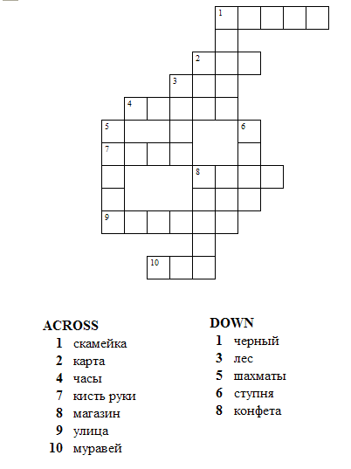

2 ВАРИАНТ

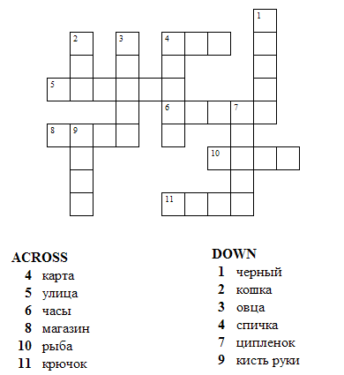

Карточки к игре

What is it?  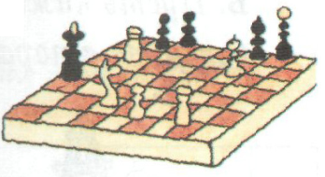 | What is it?  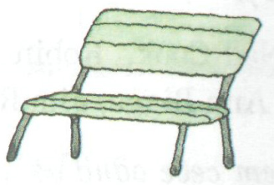 | What is it?  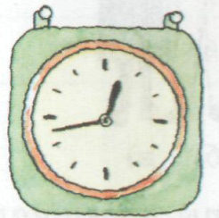 | What is it?  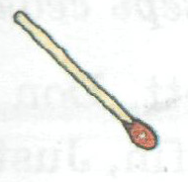
What is it?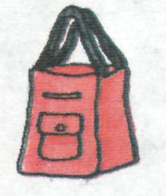 | What is it?  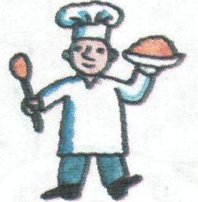 | What is it?  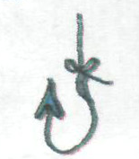 | What is it?  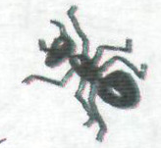
What is it?  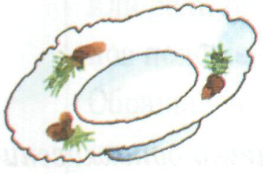 | What is it?  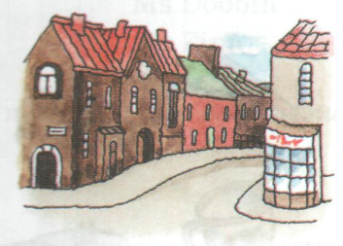 | What is it?  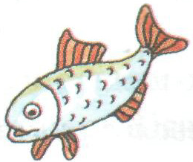 | What is it?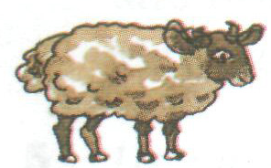
Translate:  Мое имя Энн. | Translate:  Познакомься с Томом. | Translate:  Как у тебя дела? | Translate:  До свидания!
Translate:  Приятно познакомиться! | Translate:  Как тебя зовут? | Translate:  Здравствуйте! | Translate:  Привет! Я - Полли

