MEALS SONG
EXERCISE 1. Write and sing words (to the tune of Oh, my darling Clementine) instead of pictures! Unscramble the red meal words.
IN THE MORNING, IN THE MORNING
I EAT MY RAKFEBATS EVERY DAY
AND BUTTER, 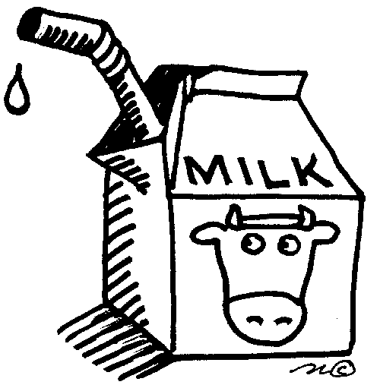AND FRUIT
A HEALTHY RAKFEBAST EVERY DAY

THEN AT NOON, THEN AT NOON
I EAT MY CHUNL EVERY DAY
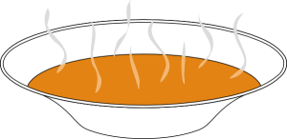AND VEGIES, STEAK, 
A HEALTHY CHUNL EVERY DAY

IN THE EVENING, IN THE EVENING
I EAT MY REDNIN EVERY DAY
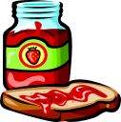AND COCOA, TEA AND 
A HEALTHY REDNIN FOR GOOD NIGHT

TEACHER’S NOTES
MEALS SONG
IN THE MORNING, IN THE MORNING
I EAT MY BREAKFAST EVERY DAY
BREAD AND BUTTER, MILK AND FRUIT
A HEALTHY BREAKFAST EVERY DAY

THEN AT NOON, THEN AT NOON
I EAT MY LUNCH EVERY DAY
SOUP AND VEGIES, STEAK, POTATOES
A HEALTHY LUNCH EVERY DAY

IN THE EVENING, IN THE EVENING
I EAT MY DINNER EVERY DAY
JAM AND COCOA, TEA AND COOKIES
A HEALTHY DINNER FOR GOOD NIGHT
After this, you can change the food words to suit whatever kids eat. You can even use it for a flashcard game. Place all flashcards on the board, then sing to the children what you 'eat' and they have to bring you the correct flashcard (change the original text, it doesn't have to rhyme for this.) You can also add the line: 'in the meantime, in the meantime, I eat my snack every day', etc.
Don't overdo it, because, the song is useful and easy to remember, but it gets boring after a while, and then you ruin the useful effect from the beginning.

