



















wings

a beak

feathers

a tail

scales

claws

paws

whiskers

fur

fins

a shell



|  |  |  |
| --- | --- | --- |
| A snake | A kangaroo | A parrot |
| A horse | A mouse | A snail |
| A fly | An ox | A dolphin |
| An owl |  |  |
| A shark | A tiger | A tortoise |
| A swan | A moscuito | A peacock |

My favourite animal

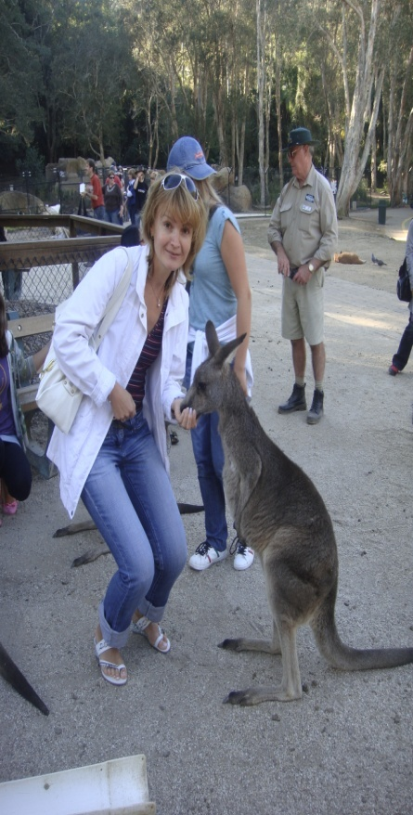

My favourite animal is a kangaroo.

It lives in Australia.

It has got a big body, a small head, two ears and a long tail.

It has got fur on its body, too. It has got a pocket to carry babies!

It can run and jump very fast!

I like this animal because it is funny but very strong.

Writing

My favourite animal.

|  |
| --- |
| My favourite animal is a___________________________________________It lives in___________________________________________  It has got  ____________________________________________________________________________________________________________________________________  It can _______________________________________________________________________________________  I like this animal because____________________________________  ____________________________________________ |