- 1. This is a living-room. 2. This is a study. 3 There are two armchairs, a wall-unit (стенка) and a
- sofa in the room. 4 There is a piano to the left of the door. 5. There is a desk and two chairs in
- the room. 6. There are flowers on the table. 7. There is a lamp on the table. 8. There is a lamp
- above the table. 9. There are a lot of books on the desk, 10. There are two pictures on the wall.
- 11. There is a bookshelf with English books and textbooks on the wall in the room. 12. There is
- a small table in the middle of the room. 13. There is a floor-lamp (торшер) between the sofa
- and the TV set. 14. There is a TV set in the corner of the room.

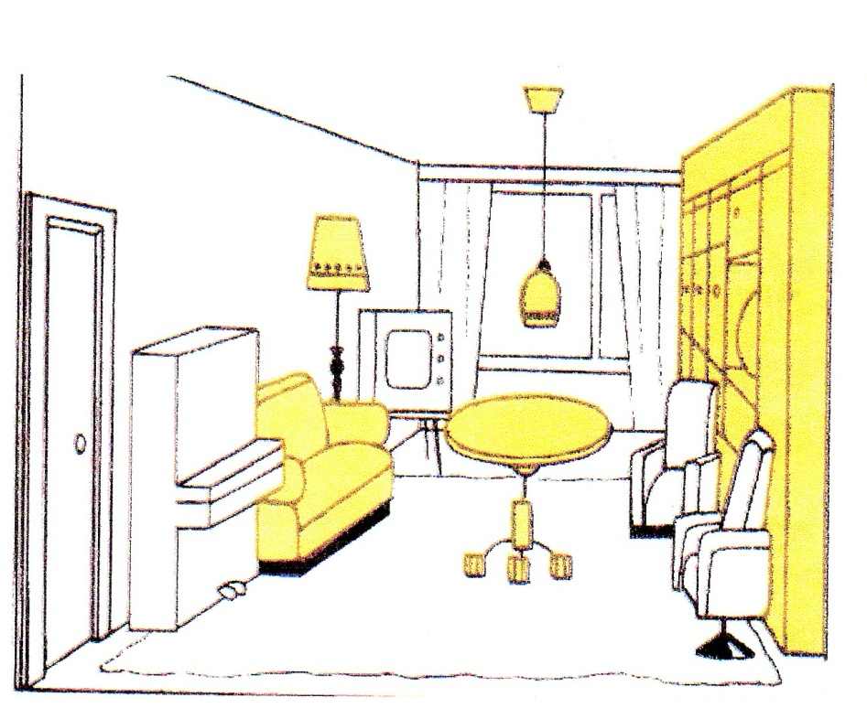
Picture № 1
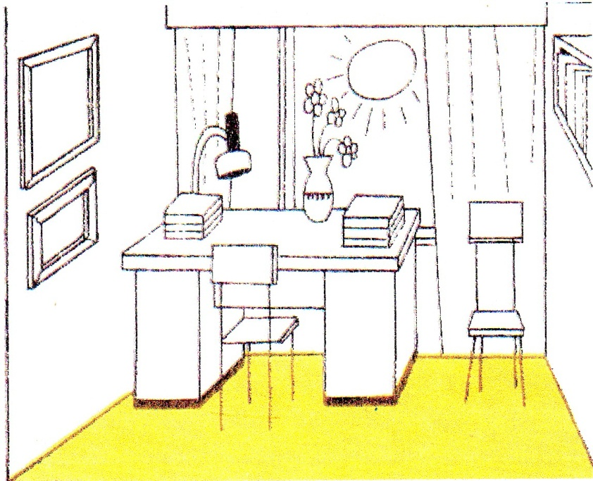
Picture № 2

