5, Amurskaya Street 21
Omsk
Russia
644086

6 April

Dear boys and girls,

I am happy to hear that you want to change your bad habits. There are a lot of things you can do to keep fit and healthy.
Firstly, you should eat a lot of fruit such as:  , ,  and . Vegetables are also full of vitamins: ,  and  . Do not eat many and .
In the morning you should drink a glass of 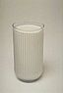 or . They will give you a good start to the day. Do not drink 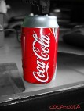, it is full of sugar.
I hope my advice will help you. Good luck.
Love,
Doctor Brown.

