Приложение 2.

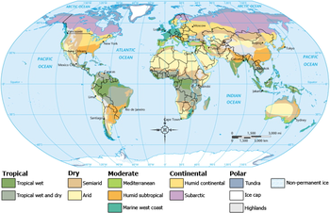

Traveller’s card

country | seasons | climate
Greenland

Great Britain

Spain

Egypt

India

Brazil

