***Творцы науки***

|  |  |  |  |  |  |  |  |  |  |
| --- | --- | --- | --- | --- | --- | --- | --- | --- | --- |
|  | | | | | 1 |  |  |  |  |
|  |  |  |  | 2 |  |  |  |  |  |
| 3 |  |  |  |  |  |  |
| 4 |  |  |  |  |  |  |  |
| 5 |  |  |  |  |  |  |  |  |
| 6 |  |  |  |  |  |  |  |  |  |

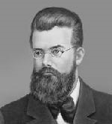Вставьте в клетки по горизонтали фамилии учёных - создателей молекулярно - кинетической теории и термодинамики.

