Plan | 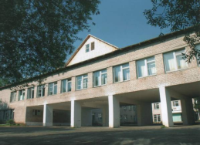 | Maiskaya  Secondary  School  Central Street  Maisky | 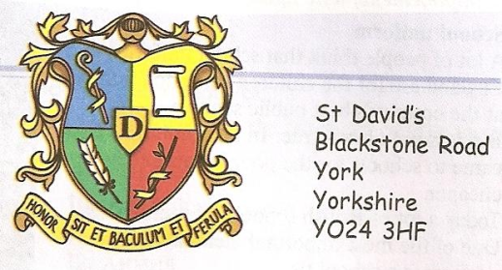
1. School (type, building, payment)  2. Scholarship  3. School uniform  4. Teachers  5. Punishments  6. Subjects  7. Lessons  8. Classmates | 1. It is a state school. Boys and girls study together. They don’t pay money for studying.  Maiskaya School is in a new building.  2. Pupils don’t get a scholarship.  3. Pupils don’t wear a school uniform but some classes have their own school uniform.  4. Teachers are kind.  5. Pupils don’t get punishments.  6. All subjects are compulsory.  7. Pupils have 6 or 7 lessons a day.  8. Classmates are friendly. |  | 1. It is a public school. It is a school for the rich. It is a all-boys school. Only boys study there. It is a boarding school. Pupils study and live there. St David’s school is in an old castle. Parents pay money for studying. It is expensive.  2. Pupils get a scholarship when their results are good.  3. Pupils have to wear a school uniform: trousers, a shirt, a blazer, a pullover, a hat, a tie.  4. Teachers are strict.  5. Pupils get a lot of punishments. They get detentions and do lines.  6. Some subjects are compulsory but pupils can choose some optional subjects.  7. Pupils have 9 lessons a day.  8. Classmates are cheeky and bully each other.

