Приложение 2
Name______________________________________ class ____________

Country | Location | Capital | Flag | People | Interesting things
 | in Europe |  | 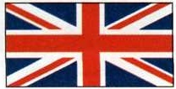
 | in the south hemisphere |  | 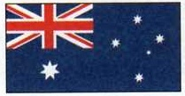
 | in the south hemisphere |  | 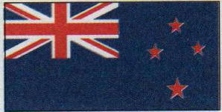
 | in North America |  | 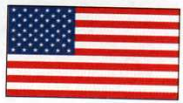
 | in North America |  | 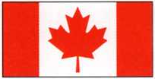

Niagara Falls, Statue of Liberty, Big Ben, Opera House, geysers and volcanoes, New Zealanders, Maori, British, Canadian, Eskimo, Indian, Cowboy, American, Australian

Tic true or false | True | False
The Queen of England is an old woman.
The colours of British flag are red, white and blue.
All busses in Britain are red.
Tea is a traditional British drink.
There lots of kangaroos in Britain.
Maoris are the people of Canada.
There are fifty states in Canada.
The statue of Liberty is in New Zealand.
Indians are Americans.
There are lots of sheep in New Zealand.
All taxis in London are yellow.
Sidney is the capital of the USA.
Canadian flag has many stars.
Ottawa is the capital of Canada.
Some people in Canada speak Eskimo.

