$6\text{cos}x+8\text{sin}x=5$ ОДЗ: $x∈R$
По формуле Муавра
$$\text{cos}α=\frac{6}{\sqrt{6^{2}+8^{2}}}\text{;cos}α=\frac{3}{5};α=\text{arccos}\frac{3}{5}$$
$$\text{sin}α=\frac{8}{\sqrt{6^{2}+8^{2}}}\text{;sin}α=\frac{4}{5};ε=\text{arcsin}\frac{4}{5}$$
$$\text{cos}β=\frac{5}{\sqrt{6^{2}+8^{2}}}\text{;cos}β=\frac{1}{2};β=\text{arccos}\frac{1}{2};β=\frac{π}{3}$$
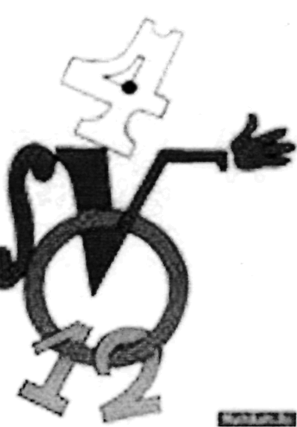
Так как $\begin{aligned}x=α±β+2πn,n∈Z \\ x=\text{arccos}\frac{3}{5}±\frac{π}{3}+2πn,n∈Z\end{aligned}$
Ответ:
$$\text{arccos}\frac{3}{5}±\frac{π}{3}+2πn,n∈Z$$

