Приложение 1.

You are going to read a newspaper article about unhealthy food. Six paragraphs have been removed from the article. Choose from paras A-G the one which fits each gap (1-5). There is one extra paragraph which you do not need to use. There is an example at the beginning.

Junk food

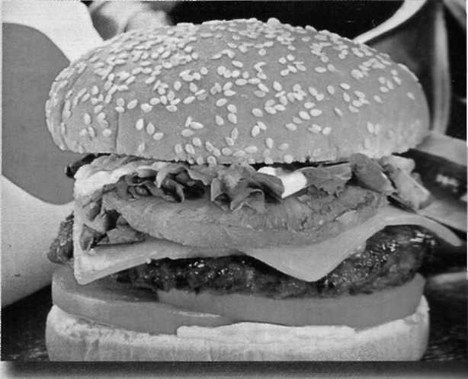
In today's fast-moving world, people have less and less time to spend eating, let alone cooking. It is probably for this reason that junk food has become so popular, and there's no doubt that it's here to stay. In fact, it seems that you simply can't get away from it. One British hotel group recently announced that its guests are able to order fast food through room service, a move which is seen by many as signifying a new era in the couch potato lifestyle. So what exactly is junk food?

0-B

Obviously, a diet of junk food is not the best thing for your health, particularly as it is high in saturated fat. In 1993, the Journal of the National Cancer Institute reported this type of fat to be associated with a greater risk of cancer.

1-

The best advice, then, for those who cannot live without their hamburgers or chocolate bars, is to limit the amount of junk food they eat. A little now and then will probably do no harm. But
why have our eating habits changed? "It's lack of time and loss of tradition," says one expert.

2-

Another alarming thing about people's lifestyles today is that while the amount of junk food we eat has increased, the amount of exercise we do has actually decreased. Exercise plays an important part in keeping the body fit and healthy; it helps to control our weight and, if taken regularly, can also decrease our chances of having a heart attack in later life.

3-

Even though people nowadays are actually far more aware of the importance of exercise and a healthy diet than they were a few years ago, the new unhealthy way of life is surprisingly popular. This is illustrated by statistics gathered by researchers over the past two decades.

4-

Researchers suggest that the new generation will be much more likely to suffer from heart and liver disease. What can't be emphasised enough is the fact that a balanced diet and regular exercise bring significant health benefits.

5-

Ironically, if they were to make time to exercise and improve their eating habits, they would probably find that they were far better equipped to deal with their stressful lifestyles than they are now.

A Recent research has shown that young French people, who prefer burgers and chips to rich gourmet dishes, tend to become overweight Weight gained in adolescence is extremely hard to lose in later life, so researchers are predicting thai the new French generation are not going to be admired for their slim figures as the French have traditionally been.
В Basically, it is anything that is high in calories but lacking in nutrition. Hamburgers, crisps, chocolate bars and hot dogs fall into this category. Pizzas, although they can have vegetable and cheese toppings, are also included as they contain a lot of fat
С Not all junk food is bad for your health, however. Some hamburgers, for example, are very high in nutrients and low in fat. It is just a question of finding out what goes into the food before you decide to eat it.
D Apart from the risk of cancer, another side effect of consuming highly fattening junk food is that you are likely to gain weight. This is especially true because you tend to eat more, as junk food is less satisfying and lower in vital nutrients than healthier food.
E You can gain anything from glowing skin to an all-round feeling of good health. One way or another, the vast majority of people seem to be missing out on this, due mainly to the pressures of modern life.
F What is more, you don't have to exercise much to gain visible benefits. Doctors say that twenty minutes' exercise three times a week is all that is necessary.
G He explains that people are too busy to cook and eat proper meals, so they grab whatever is avai-able - and that is usually junk food. Also, the style of life represented on TV, especially in music videos, is fast. Young people pick up the idea thai speed means excitement, whereas anything traditional is slow and boring. As a resurt, they tim down traditional food and go for junk food instead

