Внеклассное мероприятие: “Творческая защита проектов “Мой
домашний питомец”

Цели и задачи: развитие и повышение интереса к предмету, повторение и закрепление
ранее изученной лексики,
развитие навыков устной речи и аудирования,
развитие познавательных интересов учащихся,
способствовать повышению личной уверенности у каждого участника процесса
обучения, позволить каждому ученику увидеть себя как человека способного и
компетентного;
развивать у учащихся «командный дух» и «чувство локтя», а также умение
сотрудничать;
обеспечить механизм развития критического мышления ребенка, умения искать
путь решения поставленной цели;
развивать у учащихся исследовательские умения.

Оснащение: компьютер, мультимедийный проектор.
Good afternoon, boys and girls! Good afternoon, dear guests! Today we have the projects’ lesson. We are going to talk about animals. Your classmates prepare poems, short plays and projects about their pets. By the way, do you like animals? Do you have a pet? What kind of pet do you have?
And at first we listen to the poem about one boy, who wants to have an animal.
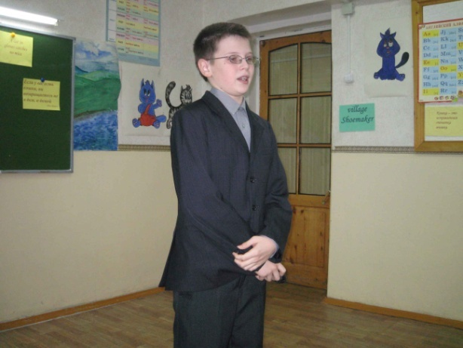
I want to buy an animal.
I want to buy an animal,
I’d like to buy a cat;
But the dog is sure to kill it;
So I can’t buy that.

I want to buy an animal,
An elephant would do;
But our house has such a little door!
I’d never get it through!
I want to buy an animal,
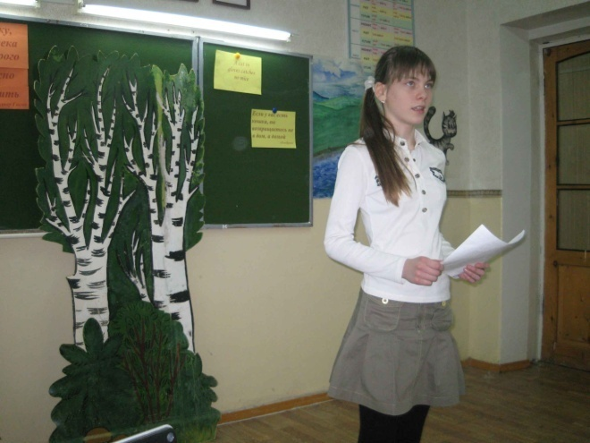
I’d like to buy a bird;
But father says,”Oh, stop that noise!
I can’t make myself heard!”

I want to buy an animal
(I really don’t know why);
It must be very, very small,
And it must no noise at all.
I think I’ll buy a fly.

Natasha Kulikova’s project: Dogs loves cats.
I love our cat. He is very nice and kind. I love Persian cats very much. Persian cats are very nice. They are fluffy. My granny has a cat too. His name is Ryzhik. Ryzhic is a Persian. Ryzhik eats kitiket and drinks milk.
My granny has a dog Rottweiler. His name is Cheers. He is kind, nice, beautiful and independent.
Cheers are always merry. He loves cats. Cheers plays with cats. He eats very much. Cheers sleep on a floor.
He loves children and plays with them.
I love Cheers and Ryzhik very much. They are kind, good and nice.
Kulikova Natalia 6 “A”
Traveller.(6б)
Pussy-cat, pussy-cat,
Where have you been?
I’ve been to London
To look at the Queen.
Pussy-cat, pussy-cat,
What did you do there?
I frightened a little mouse
Under her chair.
В гостях у королевы.
- Где ты была сегодня, киска?
- У королевы у английской.
- Что ты видала при дворе?
- Видала мышку на ковре.
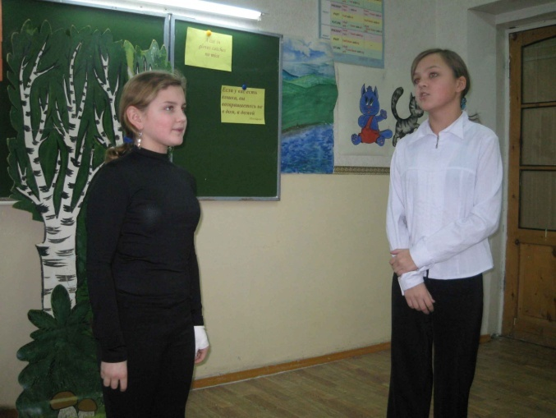
6а
Pussy Cat, Pussy C at,
Close your eyes.
Pussy Cat, Pussy C at,
Don’t catch mice.
Pussy Cat, Pussy C at,
Eat some cream.
Pussy Cat, Pussy C at,
Sleep and dream

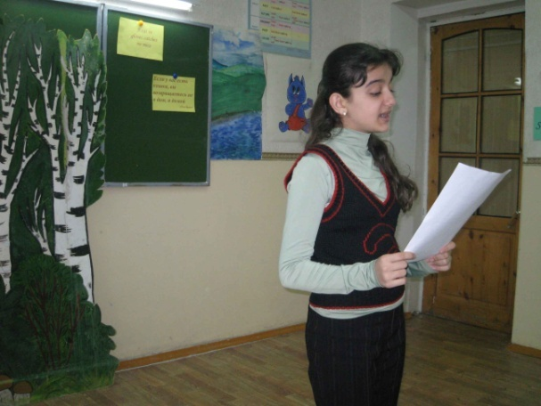
Five little cats are playing on the floor.
One runs away – and now there are four.
Four little cats are hiding in the tree.
One runs away – and now there are three.
Three little cats are walking at the zoo.
One runs away – and now there are two.
Two little cats are lying in the sun.
One runs away – and now there is one!

Алиева Арзу- проект My cats are always there for us.
I love my pets. They are cats. They are Kate and Murka. They are my best friends and members of the family. My cats are always there for us.
They like when we wash them in a bath, when I play with them, when they play with cats in the street, when I feed them.
Kate is black and white. She is nice, kind, clever, beautiful and independent. She is small. She comes to my room in the morning, because she likes to relax in my bed. She likes eat “kite cat” and milk. She likes to sleep, to go for a walk, to jump, to run and to play with balloon.
Murka is grey and white. She likes to sleep on the armchair. She likes to play with other cats, to eat her lunch, to play, to wash, to see photos, to put shoes on her back paw. I am happy with my cats. And I like my small cats very much!!!
Alieva Arzu 6 “A”

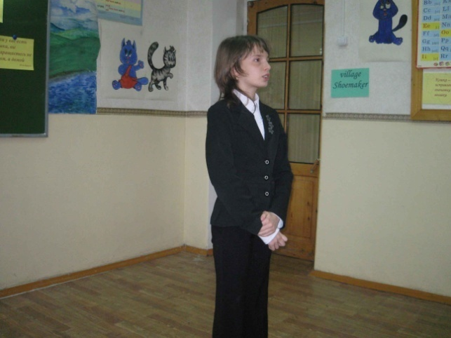
Страшнее кошки зверя нет!
Теперь уже и в Internet
Проникли кошки. Вот беда!
От них не скрыться никуда!
Но что же делать? Как же быть?
Придется кошек полюбить!

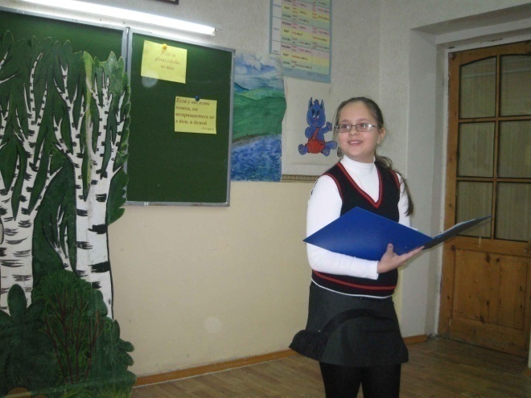
Аня Житникова (проект) Приложение 1
My cat’s name is Manya. It is very nice cat. Manya likes to play with me and likes to run over the flat. Manya likes to watch TV. Her tail is very fluffy. Manya’s nose is pink. Her ears are big. Manya likes “Wiskas and Kitecat”. Manya likes to sit on the window and looking at everything. It likes sleeping in bags. It tries to catch mice and birds.
My cat is very lazy, but I like my cat!!!

Three Little Kittens. 6б
Three little kittens,
they lost their mittens,
And they began to cry,
Oh, Mother dear,
We greatly fear,
Our mittens we have lost. Lost your mittens,
You naughty kittens!
Then you shall have no pie.
Miew, miew, miew,
No, you shall have no pie.
Three little kittens,
They found their mittens,
And they began to cry,
Oh, Mother dear,
See here, see here,
Our mittens we have found.
Found your mittens, you clever kittens,
Then you shall have some pie.
Purr, purr, purr,
Oh, let us have some pie.
Познакомьтесь с переводом стихотворения “Three Little Kittens” на русский язык.

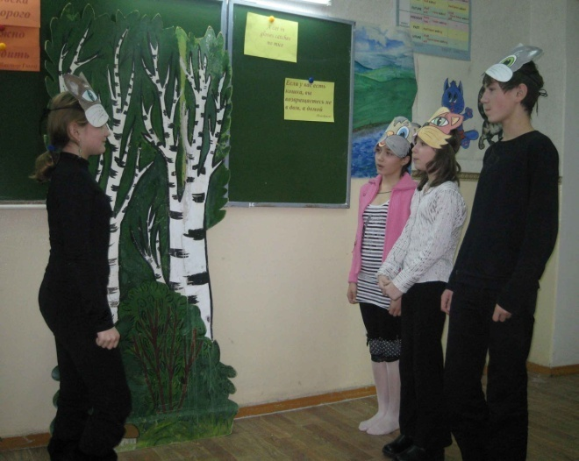
Перчатки.
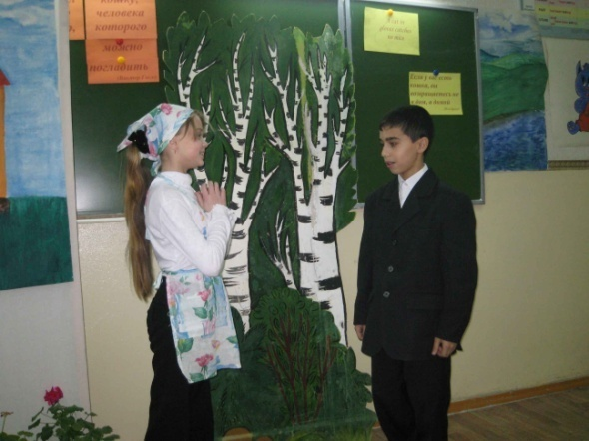
Потеряли котятки
На дороге перчатки
И в слезах прибежали домой:
- Мама, мама, прости,
Мы не можем найти,
Мы не можем найти
Перчатки!
- Потеряли перчатки?
Вот дурные котятки!
Я вам нынче не дам пирога.
Мяу-мяу, не дам,
Мяу-мяу, не дам,
Я вам нынче не дам пирога!
Побежали котятки, отыскали перчатки
И, смеясь, прибежали домой:
- Мама, мама, не злись,
Потому что нашлись,
Потому что нашлись
Перчатки!
- Отыскали перчатки?
Вот спасибо, котятки!
Я за это вам дам пирога.
МУР-МУР-МУР, пирога,
Мур-мур-мур, пирога,
Я за это вам дам пирога!

6а Millions of cats
Once upon a time there was a very old man and a very old woman. They lived in a nice clean house which had flowers all around it. But they couldn’t be happy because they were very lonely.
- If only we had a cat!
- A cat?
- Yes, a sweet little cat!
- I will get you a cat, my dear.
And he went over the hills to look for one. He walked a long, long time and he came to a hill which was covered with cats.
Cats here, cats there,
Cats and kittens everywhere,
Hundreds of cats, thousand of cats,
Millions and billions and trillions of cats.
- Oh,- cried the old man happily, - now I can choose the prettiest cat and take it home with me.
So, he chose one.
- Oh, it’s white. It is very nice! And this is black and white and it is as pretty as the first. I’ll took this one too. But this is a grey kitten which is pretty as the others, I’ll take it too!
And just then the very old man found a kitten which was black and very beautiful.
So he takes it. And then he see a brown and yellow cat.
- I must take it!- cried the very old man, and he did.
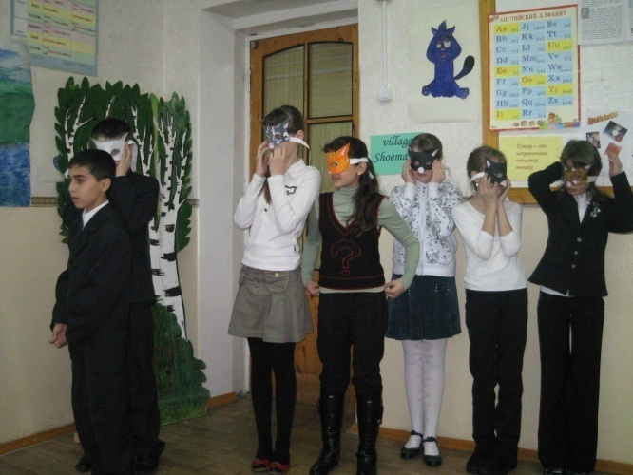
So it happened that every time the very old man looked up, he saw another cat which was so pretty, and he chose them all. And so he went back to show all his pretty kittens to the very old woman.
They came to a pond.
- Mew, mew! We are thirsty! – cried the hundreds of cats.
- Well, here is a lot of water. – said the old man.
Each cat drank some water, and the pond was gone.
-Mew, mew. We are hungry!
-There is a lot of grass on the hills.
Each cat ate some grass and nothing was left.
The very old woman saw them coming.
- My dear! What are you doing? I asked for one little cat, and what do I see?
Cats here, cats there,
Cats and kittens everywhere,
Hundreds of cats, thousand of cats,
Millions and billions and trillions of cats.

I love my pets
I love my pets. It is a cat. Her name is Karolina. She is my best friends and а member of our family. She is always there for me and I am always there for it. She likes to play with me, go for a walk, play with small ball and play with my friends. She likes to wash in a bath and to play with cats in the street.
Karolina is brown and white. She is nice, clever, independent, kind, beautiful, fine, bright and ridiculous. She likes to sleep with me, eat with me. She is a sportsman. She likes to run, to jump through a skipping rope, to be tightened wrung out, swing and swim!!!
Малыгин Дмитрий 6 «А»
The two little kittens
Two little kittens, one stormy night,
Began to quarrel, and then to fight.
“I’ll have that mouse,” said the bigger cat.
“You’ll have that mouse? We’ll see about that!”
“I will have that mouse,” said the older one.
“You shan’t have the mouse,” said the little one.
I told you before it was a stormy night,
When these two little kittens began to fight.
The old woman seized her sweeping broom,
And swept the two little kittens right out of the room.
The ground was all covered with frost and snow.
And the two little kittens had nowhere to go.
So they lay them down on the mat at the door,
While the old woman finished sweeping the floor.
Then they crept in as quiet as mice,
All wet with the snow, and as cold as ice.
For they found it much better, that stormy night,
To lie down and sleep, than to quarrel and fight.

Котята
Два маленьких котенка поссорились в углу.
Сердитая хозяйка взяла свою метлу
И вымела из кухни дерущихся котят,
Не справившись при этом, кто прав, кто виноват.
А дело было ночью, зимою, в январе.
Два маленьких котенка озябли во дворе.
Легли они, свернувшись, на камень у крыльца.
Носы уткнули в лапки и стали ждать конца.
Но сжалилась хозяйка и отворила дверь.
«Ну что,- она спросила,- не ссоритесь теперь?»
Прошли они тихонько в свой угол на ночлег,
Со шкурки отряхнули холодный, мокрый снег.
И оба перед печкой заснули сладким сном.
А вьюга до рассвета шумела за окном.
(перевод С. Маршака)

Кот на печке...Кот, ты спишь?..
Кот устал, не слышит.
Из-под печки лезет мышь -
Трусит, еле дышит.
Видит Кот приятный сон -
На скамейке у окон
Из большого чана
Льет сметана!..
Тут и сливки - целый пруд!..
Лижет Кот и там, и тут...
Съесть все это хочет,
Лапы мочит!..
Мышь смекнула: "Дремлет вор!..
Будет нам раздолье!
Эй, скорей из темных нор,
Мыши, из подполья!"
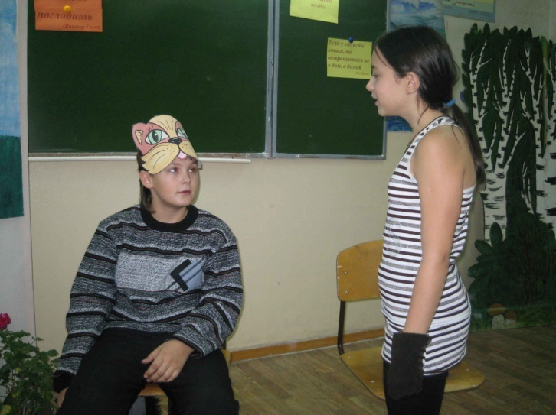
На разбой идут ночной,
Шмыг да шмыг по лавке,
Лапку маленькой одной
Отдавили в давке.
А уж Кот в приятном сне
Лижет ус сметанный...
Вдруг он видит - мышь на дне!
Случай очень странный!..
Не поверил счастью Кот,
Стал поглаживать живот:
"Вот такой-то ужин
Нам, котам, и нужен!.."
Потянулся...
Облизнулся...
Мышь кота за морду - хвать!
И в сметану прыг опять!
Вздрогнул Кот, проснулся;
Дыбом шерсть, глаза горят.
Свет в избе потушен,
Нос горит - укушен...
"Верно, - думает,- блоха!"
А в подполье: "Ха-ха-ха!
Будешь помнить, Котофей,
Как ловить во сне мышей!
Пропадет охота! То-то

Thank you for your interesting poem. Now, let’s watch a play about a Cat and A Mouse.
Good afternoon, everybody! I have a fine story for you. It is about a greedy Cat and a clever Mouse. Look! The Cat is sitting at the table in the garden. She is having her supper: she has a plate of soup, a plate of porridge, a cup of milk, some butter and some sugar.

Cat: My soup is very good. I’ll put some butter in my porridge and some sugar in the milk. The porridge is sweet and there is a lot of it! That’s good!
Mouse (come up to the Cat): Mrs. Cat, I am very, very hungry! Please, give me some soup!
Cat: Go away, go away, Mouse! There is not enough soup for you. (eats greedily)
Mouse: Well, I’ll sit down and look at the moon. (sits down not far from the Cat)
Mrs.Cat, do you like this nice weather?
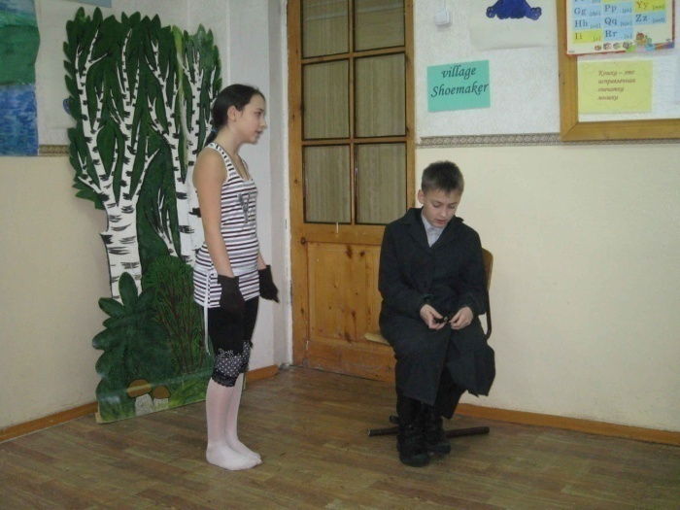
Cat: Yes, I do.(eats)
Mouse: Don’t you want to dance in such nice weather?
Cat: Yes, I do. (eats)
Mouse: Then, why don’t you dance?
Cat: I can’t. I don’t know how. (eats and drinks)
Mouse: I can teach you to dance. Wait a little! (runs away)
Story- teller: Look! The Mouse is running to the village. A Shoemaker lives there.
Mouse: How do you do, Mr. Shoemaker!
Shoemaker: How do you do, Mrs. Mouse! What can I do for you?
Mouse: Have you got any magic boots? I want to give them to the Cat.
Shoemaker: You are my friend, dear Mrs. Mouse. I will give you my magic boots. Here they are!
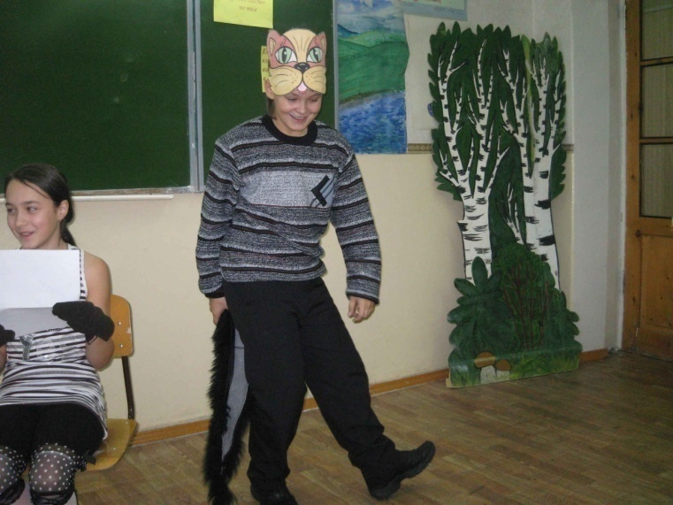
Mouse: Thank you very much, Mr. Shoemaker! Good-bye!
Shoemaker: That’s all right. Good-bye!
Mouse (entering) : Mrs. Cat, put on these boots. They are the magic boots. If you put them on, you will dance very well. (The Cat puts on the boots, and the Mouse switch on the music)
Cat: Oh, I am tired! I don’t want to dance any more, but I can’t stop! Stop me, my dear Mouse!
Mouse: I can’t stop you. These are the magic boots. You must dance and dance!
Cat: Oh, stop me! Stop me! I am very, very tired!
Mouse: You must dance all night long and I will eat up the rest of your supper.
Story-teller: So the Cat dances and dances and the Mouse eats up the rest of her supper. Are you sorry for the Cat? I am not, because she is very greedy.

Рыжова Настя (проект) Приложение 2
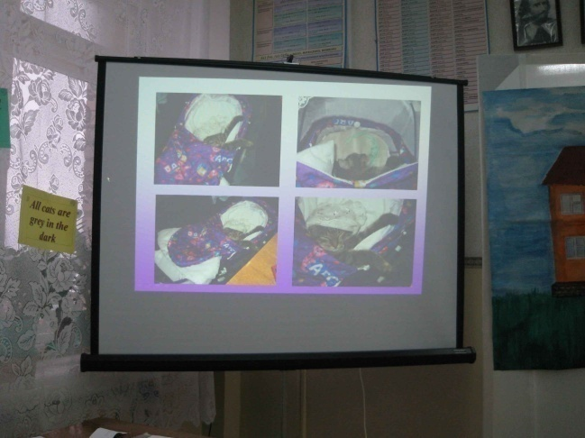
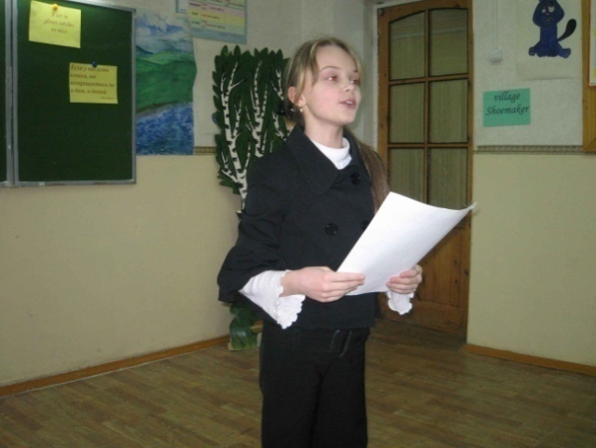

My cat is Garfild!
I love my cat! He is clever, kind, beautiful, independent and very curious. Garwik is always there for us. Garfild is a Siberian cat. He has many names: Garfild, Gafildiliero, Garfik, Garvik, Gaika. He is three-colours: grey, black, brown. He is a great hunter! Garvik hunts every night. He likes to sleep in my bed. Garfik likes to play outside and at home. He is very happy, we play in hide with him. It is very interesting. We brush him every day. Garfik have a personal comb and a personal toy’s carriage. Garfik doesn’t let to put toys there. He is our best friend and a member of our family!

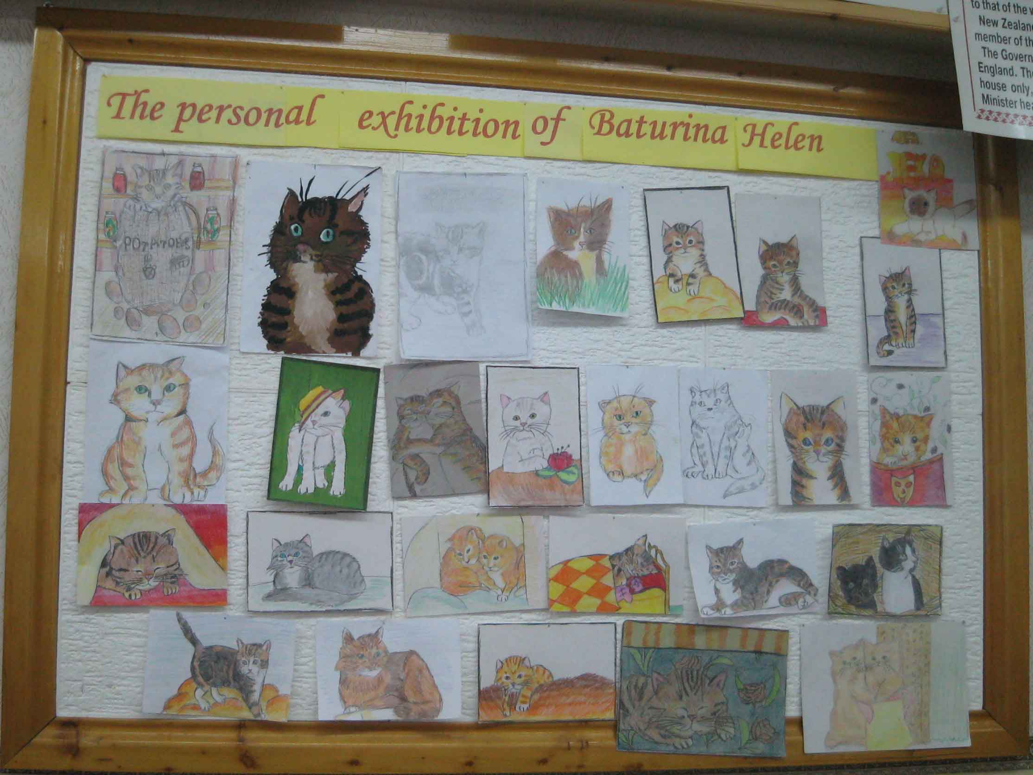

Что за шyм сpеди потёмок?
Это яблоко в садy
Вдpyг yпало, и котёнок
Покатил его к пpyдy.
Подтолкнyл его, однако,
В стоpонy, где беpег кpyт,
И yпало яблоко
Пpямо в темный пpyд.
Пpямо в пpyд оно yпало,
И пpопало. А со дна
Желтая, огpомная
Выплыла лyна.
Выныpнyла из потёмок,
Засияла над волной.
-Это я, -pешил котёнок,-
Сделал яблоко лyной!

You show, that you like cats very much. Now, let’s remember the expressions and proverbs about cats.

• All cats are grey in the dark (in the night) (All shapes, all colours are alike in the dark. The night obscures all distinguishing features) - букв. Все кошки серы в темноте (В темноте все формы и цвета становятся похожими. Ночь стирает все отличительные признаки) Русский аналог: "Ночью все кошки серы". "Ночью все кони вороные".
• The cat shuts its eyes when it steals the cream (People are inclined to shut their eyes to their own sins and vices) - букв. Кошка закрывает глаза, когда ворует сливки (Людям свойственно закрывать глаза на свои прегрешения) Русский аналог: "Знает кошка, чье мясо съела". "Ахал бы дядя, на себя глядя"
• A cat in gloves catches no mice (Restraint and caution achieve nothing; if you want to get something, you should immediately start working for it) - букв. Кот в перчатках мышей не поймает (Смысл: будешь белоручкой — дела не сделаешь) Русский аналог: "Без труда не вытащишь и рыбки из пруда". "Не замочив рук, не умоешься".
• A cat may look at a king (There is nothing to prevent an ordinary person from looking at a person of great importance so long as he tries to do no harm)
- букв. И кошка может смореть на короля Русский аналог: "За погляд денег не берут"
• Curiosity killed a cat (A person who tries to find out too much about other people's affairs is likely to suffer injury or harm; a warning to mind one's own business) - букв. Любопытство убило кошку (Смысл: любопытство до добра не доведет) Русский аналог: "Любопытной Варваре на базаре нос оторвали". "Много будешь знать — скоро состаришься". "От любопытства кошка сдохла".
• When the cat is away, the mice will play - букв. "Когда кота нет поблизости, мыши резвятся"
Русский аналог: "Без кота мышам раздолье".
• It is enough to make a cat laugh - букв. "Этого достаточно, чтобы рассмешить кошку"
Русский аналог: "Курам на смех". "Это и кошку рассмешит".
• Care killed the cat - букв. "Забота убила кошку" Русский аналог: "Беды да печали с ног скачали". "Не работа старит, а забота". "Кручина иссушит и лучину". "Морских топит море, а сухопутных — горе".
• A shy cat makes a proud mouse - букв. "У робкой кошки мышь хвастлива"
Русский аналог: У робкой кошки мышь резвится.

• Rain cats and dogs (It rains cats and dogs) - Проливной дождь, как из ведра. (Дождь льет как из ведра). Букв. "Дождь поливает и кошек и собак"
• Look like a cat who swallowed the canary - Иметь довольный вид.
Букв. "Выглядеть, как кот, который слопал канарейку"
• Watch one as a cat watches a mouse - Подстерегать как кошка мышку
• It's no place to swing a cat
Переводится как "Негде кошкой помахать" :)), т. е. синоним нашего "негде яблоку упасть".

Our lesson is over. I think you like it. All of you are very active, Almost everybody presents your projects and here you see the excellent pictures of cats, which presented by Lena Baturina.

Литература:
1. К.Кауфман “Happy English. Ru” Обнинск, «Титул» 2008.
2.«Школьные вечера на английском языке» составитель С.Б.Закс. М. «Просвещение» 1984
3. М.И.Дубровин «Английские и русские пословицы и поговорки в иллюстрациях»
3.Т. Клементьева “Happy English” Обнинск, «Титул» 2000..
4. ИЯШ – 2001, 2003, 2006.
5. песня Кузмичевой «Киска» использована в презентации Ани Житниковой.

