Приложение.

Mr. and Mrs. B Webster
request the pleasure of your company
at the wedding of their daughter
Belinda Catherine
to
Mark Stephen
son of Mr. and Mrs. J Collins of 13 Newbury Road, Camford.
The service will be at St Andrew’s Church, Binglley Road
at 11 a.m. on Saturday 29th November
with a reception at
the Royal Avon Hotel from 12 noon to 3 p.m.

Wedding Quiz.
- Who had problems with the law?
- Who has been having serious financial difficulties?
- Who has a drinking problem?
- Who has been divorced for two years?
- Who has had lots of girlfriends and like to go to nightclubs?
- Who was secretly engaged for many years but broke up?
- Who went to university only because father paid a lot of money?
- Who worked as a dancer in a famous nightclub?
- Who has a secret girlfriend?
- Now, let’s check the results. What are your answers to these questions?

The Wedding.

Ex. I Who is at the Wedding?
The bride The bride is the woman who is getting married.
The groom The groom (or bridegroom) is the man who is getting married.
The best man The best man is a friend or brother of the groom. He stands with the groom during the wedding. He’s the one who looks after the ring.
The bride’s father He’s one that stands with the bride during the wedding. He ‘gives her away’. (If her father is dead, an uncle, brother or friend ‘gives her away’.)
The vicar A vicar is a priest of the Church of England. In Britain you can get married in a registry office or in a church.
The bridesmaids (girls) and pages (boys) They’re the children who walk behind the bride. They’re the ones that help her with her long dress.

Ex. II “Waiting at the Church”

Fill in the gaps with missing words:
Uncle Roland, Belinda, hole, Mark, minute, Mark, ring, Clive, two hundred, pocket, wedding car.

Clive Well, everybody’s here now.
Mark Except . . . .
Clive Calm down, . . . . . She’ll be here in a minute. Who’s bringing her?
Mark Her . . . . . . . You know, he’s the one that’s got the business.
Clive Oh, right.
Mark Have you got the . . . . ?
Clive Yes, it’s in my . . . . . . . Hold on . . . It isn’t there any more. That’s funny. It was in this pocket . . . or was it this one?
Mark Oh, come on, . . . . !
Clive It’s here somewhere . . . . Oh, no, there’s a . . . .
Mark That ring was . . . . . . pounds . . .
Clive I’m sorry, I’m sorry, . . . . I’ll find it.

Ex III. Look throught the sentences and say if it is true or not and give right information.
- Terry is Mark’s brother.
- Terry takes photographs.
- Clive is going to buy a ring.
- Clive has got any money to buy a ring.
- Mark hasn’t got a ring, a best man and a bride.

Timetable.

  - Mrs. Webster & bridesmaids to the church
  - Wedding car collects Belinda, Me. Webster
11.00 Wedding service
11.30 Photographs outside the church
12.00 Reception at the Royal Avon Hotel
1.00 Lunch
1.45 Speeches
2.00 Cut the wedding cake
3.00 Belinda and Mark leave the reception
3.45 Arrive at the airport
5.15 Plane leaves the airport
7.45 Arrive in Majorca for the honeymoon

Role cards.

- You are Charlie Richards, the best man.
You work at a bank in the city.
You know that the groom had problems
with the law and has been arrested at least once!

- You are John/Jane Fletcher, a friend of the groom's family.
You are a retired doctor.
You know that the groom's father
has been having serious financial difficulties. It is a good
thing that the bride's family is rich!

- You are Mrs. Emily Watson. You are the groom's godmother.
You are retired.
You love your godson (the groom) very much,
but you are worried he has a drinking problem!

- You are Paul/Paula Jones. You are a friend of the groom's.
You are a medical student.
You know that the groom's parents have been divorced for two years.

- You are Kylie/Keith Griffith. You are a friend of the groom's.
You are the owner of a well-know nightclub.
You know that the groom has had LOTS of girlfriends and he likes to go I
to nightclubs. He met his bride at one!

- You are Jennifer Andrews, the maid of honor. You have known
the bride for fifteen years. You work as a model.
You know that the bride was secretly engaged to your brother for many
years but they broke up.

- You are Debbie Harris, a friend of the bride's father
(you are actually his secret girlfriend, but don’t tell anyone!)
You are a dance instructor.
You know that the bride went to university only because her father paid a lot of money!

- You are Sam/Samantha Williams. You are a friend of the bride's.
You are a hairdresser.
You know that the bride worked as a dancer in a famous nightclub.

- You are Peter/Petra Donovsky. You are a business associate
of the bride's father (you decide what the business is).
You don't trust the groom or anybody in his family.
In your opinion, they are all dishonest.

- You are AnnMarie Meller. You are a friend of the bride's mother.
You are a widow (your husband died two years ago).
You have heard that the bride's father has a secret girlfriend,
a young woman from the city.

Wedding vocabulary
Crossword by Agata Zieba-Warchoiak

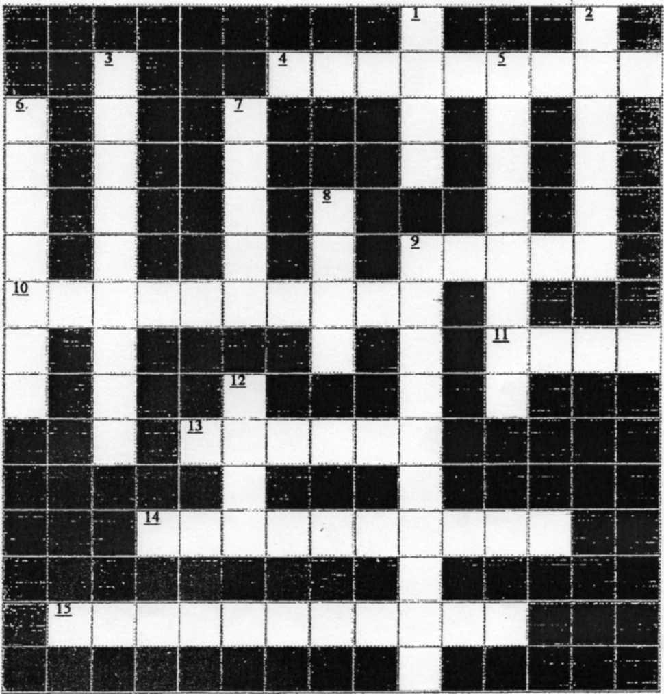

Down: 1. covering of fine net worn by a bride to hide her face
Down: 2. two people, esp. a man and woman together
Down: 3. party after a wedding ceremony
Across: 4. holiday taken by a newlywed couple
Down: 5. Segal union between a man and woman
Down: 6. male friend or relative of a groom who supports him at his wedding
Down: 7. man on his wedding day
Down: 8. traditionally cut by a young couple at their reception
Down: 9. young woman or girl attending a bride at her wedding
Across: 9. woman on her wedding day
Across: 10. person who likes trying to find a husband for a girl
Across: 11. long dress for special occasions
Down: 12. usually a golden one, given to the bride by the groom
Across: 13. man to whom a girl is engaged to be married
Across: 14. agreement to many
Across: 15. a sign at the back of newlyweds' car

