Приложение №3
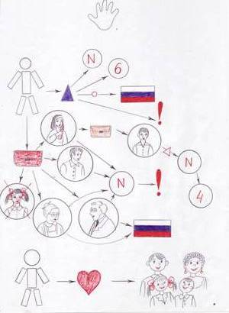
My family.
Hi! I am Lena. I am six. I am from Russia. I am fine.
I have got a mother. Her name is Dasha. She is fine. My mother has got a son. He is my brother. His name is Sasha. He is one.
I have got a father. His name is Nikita. He is fine. My father has got a brother. He is my uncle. His name is Boris. He is from Moscow.
I have got a grandmother. Her name is Nastya. She is fine. She is from Kumertau.
I have got a grandfather. His name is Ivan. He is from Kumertau.
I haven't got a sister.
I love my family.

