Приложение 1.
Read , find and match:
А- a long period of time when there is little rain or no rain -(drought)
B- a violent storm with extremely strong winds and heavy rain -(hurricane)
C- a large amount of water that covers an area that was dry before -(flood)
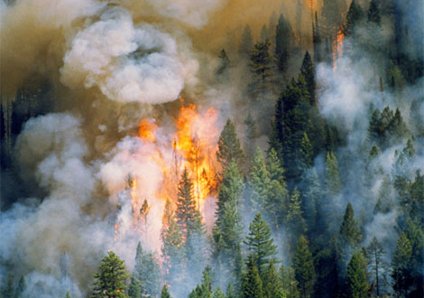 | 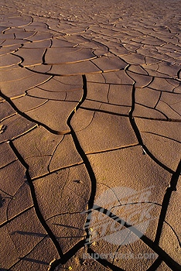
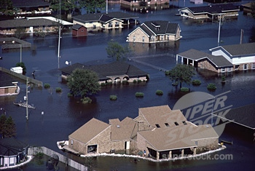 | 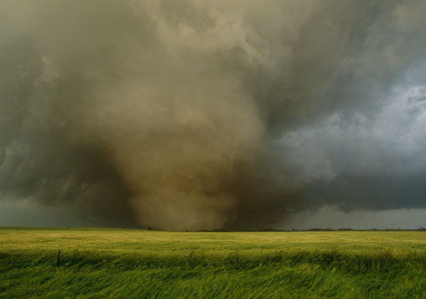
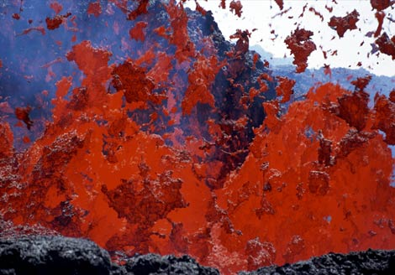 | 