ПРИЛОЖЕНИЕ № 2

ПЕСНИ

Let it snow

Oh the weather outside is frightful
But the fire is so delightful
And since we’ve no place to go
Let it snow! Let it snow! Let it snow!

It doesn’t snow since of stopping
And I’ve bought some corn for popping
The lights are turned away down low
Let it snow! Let it snow! Let it snow!

When I finally kiss goodnight
How I’ll hate going out in the storm
But if you’ll really hold me fight
All the way home I’ll be warm

The fire is slowly dying
And my dear were still goodbying
But as long as you love me to
Let it snow! Let it snow! Let it snow!

Oh the weather outside is frightful
But the fire is so delightful
And since we’ve no place to go
Let it snow! Let it snow! Let it snow!
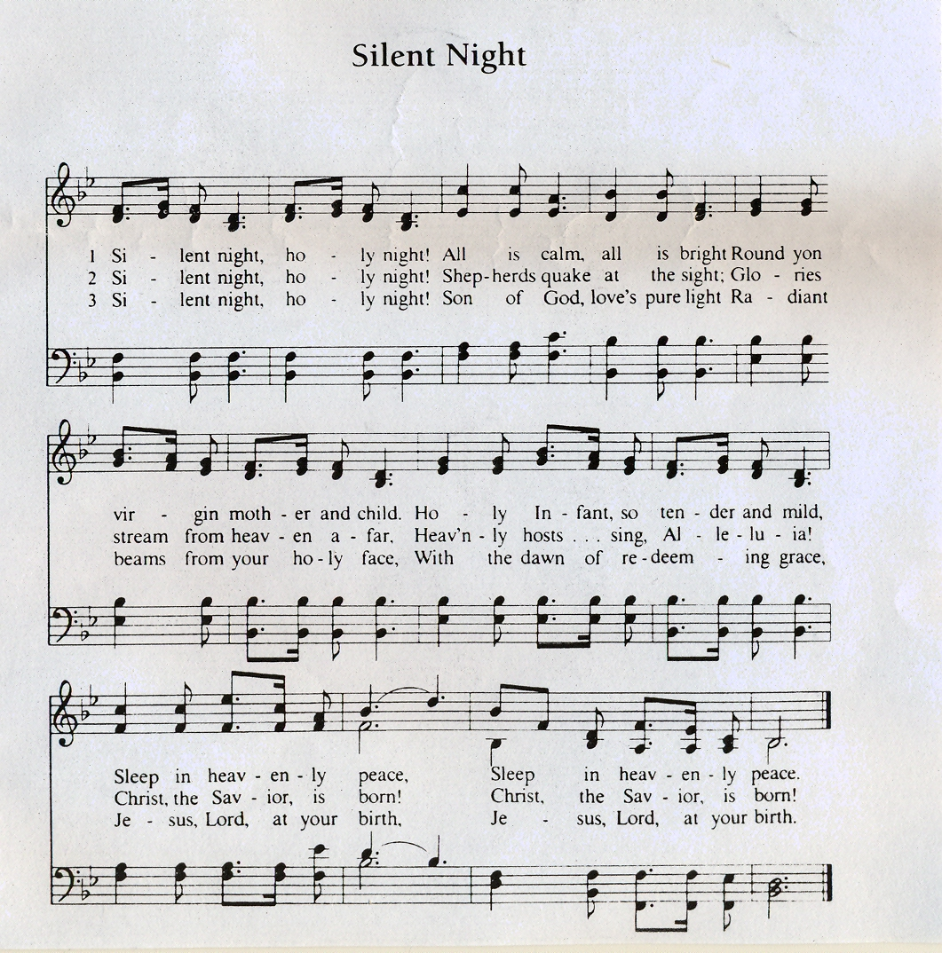

A fir was born.

A fir was born in deep, deep wood
And in the wood grew tall.
And there in all seasons she stood
The greenest tree of all

The snowstorms whispered lullabies
And wrapped up all the trees
She sang “now close your lovely eyes
Make sure you don’t freeze”.

The fir to our party’s come
And all this winter night
She brings such joy to everyone
What a lovely night.

Mistletoe

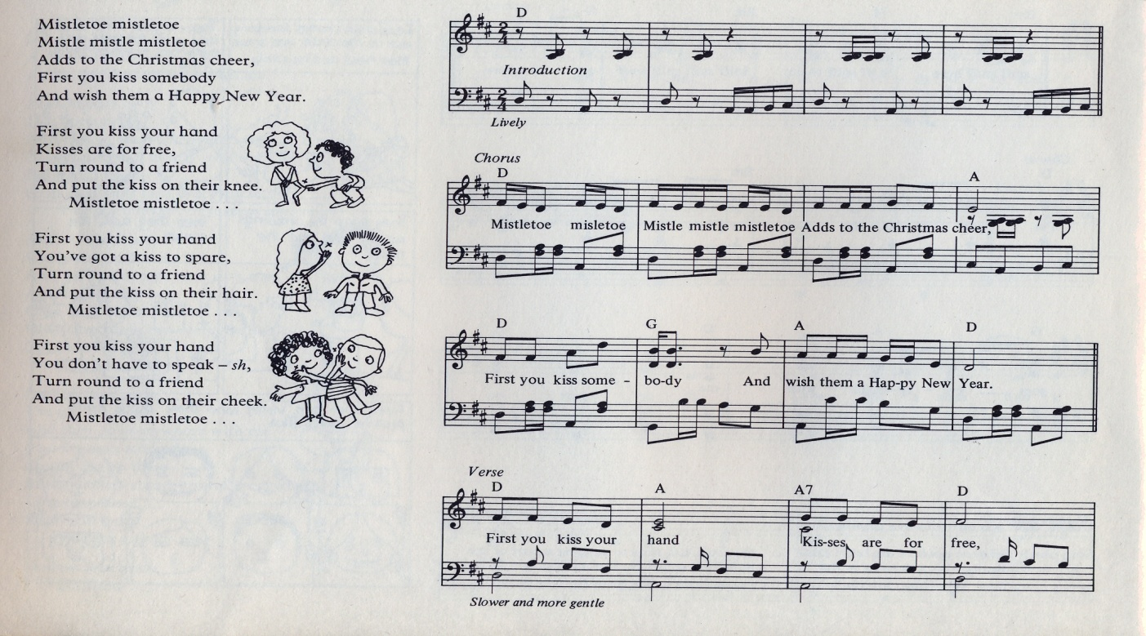
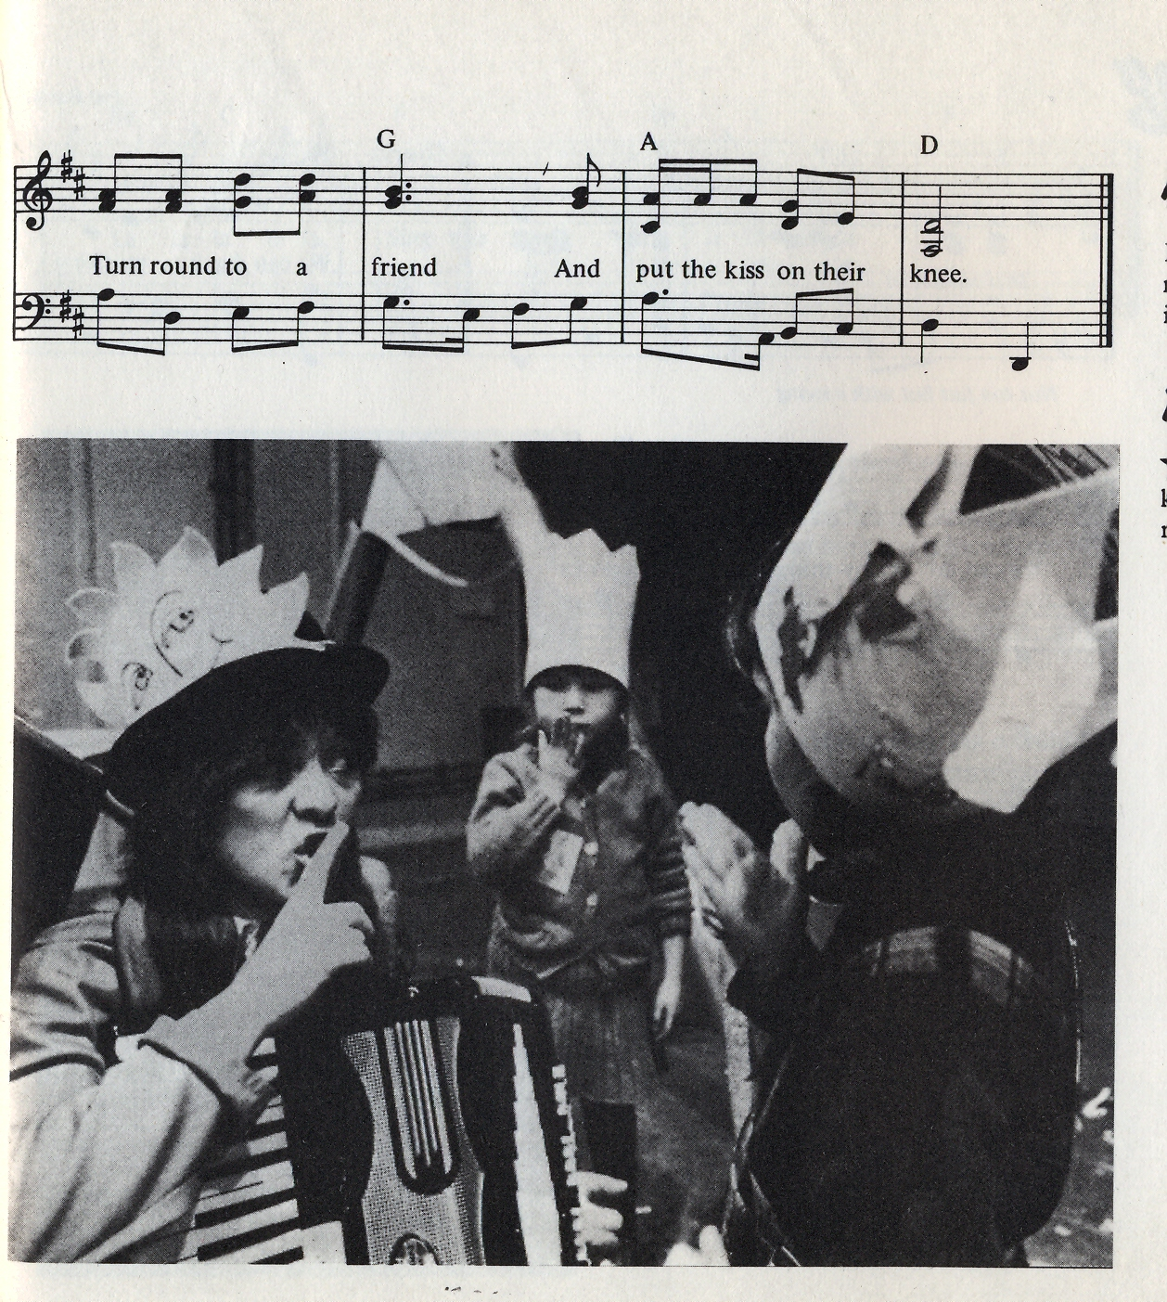

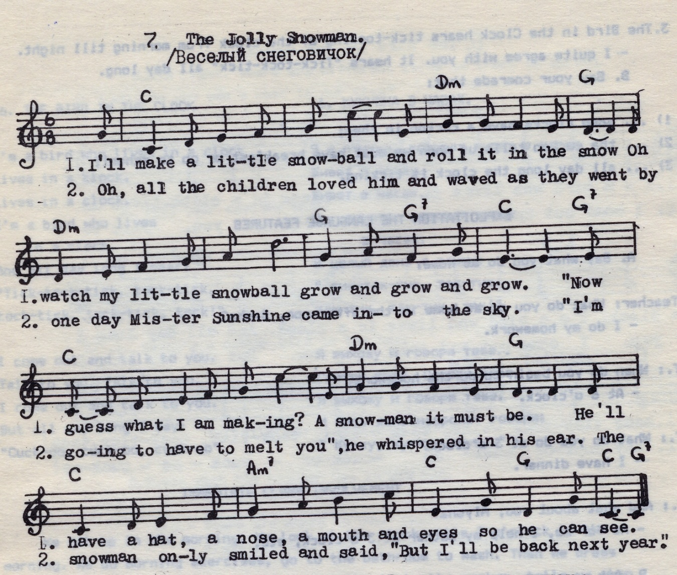

The Jolly Snowman

I’ll make a little snowball,
And roll it in the snow.
Oh watch my little snowball
Grow and grow and grow.
“Now guess what I am making?
A snowman it must be.
He’ll have a hat, a nose,
A mouth and eyes so he can see.

Oh, all the children loved him,
And waved as they went by.
But the Mister Sunshine
Came into the sky.
“I’m going to melt you”,
He whispered in his ear.
The snowman only smiled and said,
“But I’ll be back next year”.

JINGLE, BELLS
Dashing through the snow
In a one-horse open sleigh
Down the hill we go
Laughing all the way.
Bells on bobtail ring,
Just making spirits bright;
Oh, what fun it is to ride and sing
A sleighing song tonight.
REFRAIN:
Jingle, bells!
Jingle, bells!
Jingle all the way!
Oh! What fun it is to ride
In a one-horse open sleigh. (2)
A day or two ago,
I thought I’d take a ride,
And soon Miss Fannie Bright
Was seated by my side.
The horse was lean and lank,
Misfortune seemed-his lot;
He got into a drifted bank,
And we, we got upset.
REFRAIN.
Now the ground is white,
Go it while you’re young,
Take the girls tonight,
And sing this sleighing song.
Just get a bobtail bay,
Two forty for his speed;
Then hitch him to an open sleigh,
And crack! You’ll take the lead.
REFRAIN:
Jingle, bells! Jingle, bells!
Jingle all the way!
Oh! What fun it is to ride
In a one-horse open sleigh. (2)
Happy New Year

No more champagne
And the fireworks are through
Here we are, me and you
Feeling lost and feeling blue
It’s the end of the party
And the morning seems so grey
So unlike yesterday
Now’s the time for us to say

Happy New Year!
Happy New Year!
May we all have a vision now and then
Of a world where every neighbor is a friend?
Happy New Year!
Happy New Year!
May we all have our hopes, our will to fly
If we don’t we might as well lay dawn and die
You and I.

Seems to me now
That the dreams we had before
Are all dead nothing more
Than confetti on the floor
It’s the end of a decade
In another ten years time
Who can say what we’ll find
What lies waiting down the line
In the end of eighty nine?

Happy New Year!
Happy New Year!
May we all have a vision now and then
Of a world where every neighbor is a friend?
Happy New Year!
Happy New Year!
May we all have our hopes, our will to fly
If we don’t we might as well lay dawn and die
You and I.

