“MY FAVORITE SPORT”

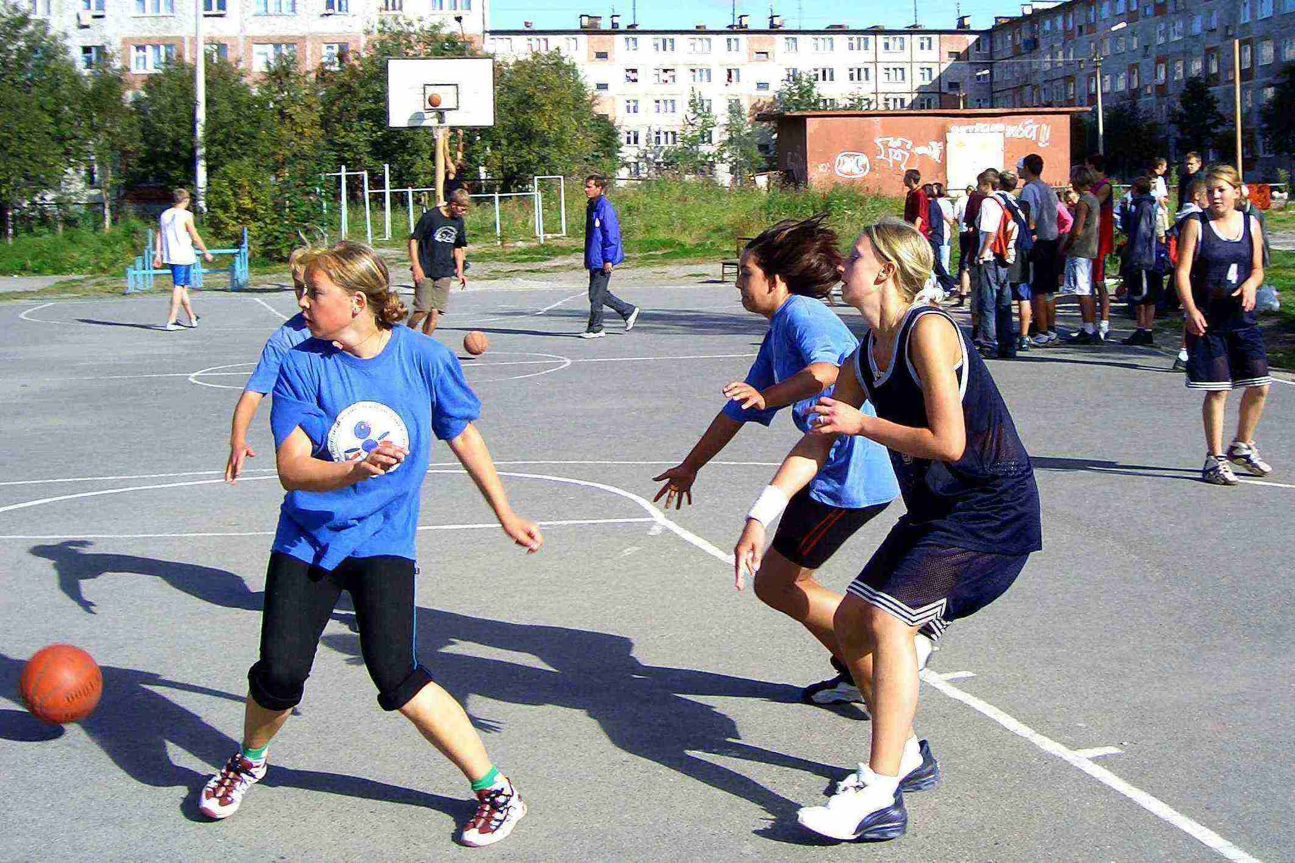
Sport is very popular in my school. There are good sport facilities there: a large gym where we have PT lessons, play games, such as volleyball, tennis, basketball, etc., a sports court and two small gyms for judo. Students go in for different kinds of sport. As for me, I am fond of basketball. It’s my favorite sport. I am a member of a school basketball team.
I am interested in everything concerning basketball. It’s a well-known fact, that the game originated in the United States of America. In 1891 an instructor at Springfield college in Massachusetts invented this game. He nailed two fruit baskets to the opposite walls of the gym. Then he put nine boys on one side and nine on the other. He told them to throw the ball to each other or bounce it and, when they were near the wall where the basket was nailed, to try and throw the ball into the basket.
He worked out some rules and asked the players to observe them.
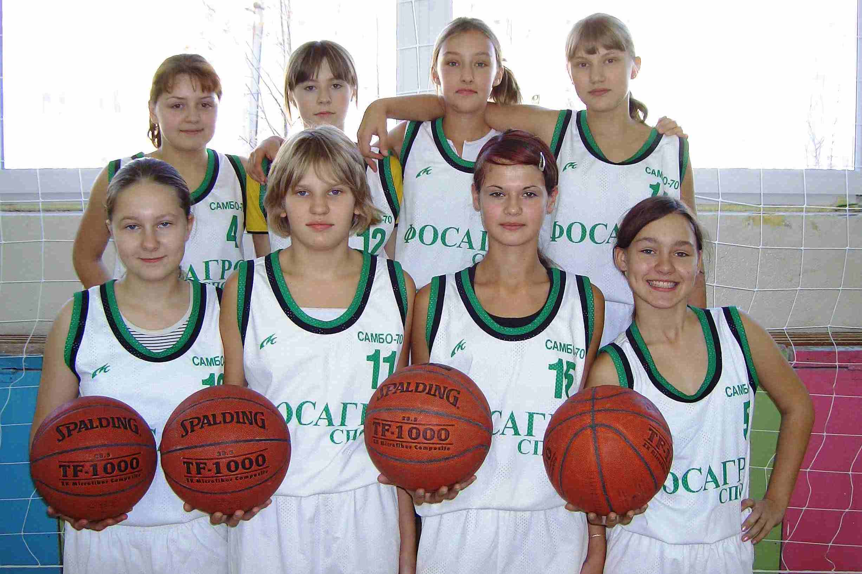
The man who nailed the fruit basket to the wall, was a young Canadian. His name was James Naismith, and he was a college teacher.
Today basketball is a very popular game not only in America but in many other countries. It can be played at any time of the year. The game is played with a large ball about 30 inches in circumference. A team is made up of 5 players.
Teams compete in basketball at many levels. Schools compete against each other.
Basketball is also a popular spectator sport. People watch basketball games in arenas and on television.
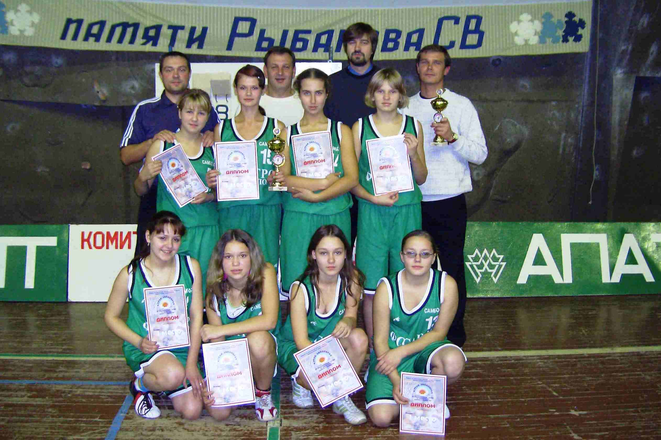
My friends Ann, Lena and I have been playing basketball for six years. We weren’t very good at first. But our coach started to teach us the fundamentals. He taught us how to move to get around other players, how to pass the ball from one player to another, how to throw the ball into the basket. The coach often says that it’s very important to learn how to work with others to reach a common goal.
Last year the traditional Sport Festival was held in our town. Eight basketball teams from different towns and cities came there to compete. The games were not easy. But we remembered everything our coach had taught us. Besides, the gym was crowded and the spectators shouted loudly cheering us. We didn’t lose a single game. We won the game and got the Cup.
In future I want to be a coach at school and teach pupils to play basketball.
To my mind teens and adults should go in for sport. Sports help people to be in good health. It’s not boring. I’m sure, to play sport is better than to watch it.

