Extreme sport
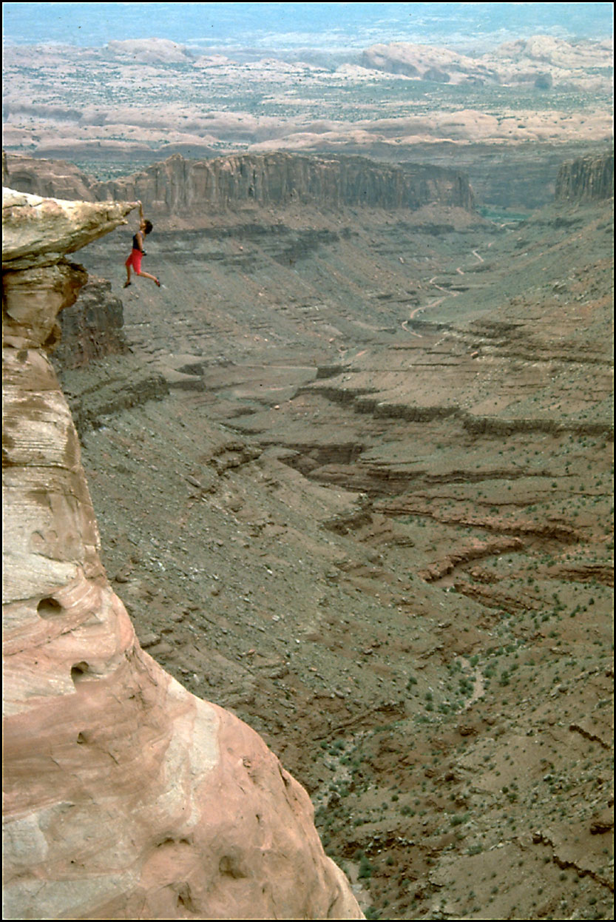
Johan Friedrich von Schiller once said, «Who dares nothing, need help for nothing”. It might be very difficult to reject that while participating in extreme sports can give you a sense of freedom and the thrill factor dominates some people’s lives.
Before we go any further, I’d like to draw your attention to this photo: Catherine Desteville climbs sheer rock faces without help of ropes or safety equipment. In France she is known as “scaling Madonna”.
- Why do you think the woman is doing this?
- Would you be prepared to try this? Why? / Why not?
- What type of character would you need to have to do this?

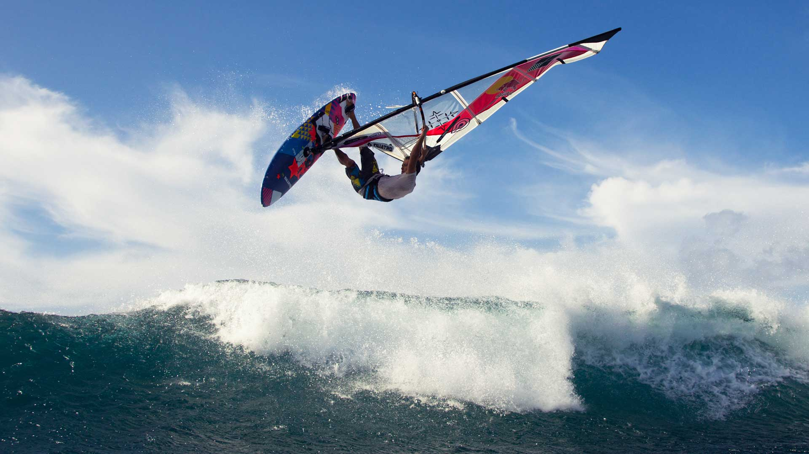

Catapulted by wind and wave, windsurfer experiences the thrill of staying in control aboard one of the most high-tech machines the is.
He leans well back into his harness and as his sail snaps into a tight aerodynamic curve, the wind’s energy curges down through his body and into the shark-like board below. He spins and twists in the air waiting for the next wave. For this is windsurfing at the edge of your skill, the edge of the nerve and the cutting edge of technology?
And now let’s sum up.
- What skills are most important for this activity? (muscular control, sense of balance, coordination, self of timing)
- What mental qualities does a windsurfer have to have? (Strong nerves, courage, determination, self-control, sesivity).
- Why is windsurfing – a cutting edge to technology?
- What drives some people to push themselves into the “edge” of their skill and nerve?
- Would you consider doing it if you had the chance? Why? / Why not?
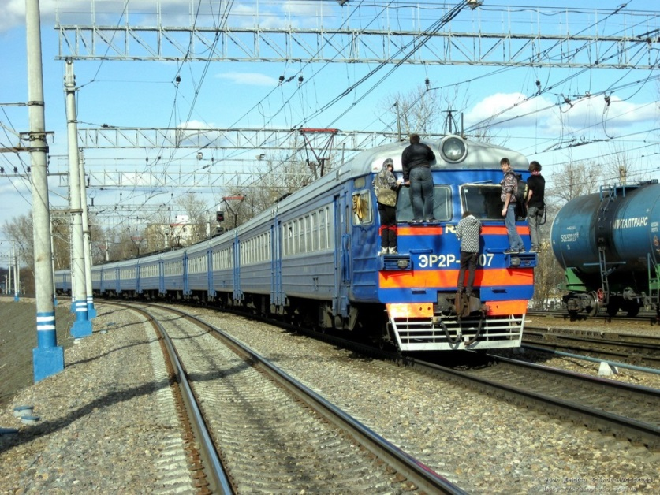
Nowadays everybody knows the word “train hopper” and “train surfer”. Who are they? In other words, they are risk takers. There is nothing in common with doing extreme sport, I recon it’s extreme activity which unfortunately appeals to adolescents and who are to my mid daredevils. What drives some teenagers to do such extreme activity?
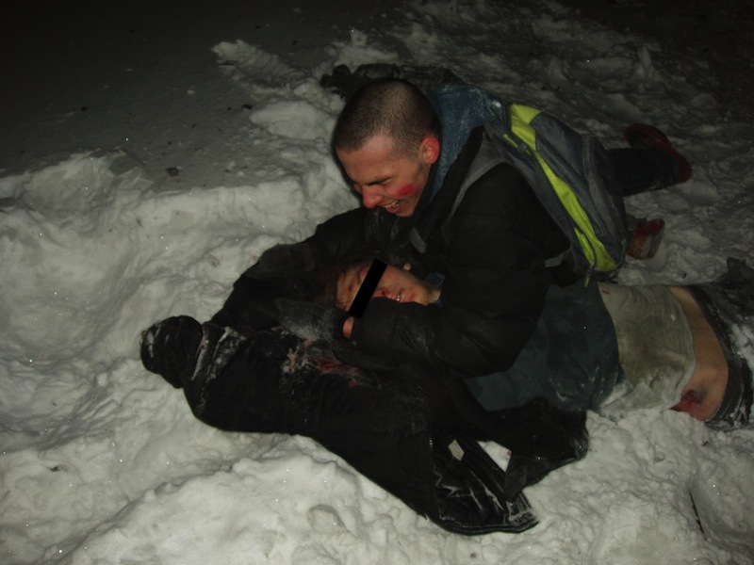
On the one hand, it’s extreme, getting adrenaline and entertainment, but on the other hand, it’s a disease or might be lack of mind and of course it can lead to death. And now think it over whether it is worth being a train hopper or not.

