Task 1:
The riddles:
- You can sleep in this room.
- You can have a bath in this room.
- Your mum can cook in this room.
- There is a TV, a sofa and armchairs in this room.
- You can have dinner in this room.
- You can see flowers and trees there.
Task 2:
Ask your partner and colour the picture.
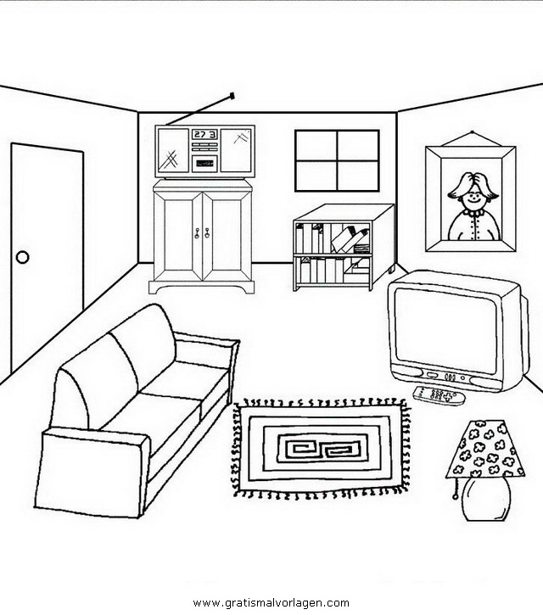
Необходимо приготовить ону цветную картинку, и несколько черно – белых для работы пар.

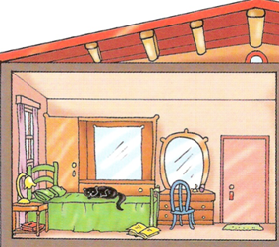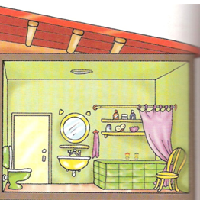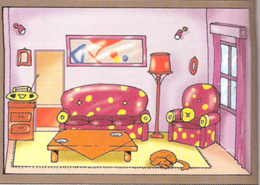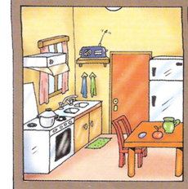

Task 3:
Read the text and make the puzzle

My name is Kate. I am ten. This is a photo of my house.
This is my bedroom. It is upstairs.
It is big and nice. Can you see my cat on the bed?

This is my bathroom. It is upstairs, too.
It’s green. I like this colour.
There is a bath and a toilet here.
This is my kitchen. It is downstairs.

It is little but nice.
There is a big table here. My mum is a housewife.
She likes her kitchen.

This is my living room. It’s downstairs.
It’s big. You can see my big sofa here and a big armchair.

Task 4:
Read the question and find the correct answer.
Данное задание выложено на платформу Kahoot
Copy and share this playable linkhttps://create.kahoot.it/share/duplicate-of-anna-k/41d0b455-6443-48f6-8f72-ee156d10ab42
Videoscript.
1. Hi. My name is Denis. Here you can see crosswords and the envelope with riddles. Do the puzzle. The teacher will help you.
2. Hi. My name is Carolina. This is my room. One of you can see this picture but It’s painted. Ask that student about my furniture and colour the pictures. Good luck.
3. Hi. My name is Sophia. You can see my house if you can read the texts about my house and do the puzzle. Look at it attentively!
4. Hi. My name is Diana. Look I’ve got a big black box with my toys. Guess the toys and you can see them.

