ПРИЛОЖЕНИЕ:
https://www.facebook.com/photo.php?fbid=966343036857619&set=pcb.1862487307115809&type=3&ifg=1

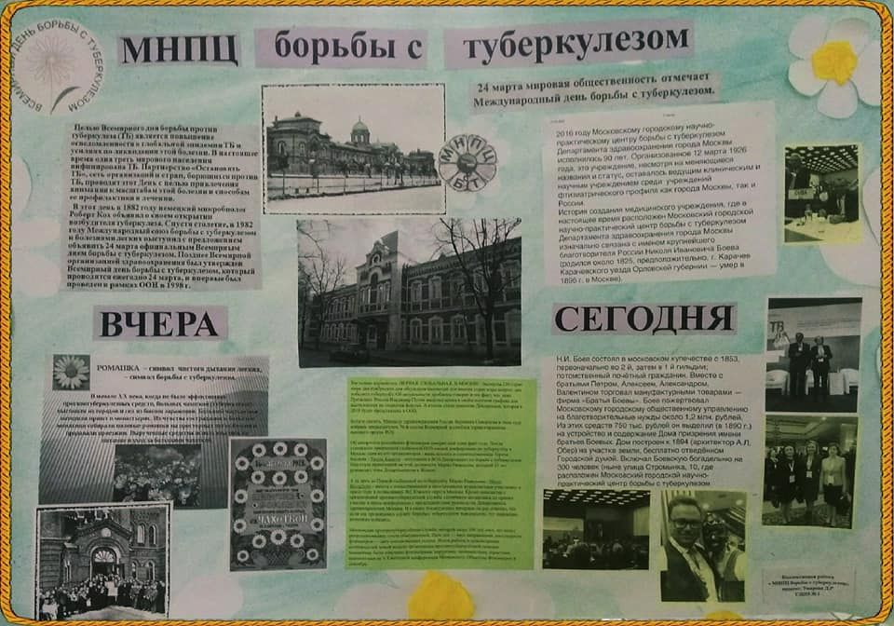

https://www.facebook.com/photo.php?fbid=964402383718351&set=pcb.1858667797497760&type=3&ifg=1

https://www.facebook.com/photo.php?fbid=960739377417985&set=pcb.1851573501540523&type=3&ifg=1

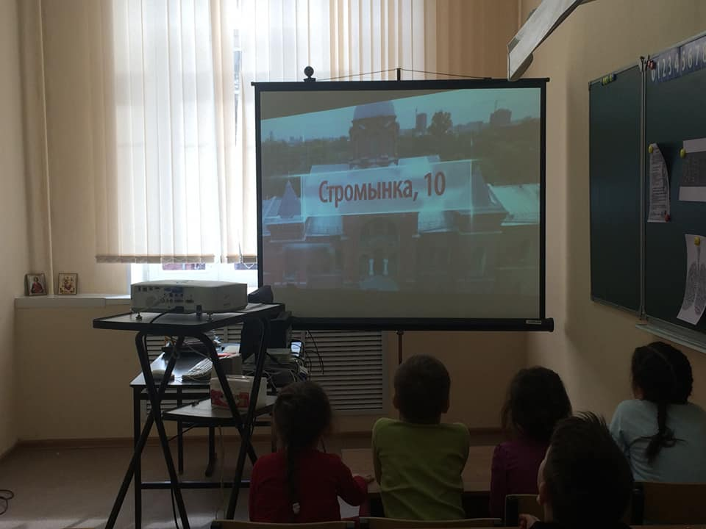

https://www.facebook.com/photo.php?fbid=966081853550404&set=pcb.1861955303835676&type=3&ifg=1

