ПРИЛОЖЕНИЕ 1 ПРИЛОЖЕНИЕ 2
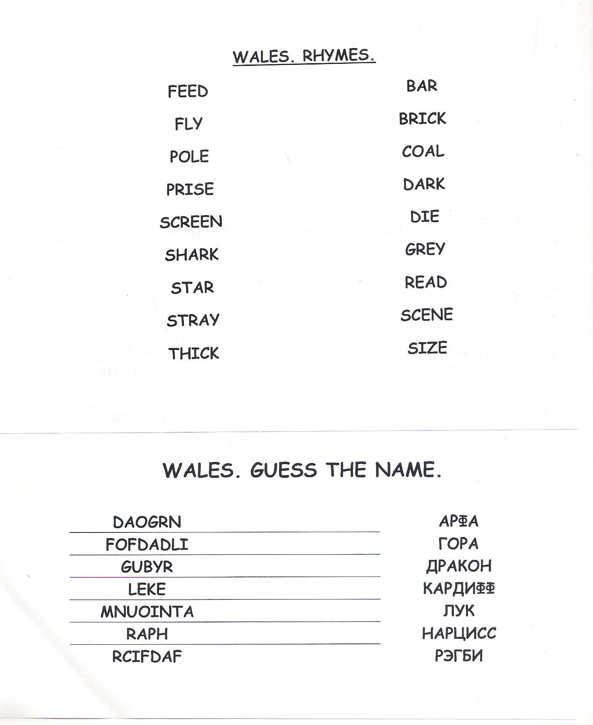

ПРИЛОЖЕНИЕ 3
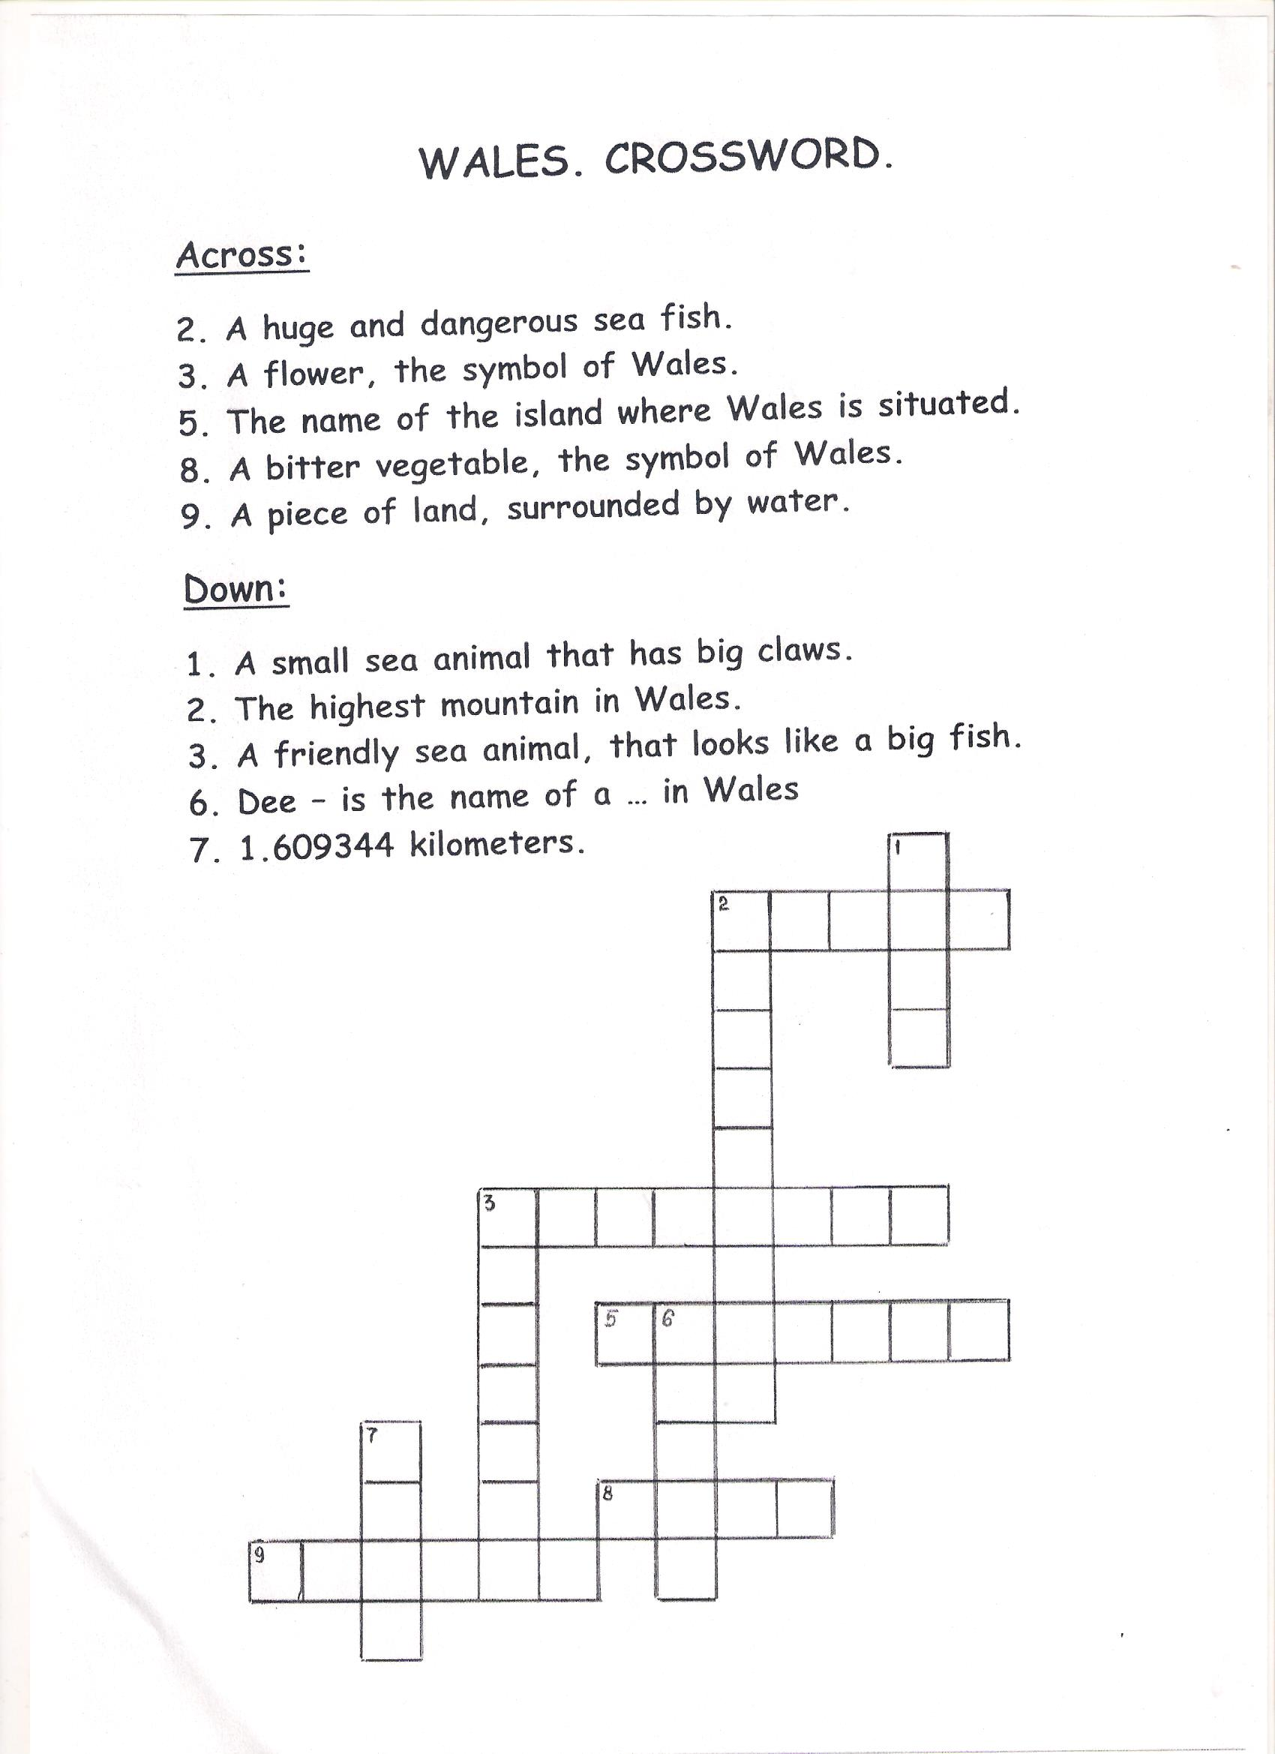

ПРИЛОЖЕНИЕ 4
WALES. DESCRIPTIONS.

- MANY IN THERE TRADITIONS ARE THE COUNTRY
__________________________________________
- SNOWDONIA IS THE HIGHEST MOUNTAIN
____________________________________________
- LEEK AND THE OF SYMBOLS DAFFODIL WALES ARE
_______________________________________________
- OF CARDIFF THE THE IS COUNTRY CAPITAL

ПРИЛОЖЕНИЕ 5

WALES.
SHORT TOUR GUIDE

NAME | DESCRIPTION | PICTURE
SNOWDONIA | A mountainous region in north Wales and a national park of 823 square miles (2,130 km²) in area | 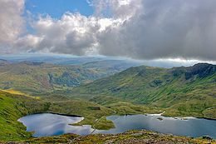
CARDIFF | The capital and largest city in Wales and the eleventh-largest city in the United Kingdom | 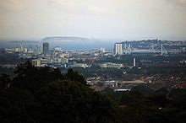
FLAG | It shows the red dragon of Prince Cadwalader | 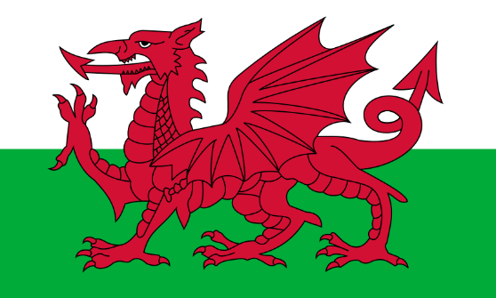
DAFFODIL | A nice flower, one of the main symbols of Wales | 