1. | 2. | 3. | 4. |  | 5. | 6.
1. What’s your name? |  |  |  | a) My grandma and grandpa.
2. What’s this? |  |  |  | b) Bill.
3. Who’s this? |  |  |  | c) They’re toy soldiers.
4. Who are they? |  |  |  | d) This is our baby brother.
5. What’s his name? |  |  |  | e) I’m Alex
6. What are they? |  |  |  | g) It’s a pencil case.
Make the Chit-Chats and act out them:

Task № 1

Choose the right word:
- He/His name is Bill.
- They/Her are brothers.
- Pam is we/her sister.
- I/My dog is happy.
- This is our/she computer.
- Its/It’s a toy soldier.
- You/Their are sisters
- Your/We doll is nice.

Task № 4

Put am, is or are in the sentences:
Dear Alice,
I 1)__Betty. This 2)__my father and this 3)__my mother. Their names 4)__Bob and Sarah. Jeff and Tom 5)__my little brothers. This 6)__my grandmother and this 7)__my grandfather. They 8)__very nice. We 9)___a happy family.
Love,
Betty

Task № 5

Look and read. Then put the names in the gaps:
Hello,
I’m 1)_____ . This is my mother and father. Their names are 2)_____ and 3)_____ . 4)_____ is my big sister and 5)______ is my little brother. We are a happy family!

Task № 6

Task № 7

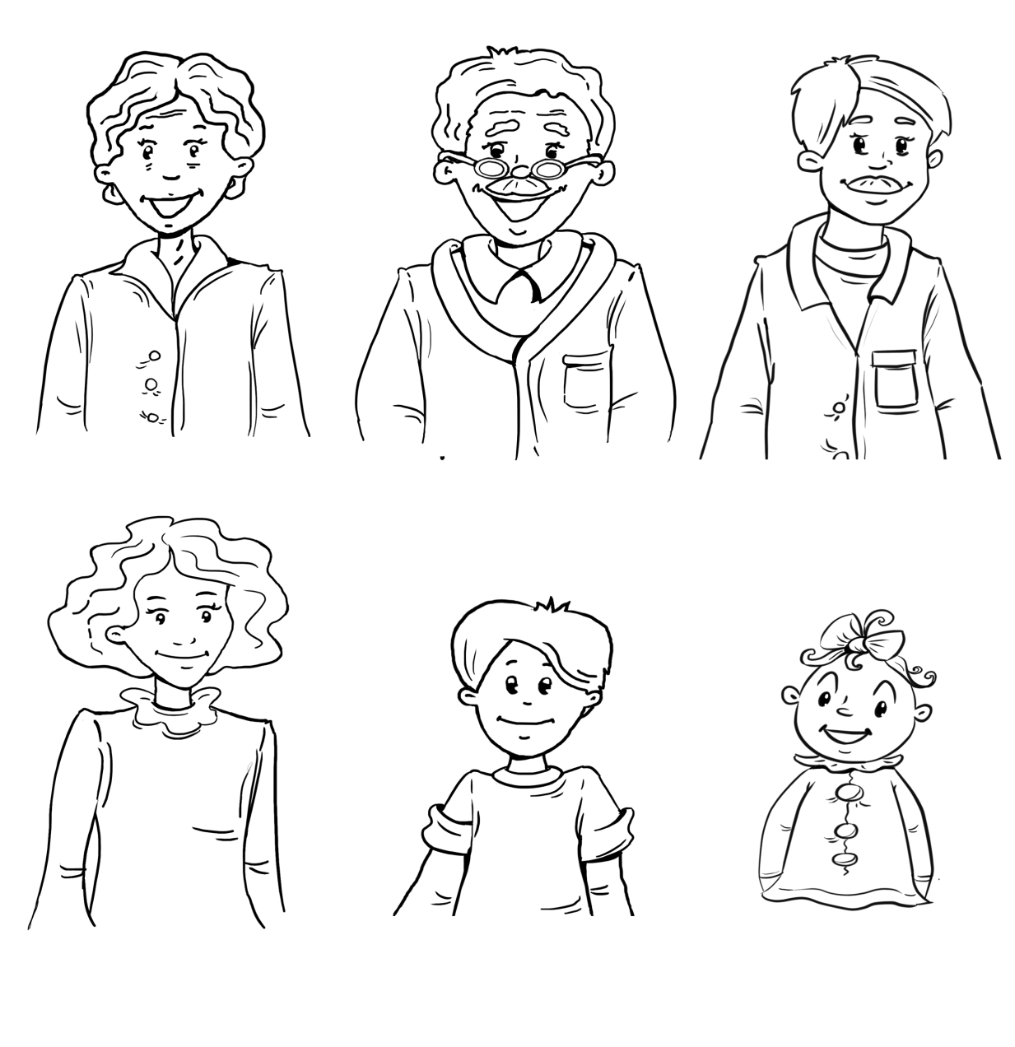
Listen and circle the right names:
Sue/Sally
Sam/Ted
Patty/Julia
Tom/Tony
Henry/Harry
Martha/Mary

Task № 3
- Father
- Brother
- Mother
- Grandfather
- Sister
- Chuckles

FOXES
WOLVES
BEARS

