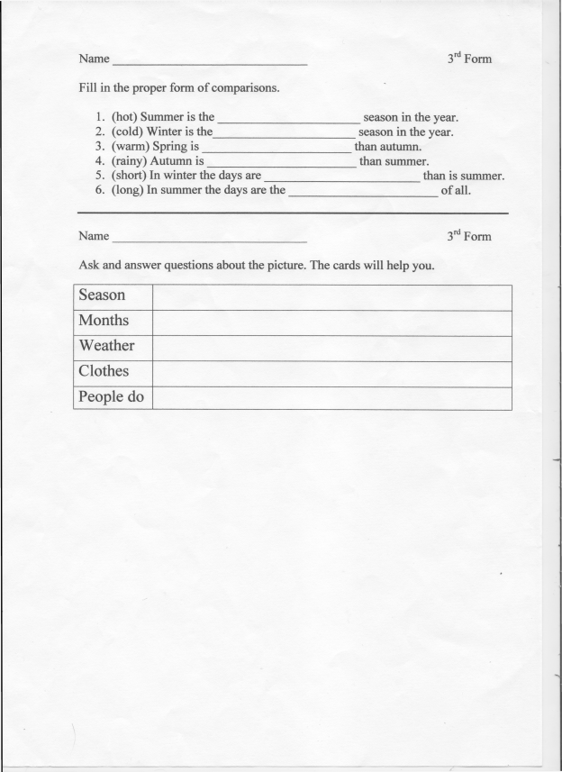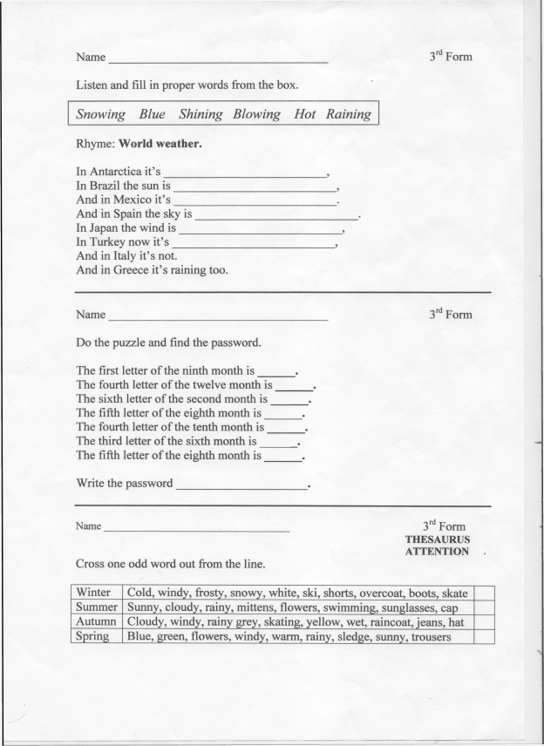
The plan of the project:
- The Season
- Months
- Weather
- Clothes
- People do
- Why do you like it?

