Приложение 4.
Паращенко С.Г. (№ 270-792-102)

Conwy Castle
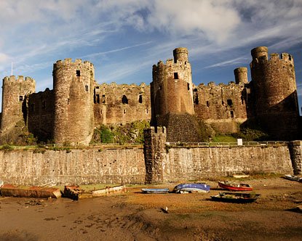
Conwy Castle sits in Gwynedd, Wales. It’s a classical 13th century fortress.
Conwy Castle is a fine medieval relic that can be found in the Welsh town of Conwy. It was built by King Edward I in an attempt to show the Welsh people that the English were in charge. Today, it lies partly in ruins. Eight huge towers and a high outer wall give this structure a true military presence. The towers are 15 meters tall. The towers offer a great view of the mountains.
Conwy Castle is enjoyable to explore. Visitors can walk along parts of the high curtain wall. The castle has a great view of the river.
It is a masterpiece of medieval architecture.

Edinburgh Castle
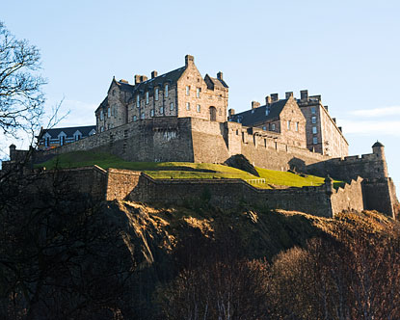
Edinburgh Castle is one of the most popular attractions in all of Scotland.
It was built on the top of an extinct volcano. It dates back to the 11th century.
Edinburgh Castle is a fortress, solid and practical, and thanks to its large size and its hilltop location, it dominates the Edinburgh skyline.
Edinburgh Castle tours are wildly popular among Scotland tourists. Visitors can also take a look at the prison rooms that housed foreign soldiers in the eighteenth and nineteenth centuries. Here you can find the museum of the guns, swords, the armory.
The parade Military Tattoo is held every year in the castle.
The castle garden is wonderful.
Visit this unique castle.

Malahide Castle

Malahide Castle is in the north-east of Dublin City, Ireland.
It dates back to the 12th century. It was used as a fortress.
Malahide Castle, set on 250 acres of park land in the pretty seaside town of Malahide, was both a fortress and a private home for nearly 800 years and is an interesting mix of architectural styles. The curcular towers are very attractive.
The Talbot family lived here from 1185 to 1973, when the last Talbot died. The house is furnished with beautiful period furniture together with an extensive collection of Irish portrait paintings, mainly from the National Gallery.
Malahide Castle has many ghostly traditions. Many historic castles and houses have one ghost, some have two or three, but Malahide Castle has five. It’s a spooky place. It’s a popular tourist place nowadays.

Tower of London
The Tower of London was built at the beginning of the eleventh century by William the Conqueror. 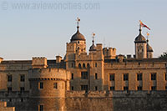
The Tower was built to enforce the power of the Norman king over the newly conquered land.
Today the Tower of London is best known for its Crown Jewels, many political opponents of the kings were locked and killed in the Tower. The Tower was also a royal residence: several kings lived here.

White Tower
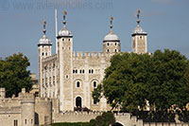
The White Tower
The oldest part of the fortress is the so-called White Tower, which was completed in 1097. This was long the tallest building in London at 27.4 meters (90ft). Its walls are 4.6 meter wide.

