The Monster | The Monster
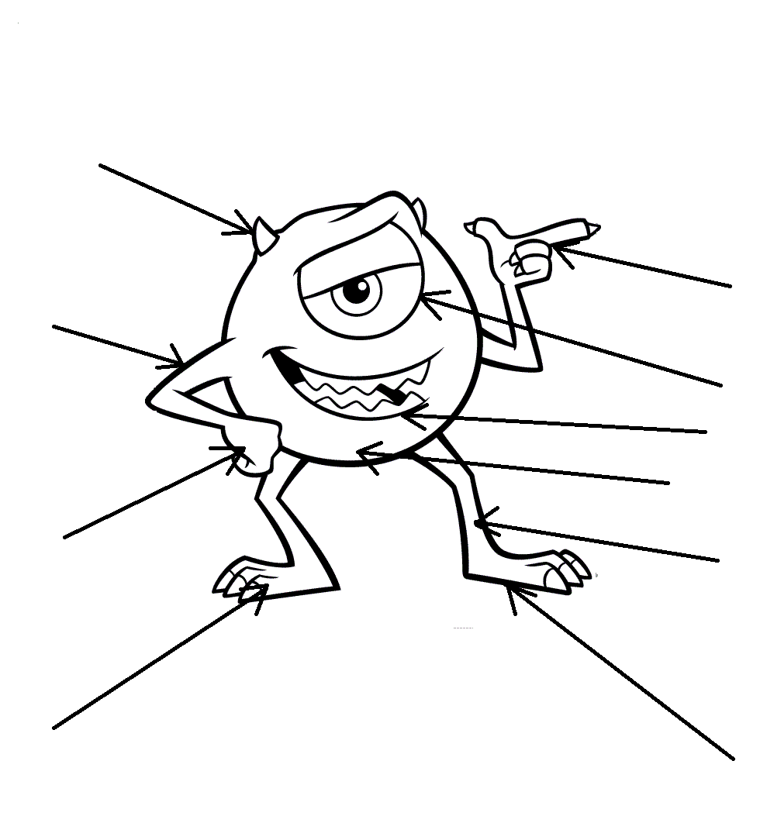
He’s got …………………………., ………..……..………..,  ……………..……..…….…...., ……………………....………..,  ……………..…………..…….., ……………………....………..,  ……………..……………..….., ……………………....………..,  …………………..………… and ………..…………...……….. .  He hasn’t got …………………………..……….. .  The song “This Is Me”:  learn-and-fun.ucoz.ru | He’s got …………………………., ………..……..………..,  ……………..……..…….…...., ……………………....………..,  ……………..…………..…….., ……………………....………..,  ……………..……………..….., ……………………....………..,  …………………..………… and ………..…………...……….. .  He hasn’t got …………………………..……….. .  The song “This Is Me”:  learn-and-fun.ucoz.ru
The Monster | The Monster
He’s got …………………………., ………..……..………..,  ……………..……..…….…...., ……………………....………..,  ……………..…………..…….., ……………………....………..,  ……………..……………..….., ……………………....………..,  …………………..………… and ………..…………...……….. .  He hasn’t got …………………………..……….. .  The song “This Is Me”:  learn-and-fun.ucoz.ru | He’s got …………………………., ………..……..………..,  ……………..……..…….…...., ……………………....………..,  ……………..…………..…….., ……………………....………..,  ……………..……………..….., ……………………....………..,  …………………..………… and ………..…………...……….. .  He hasn’t got …………………………..……….. .  The song “This Is Me”:  learn-and-fun.ucoz.ru

