Автор: Важенина Ольга Владимировна Идентификатор: 219-162-155

**Get ready for a trip to London**

**London is ____.**

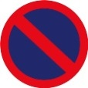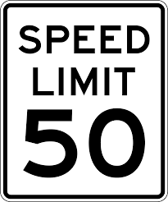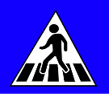

**You can get lost in London. Read Module 3 again!**

**You can try, but take a good map and a dictionary with you and don’t go alone!**

**You can go to London. It’s safe.**

**Red**

**Black**

**English**

**The streets of London**

**Routemasters**

**Black cabs**

**What’s the colour of the London taxis?**

**What should black cab drivers know?**

**How do the Londoners call the taxis?**

**2**

**1956**

**1899**

**12**

**The Subway**

**The Tube**

**157**

**275**

**How many lines are there in the London Underground?**

**How do the Londoners call the Underground?**

**How many stations are there in the London Underground?**

**1825**

**1899**

**The motorbuses appeared in ___.**

**The Routemasters appeared in ___.**

**False**

**True**

**False**

**False**

**True**

**True**

**The red buses were popular with people.**

**The conducter collects fares.**

**The first buses were pulled by three horses.**

**True**

**False**

**True**

**False**

**True**

**False**

**The red double-decker buses are very fast.**

**The red double-decker buses have a short history.**

**There are 19 bridges over the Thames.**

**can’t**

**can**

**can**

**can’t**

**can**

**can’t**

**You ___ cross the street here.**

**You ___ park here.**

**You ___ drive over 50 mph.**

**in England**

**the capital of the United Kingdom**

**not very big**