Напиши рассказ по картинке, используя слова:
Sam, 2, in the zoo, brown, funny, run, jump, play, fly, ride a bike, meat, milk

I have got a friend. __________________________________
_______________________________________________________________________________________________________________________________________________________________________________________________________________________________________________________________
Напиши рассказ по картинке, используя слова:
Rex, 4, in the house, brown, brave, run, swim, play, fly, meat, milk

I have got a friend. __________________________________
_______________________________________________________________________________________________________________________________________________________________________________________________________________________________________________________________

Напиши рассказ по картинке, используя слова:
Billy, 5, in the forest, brown, strong, run, go fishing, play, fly, honey, milk, sweets
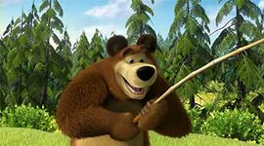
I have got a friend. __________________________________
_______________________________________________________________________________________________________________________________________________________________________________________________________________________________________________________________

