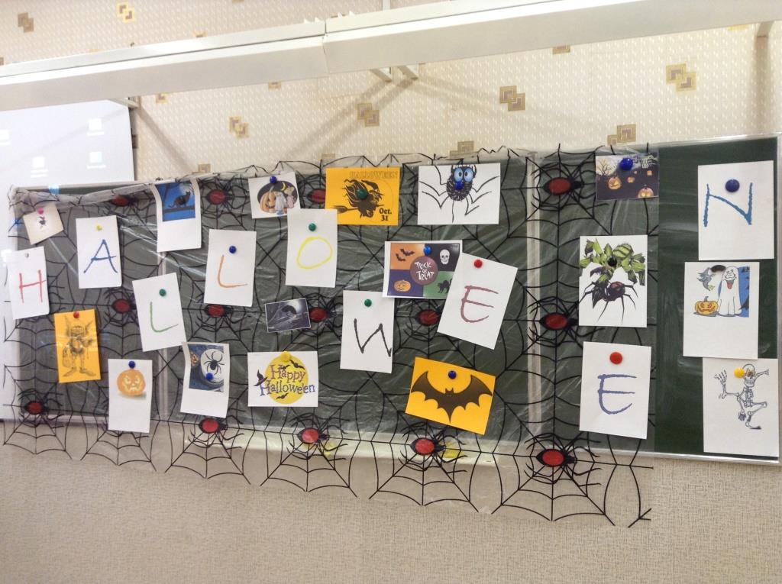

**Well come to Halloween party!**

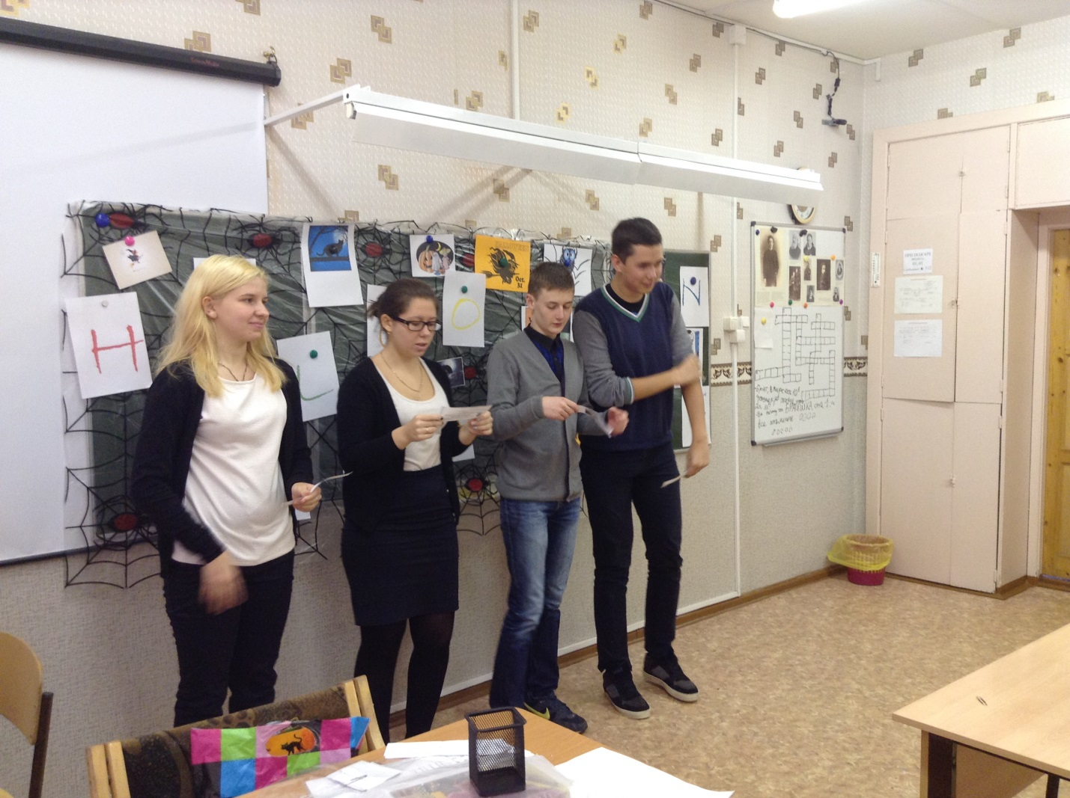

**Warming up contest**

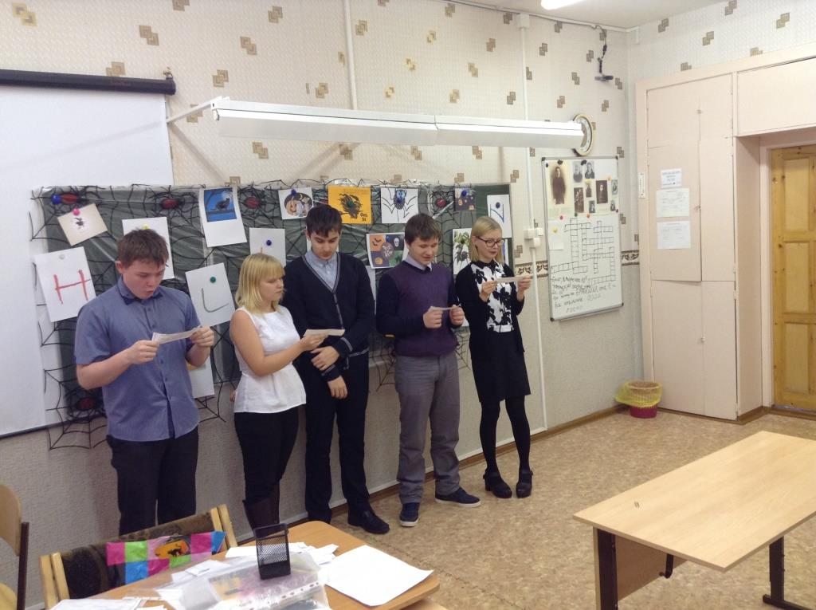

**Warming up contest**

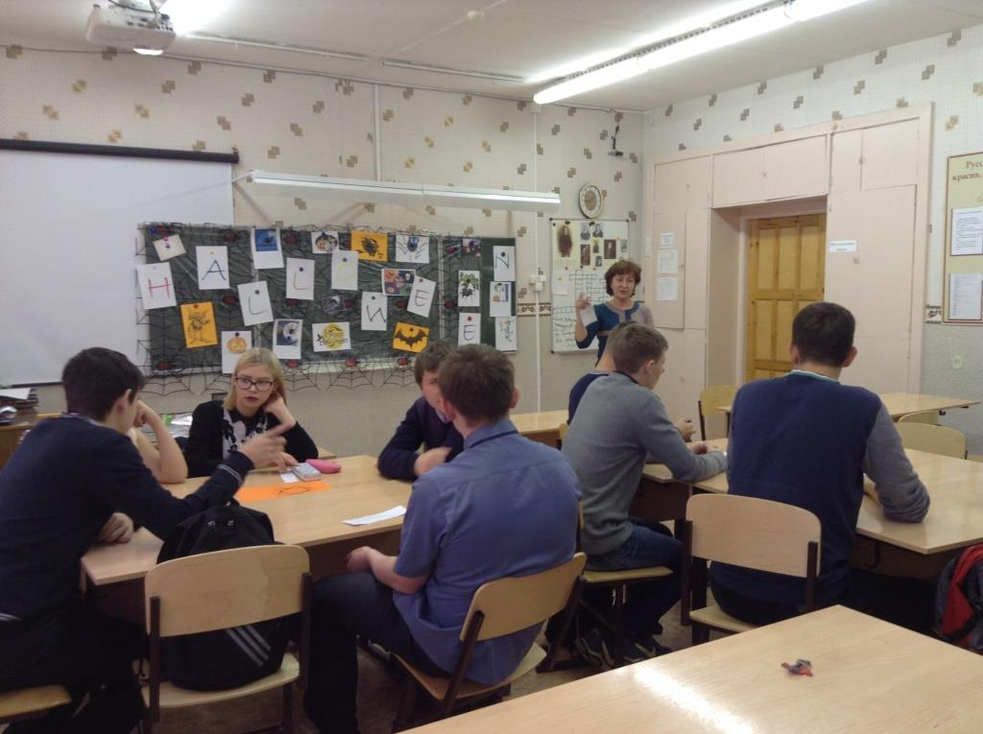

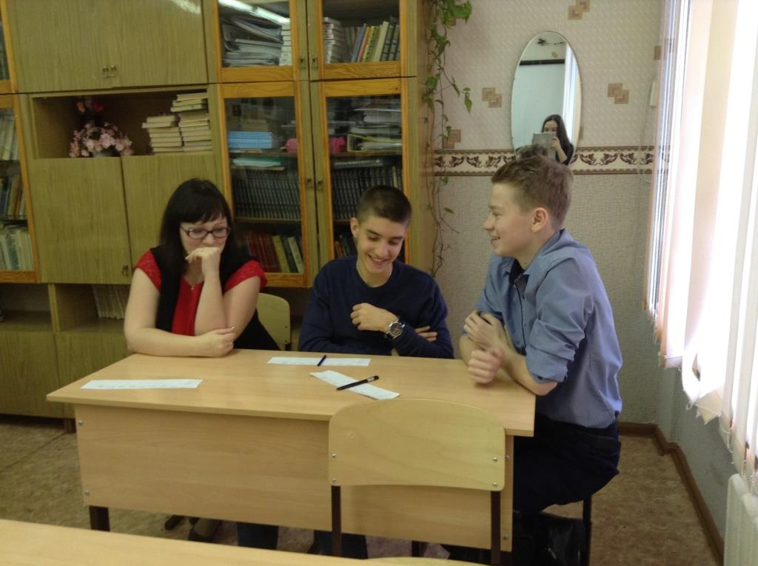

**Our judges**

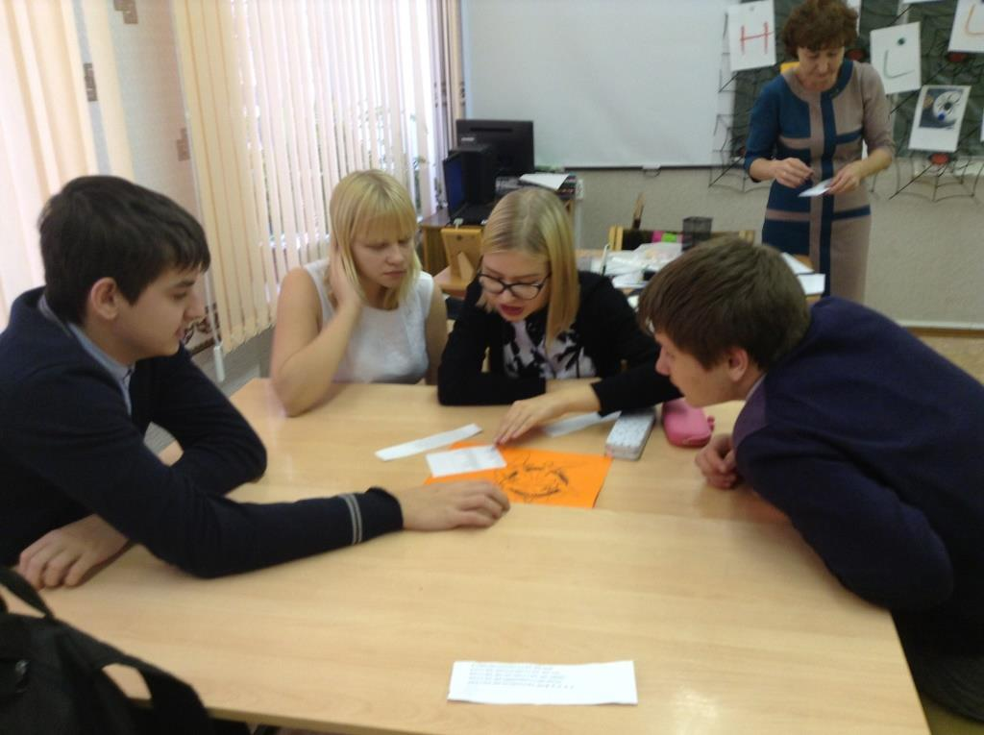

**The team “Bats” guesses scrambled words**

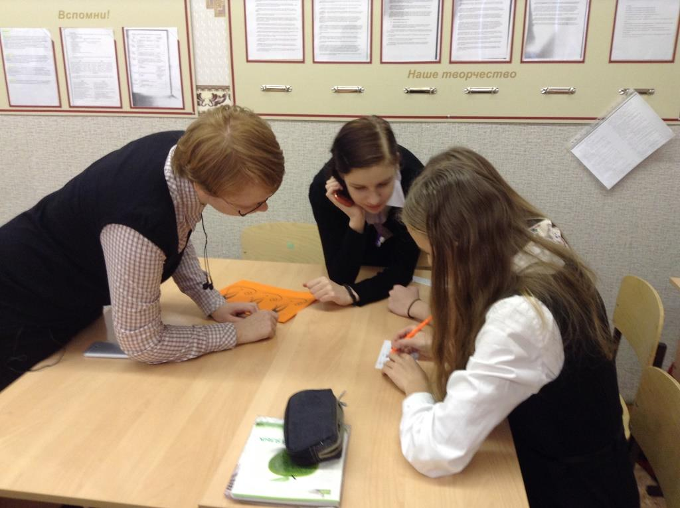

**The team “Black cats” guesses scrambled words**

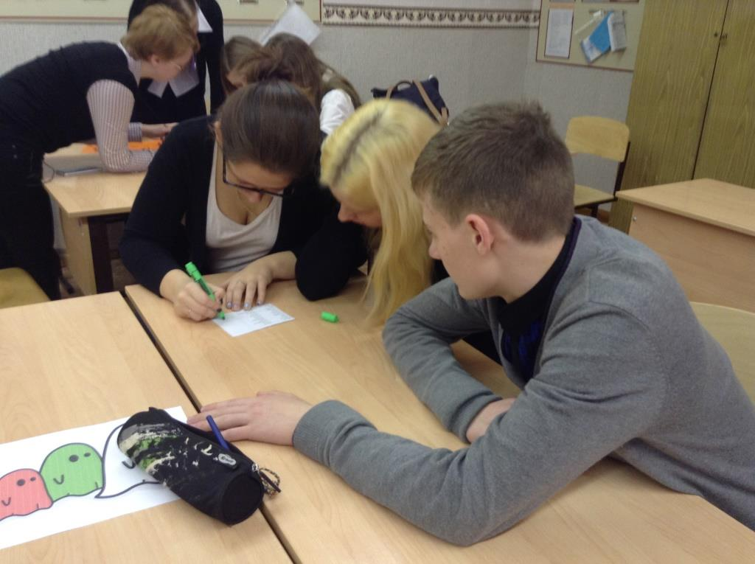

**The team “Ghosts” guesses scrambled words**

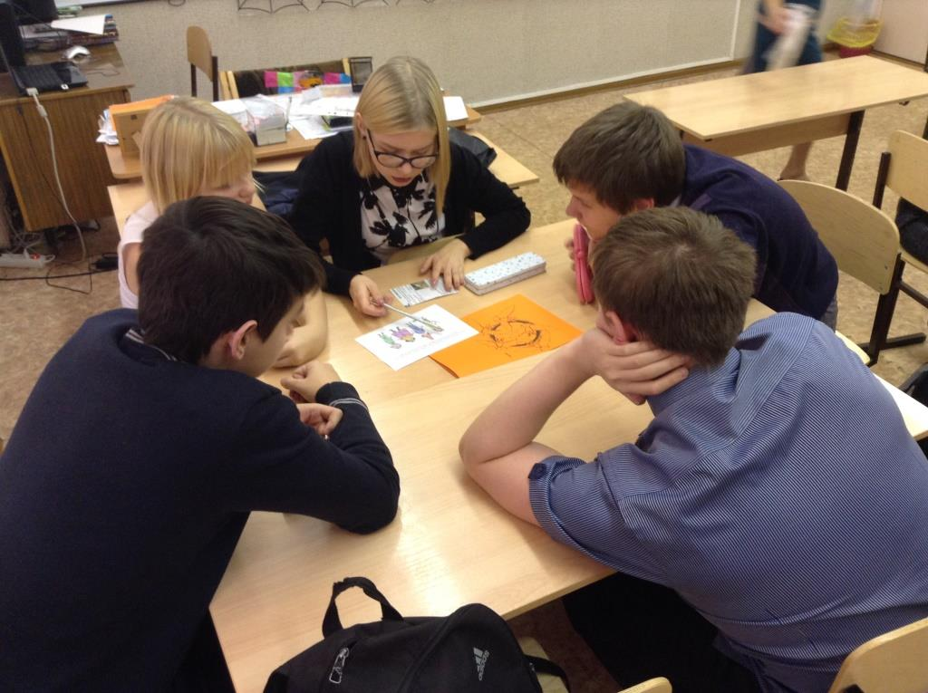

**The team “Bats” guesses the characters of Halloween**

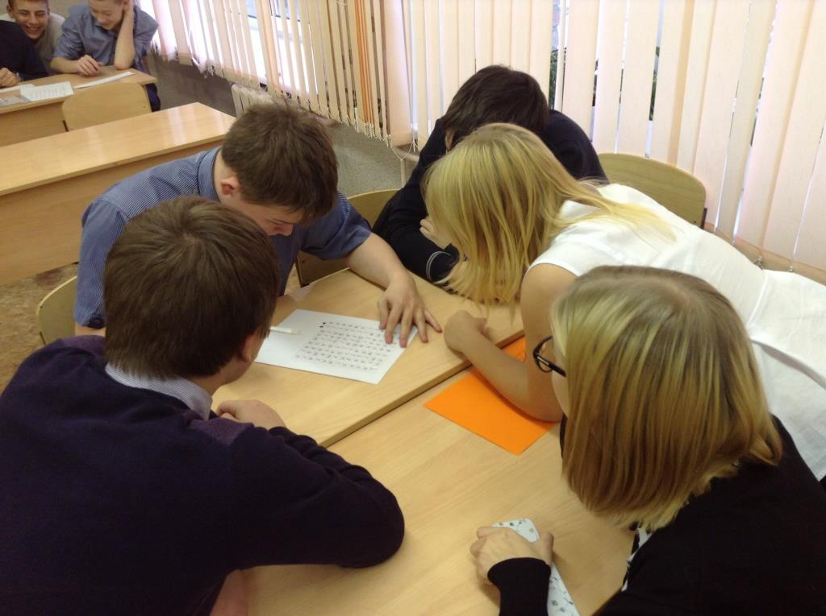

**The team “Black cats” guesses a Halloween crossword**

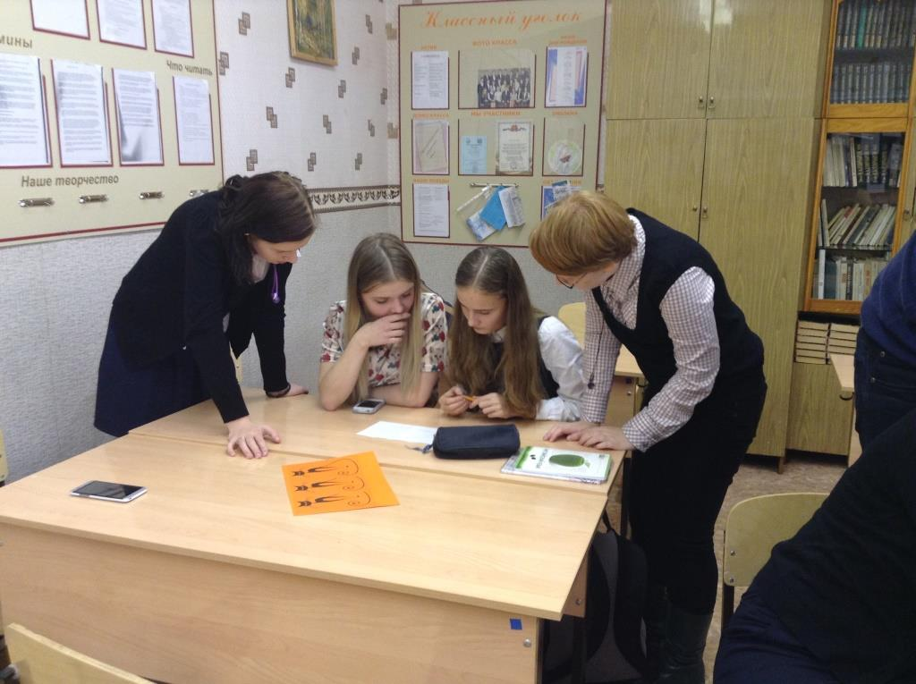

**The team “Black cats” guesses scrambled words**

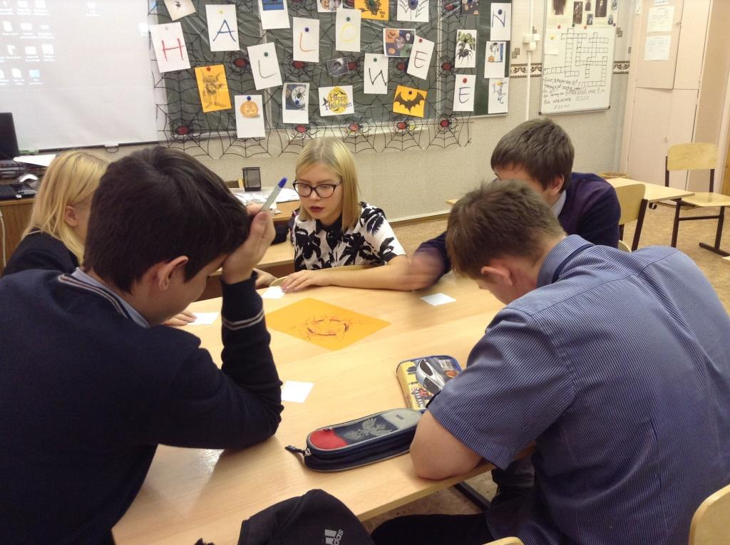

**The team “Bats” writes Halloween adjectives**

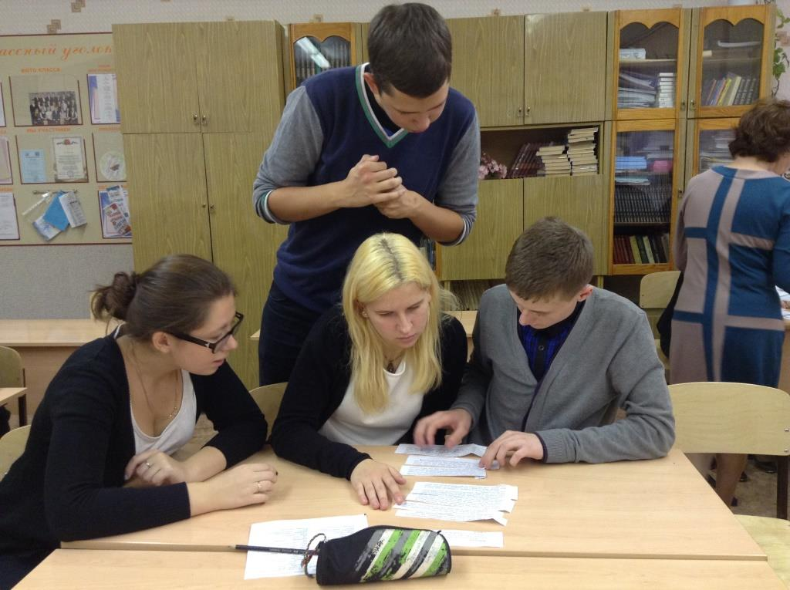

**The team “Ghosts” makes a Halloween story**

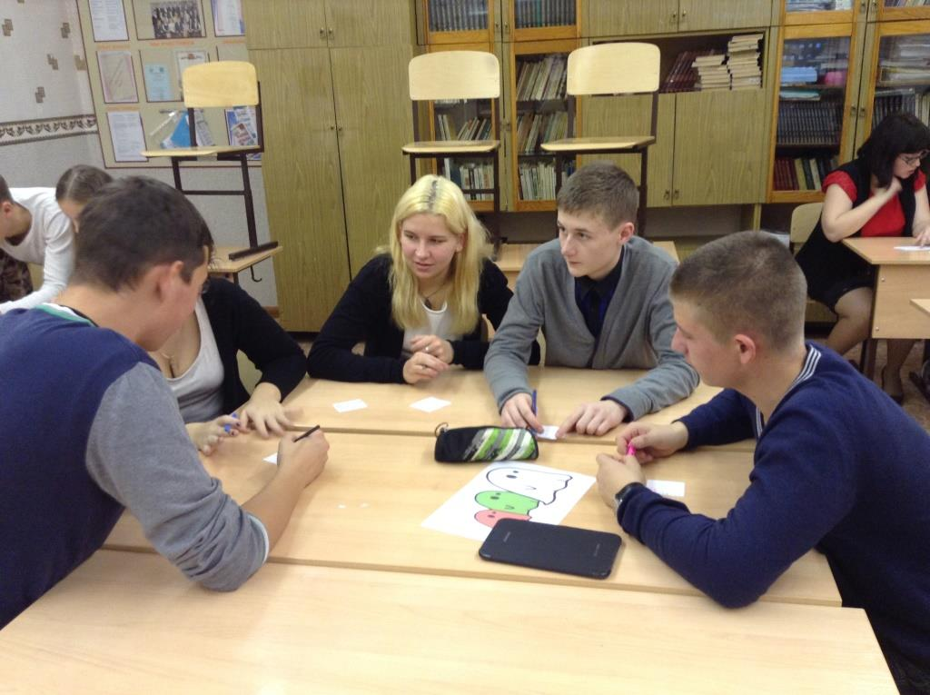

**The team “Ghosts” writes Halloween adjectives**

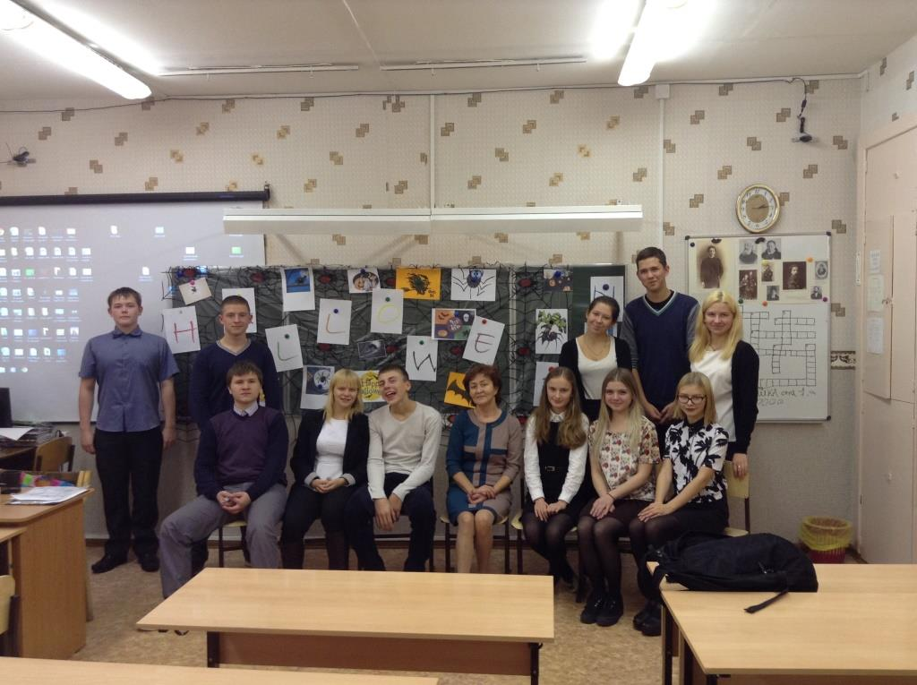

**After the Halloween lesson**

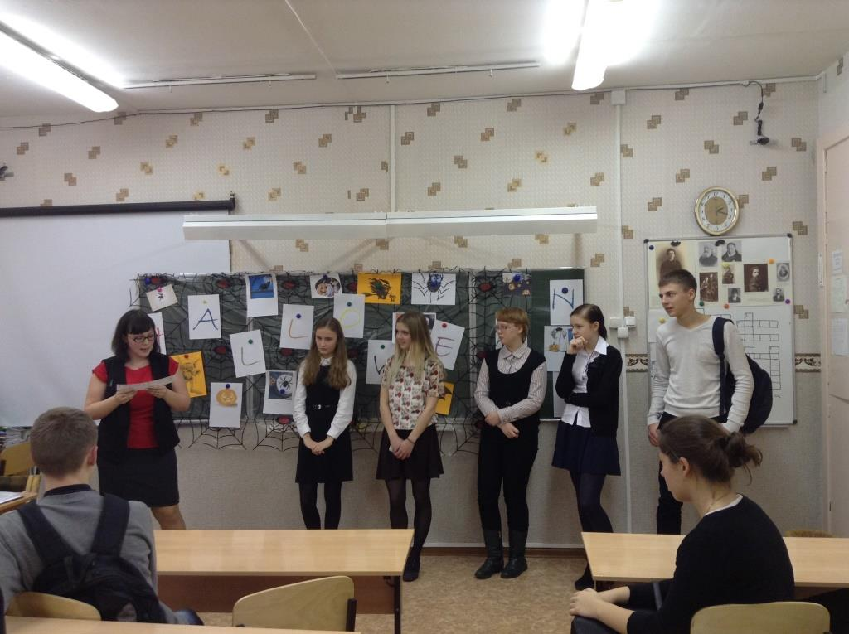

**The main judge sums up the results of the play**