Itinerary I
Follow the directions to find Margarita Rudomino All-Russia State Library for Foreign Literature.
Step 1. Go to Taganskaya Kol’tsevaya Station by metro.
Step 2.Go up by the elevator at Taganskaya Kol’tsevaya Station to the exit.
Step 3. Verhnyaya Radishevskaya Street is in front of you. Cross the road and turn left.
Step 4.Go down Verhnyaya Radishevskaya Street for about 15 minutes.
Step 5. Cross the road at the traffic light. The library is in front of you on the right in Nikolayamskaya Street. It is a big brown building.
Step 6. Go through the central entrance, pass the monuments and you are in front of the library.
Enjoy the excursion!
Itinerary II
Complete the table. Tick the floor.
names of departments | the ground floor | the  1 st  floor | the  2 nd  floor
- The bust of Margarita Rudomino All- Russia State Library for Foreign Literature

- The American Center
- Department of Japanese culture
- Department of Rare Books
- Children’s Department
- Registration Hall
- Electronic Room
- Hall subscription service
- British Council library collection
- Library dining room

Worksheet 1
A. Read the question and tick (V) the right variant.
Questions before watching:
1.Who is George?
a) a boy b) a monkey c) a panda
2. Why did George go to the Zoo?
a) to play b) to work c) to find Baby Panda
Questions after watching:
1. Where did George see Baby Panda?
a) at home b) on TV c) in the computer
2. What thing did George use to find Baby Panda?
a) a computer b) a map c) a book
3. What things did George use to put the animals in their own environments?
a) a book and keys
b) a computer
c) a map and keys
4. What did George bring to Baby Panda?
a) flowers b) leaves c)grass
B. Answer the questions.
1. Why was Baby Panda happy?
___________________________________________________________________
2. Do you like the cartoon? Why?
___________________________________________________________________
Worksheet 2
A. Match the word and its definition.
Japanese arts
1.Origami a)flower arranging
2.Ikebana b) paper folding
3.Bonsai c) growing miniature trees

B. Write the name of the craft / crafts you liked most of all.
__________________________________________________________________________
________________________________________________________
Worksheet 3
Choose the correct answer.
1. What anniversary of William Shakespeare’s birth do we cerebrate this year?
a)450 years
b) 350 years
c) 300 years
2. Where was W.Shakespeare born?
a) in Russia
b) in England
c) in France
3. What’s the Russian name of the famous Shakespeare’s tragedy at the end of the XIX century?
a) «Роман и Юлия»
в) « Ромео и Юлия»
с) «Ромео и Джульетта»
4. Why are Shakespeare’s books presented in the Department of Rare Books?
a) They are very expensive.
b) They are beautiful.
c) They are very old.
Worksheet 4
A. Complete the table. Write the names of the books, magazines, pictures and crafts, which are the most interesting in the hall.

name
books

magazines

pictures

crafts

B. Choose the correct answer.
What is the pop-up book?
a) A book with pictures.
b) A book with moveable paper elements.
c) A very popular book.
C. Which pop-up book/ books impressed you most of all? Write the names.
__________________________________________________________________________
__________________________________________________________________________
Worksheet 5
Complete the table. You can use an English-Russian dictionary.
Word | transcription | meaning
Arrange
Author
Card
Clipboard
Contain
Culture
Department
Encyclopedia
Include
Library
Manuscript
Periodical
Rare
Report
Rule
Score
Search
Staff
Sign
The American Center
Use
Worksheet

Variant 1
You want to take a book from a library.
Arrange the steps you should do in the correct order.
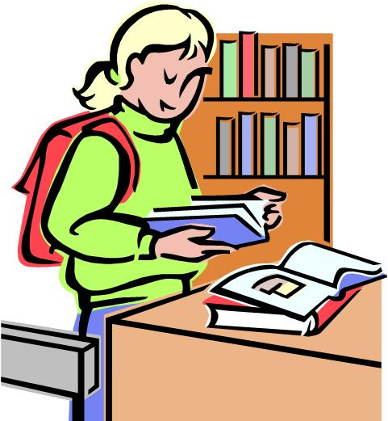

a) Get the book. _____________
b) Read the library rules. _____________
c) Bring a personal photo. _____________
d) Give personal information to fill a library card. _____________
e) Sign the card for getting a book. _____________
Variant 2
You want to take a book from a library.
Arrange the steps you should do in the correct order.

a)Give personal information to fill a library card. _____________
b)Get the book. _____________
c)Sign the card for getting a book. _____________
d)Read the library rules. _____________
e)Bring a personal photo. _____________

Libraries .
The word library comes from the Latin word liber, meaning "a book". This is a place where information in print (books, manuscripts, periodicals and musical scores) and in other forms is collected and arranged to serve people of all ages and interests.
The library today is a center for all kinds of communications: printed, pictured, recorded, and even electronically stored. People go to the library to read, look, listen, search, relax, discuss, learn, and think.
Libraries can be found in many places. There are libraries in small towns and large cities, and there are libraries in schools, universities, colleges. The largest and best known libraries in the world are: the British National Library in London, the Library of Congress in Washington and the Russian State Library.
The national libraries of different countries keep in touch and exchange books and information. Most libraries have a professionally educated staff whose first duty is to help you. Librarians also select and purchase books and other materials, organize materials so that you can easily use them, answer questions about facts, people, events, or advise you how to find the information you need.
Many people have books at home. These are the books of their favorite authors, dictionaries and reference books and the like. ( с сайта http://engmaster.ru/topic/3070)
Library rules.
Books need care as anything else. Going to the library don't forget the library
rules.
1. Wash your hands before you begin to read.
2. Do not write anything on the pages with a pen.
3. Do not make drawings in the book.
4. Do not make dog's ears in the book.
5. Do not tear the pages.
Do not lose your books or leave them in shops or buses. That means that you lose your friends.
If you keep all these rules you'll become a good reader. Books are our great friends. They teach us a lot of useful things. ( с сайта http://www.engwebcountry.ru/view_examsubject.php?id=13)

