- You like …………..  - I would like some ……..  - He likes ....... 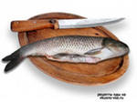  - They don’t like ……..  - We would like some ……… | - Would you like some ………… ?  - Do you like ………... ?  - Do they like …………. ?  - Would you like some …………. ?  - Does he like …………. ?
1
2
3
4
5

