Приложение 1 Серова Ирина Николаевна
251-084-560

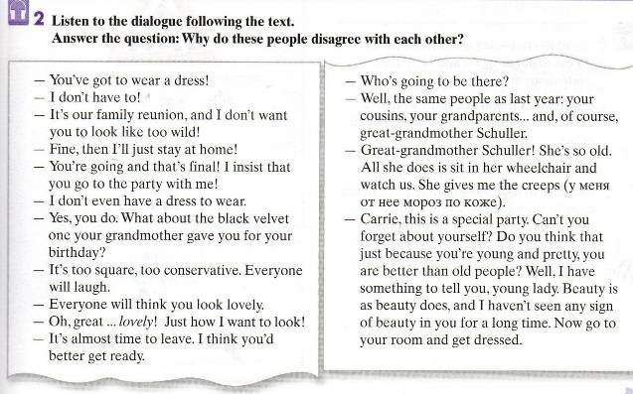
Ex. 6. Read the following statements and say if they are true or false. Correct the false ones.
- Carrie said she was not going to wear a dress. She thought everyone would laugh at her.
- Carrie said she wanted to look lovely.
- The mother said she didn’t want her daughter to look too wild. She thought her daughter would look lovely in the velvet dress.
- The mother said that she hadn’t seen any signs of beauty in her daughter for a long time.
- Carrie loved her great-grandmother very much.

Ex.19. Listen to the second part of the story “The Rose Pin”. Choose the correct answer to the questions.

Angela Baker turned back to her dishes. As she washed the last plate, her eyes filled with tears. What was happening to them? What could she do? “What we need is a miracle,” she thought. Then, a single phrase came to her mind. She said the phrase aloud. “The Rose Pin”.
Angela walked slowly down the hall, entered her room and reached for the little jewel box. She opened it and picked out a beautiful rose-colored pin in the shape of a ballerina. Angela held the pin up to her cheek. Then she walked down the hall to Carrie’s room.
She tapped softly on the closed door. There was no answer from within. Quietly, she asked, “May I come in?” A tearful voice answered, “Go away. You want me to dress like a nine-year-old. You don’t even care how I feel.”
Opening the door, Angela sat beside her daughter and held out the pin.
“W… what’s that?” (продолжение в приложении 2)

Приложение 2
Серова Ирина Николаевна
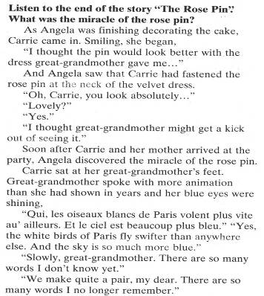
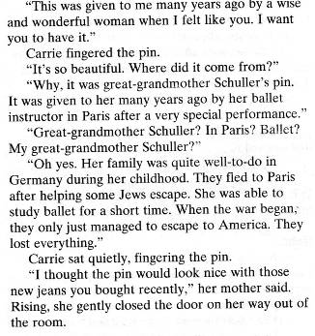
(продолжение текста) 251-084-560
