***Приложение 1***

**Appendix for Madame Tussaud**

****

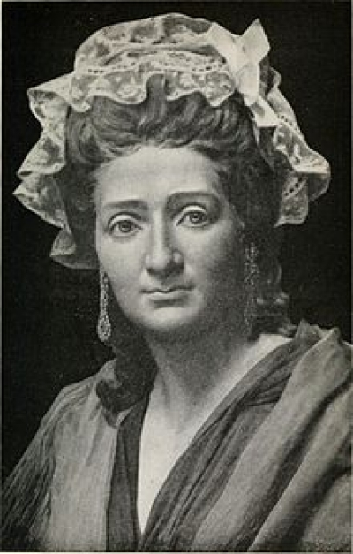

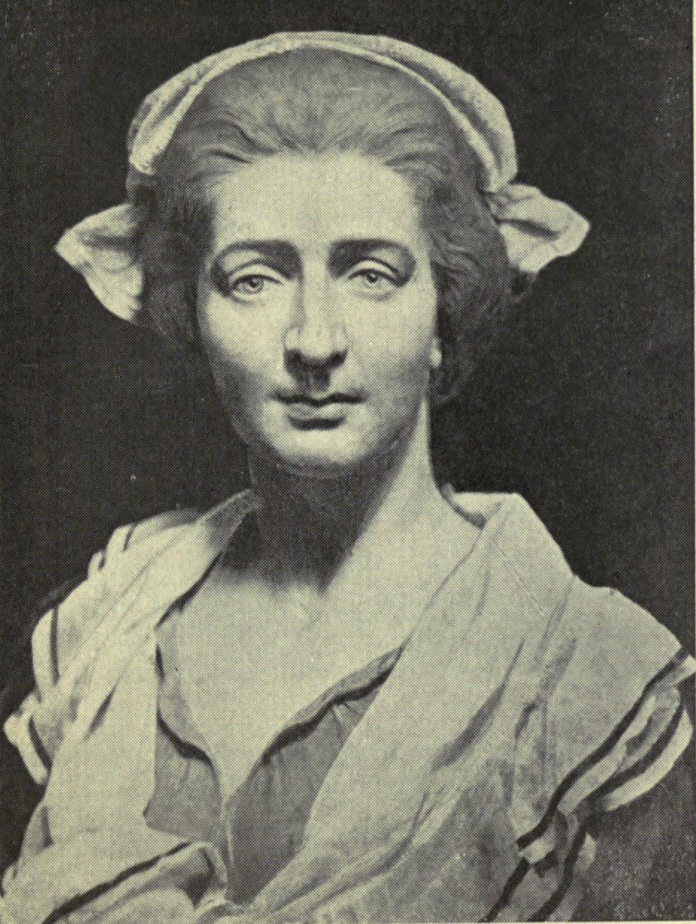

Tussaud Maria at the age of 42, when she left France for England

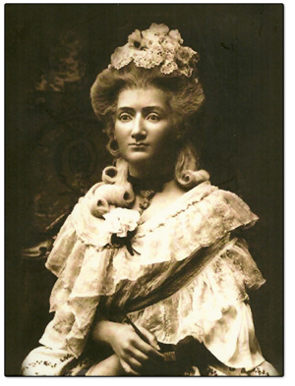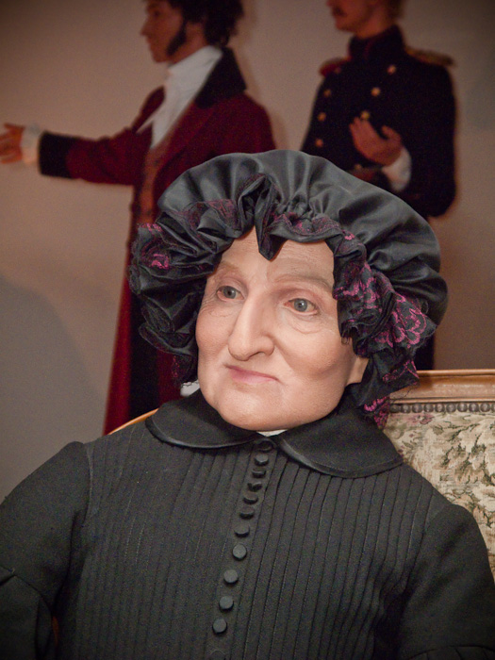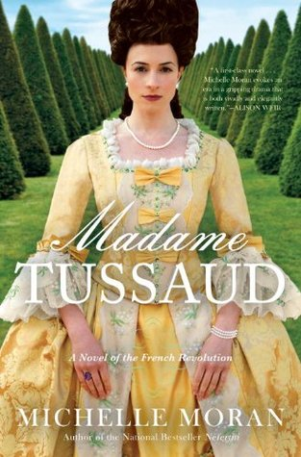

Gallery of Madame Tussaud in London

* [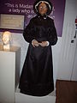](http://ru.wikipedia.org/wiki/%D0%A4%D0%B0%D0%B9%D0%BB:%27Madame_Tussaud%27_herself_at_%27Madame_tussauds_waxworks_in_London..jpg)

Madame Tussaud

* [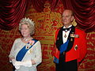](http://ru.wikipedia.org/wiki/%D0%A4%D0%B0%D0%B9%D0%BB:Elizabeth_II_Wax_Statue_in_Madame_Tussauds_London.jpg)

Елизавета II

* [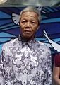](http://ru.wikipedia.org/wiki/%D0%A4%D0%B0%D0%B9%D0%BB:Nelson_Mandela_Wax_Statue_in_Madame_Tussauds_London.jpg)

Нельсон Мандела

* [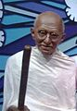](http://ru.wikipedia.org/wiki/%D0%A4%D0%B0%D0%B9%D0%BB:Mohanda_Karamchand_Gandhi_Wax_Statue_in_Madame_Tussauds_London.jpg)

Мохандас Карамчанд Ганди

* [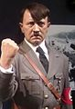](http://ru.wikipedia.org/wiki/%D0%A4%D0%B0%D0%B9%D0%BB:Adolf_Hitler_Wax_Statue_in_Madame_Tussauds_London.jpg)

Адольф Гитлер

* [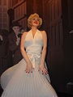](http://ru.wikipedia.org/wiki/%D0%A4%D0%B0%D0%B9%D0%BB:Marilyn_Monroe_Wax_Statue_in_Madame_Tussauds_London.jpg)

Мэрилин Монро

* [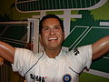](http://ru.wikipedia.org/wiki/%D0%A4%D0%B0%D0%B9%D0%BB:Sachin_Ramesh_Tendulkar_Wax_Statue_in_Madame_Tussauds_London.jpg)

Сачин Рамеш Тендулькар

* [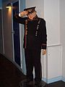](http://ru.wikipedia.org/wiki/%D0%A4%D0%B0%D0%B9%D0%BB:Benny_Hill_(Madame_Tussauds).JPG)

Бенни Хилл

* [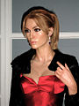](http://ru.wikipedia.org/wiki/%D0%A4%D0%B0%D0%B9%D0%BB:Madame_Tussauds_London_-_Keira_Knightley.jpg)

Кира Найтли

* [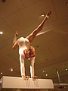](http://ru.wikipedia.org/wiki/%D0%A4%D0%B0%D0%B9%D0%BB:Madame_Tussauds_London_00813_Nevit.jpg)

Ольга Корбут

* [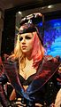](http://ru.wikipedia.org/wiki/%D0%A4%D0%B0%D0%B9%D0%BB:Gaga_vax_at_Madame_Tussauds_London.jpg)

Леди Гага

* [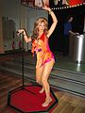](http://ru.wikipedia.org/wiki/%D0%A4%D0%B0%D0%B9%D0%BB:Beyonc%C3%A9_in_Madame_Tussauds_London.jpg)

Бейонс

* [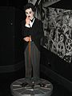](http://ru.wikipedia.org/wiki/%D0%A4%D0%B0%D0%B9%D0%BB:Charlie_Chaplin_in_Madame_Tussauds_London.jpg)

Чарли Чаплин

* [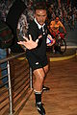](http://ru.wikipedia.org/wiki/%D0%A4%D0%B0%D0%B9%D0%BB:Jonah_Lomu_Madame_Tussaud_london.jpg)

Йохан Лому

* [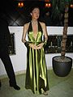](http://ru.wikipedia.org/wiki/%D0%A4%D0%B0%D0%B9%D0%BB:Angelina_Jolie_Madame_Tussauds_London.jpg)

Анджелина Джоли

* [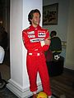](http://ru.wikipedia.org/wiki/%D0%A4%D0%B0%D0%B9%D0%BB:Ayrton_Senna_in_Madame_Tussauds_London.jpg)

Айртон Сенна

* [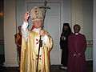](http://ru.wikipedia.org/wiki/%D0%A4%D0%B0%D0%B9%D0%BB:Religious_leaders_in_Madame_Tussauds_London.jpg)

Иоанн Павел II

* [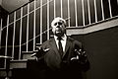](http://ru.wikipedia.org/wiki/%D0%A4%D0%B0%D0%B9%D0%BB:Alfred_Hitchcock_(Madame_Tussauds).JPG)

Альфред Хичкок

* [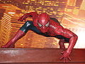](http://ru.wikipedia.org/wiki/%D0%A4%D0%B0%D0%B9%D0%BB:Spiderman.JPG)

Человек-паук

* [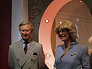](http://ru.wikipedia.org/wiki/%D0%A4%D0%B0%D0%B9%D0%BB:CharlesandCamila.jpg)

Чарльз и Камила

* [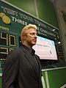](http://ru.wikipedia.org/wiki/%D0%A4%D0%B0%D0%B9%D0%BB:Borisbecker.jpg)

Борис Беккер

* [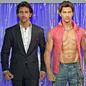](http://ru.wikipedia.org/wiki/%D0%A4%D0%B0%D0%B9%D0%BB:Hritik_Roshan_with_his_wax_statue.jpg)

Ритик Рошан

* [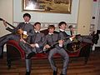](http://ru.wikipedia.org/wiki/%D0%A4%D0%B0%D0%B9%D0%BB:The_Beatles_wax_dummes.jpg)

Битлз

* [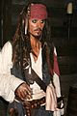](http://ru.wikipedia.org/wiki/%D0%A4%D0%B0%D0%B9%D0%BB:Jack_Sparrow_-_Johnny_Depp_(Madame_Tussauds).JPG)
* Джонни Депп (Джек Воробей)
* [](http://ru.wikipedia.org/wiki/%D0%A4%D0%B0%D0%B9%D0%BB:Kylie_Minogue-Wax.jpg)

Кайли Миног

* [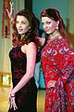](http://ru.wikipedia.org/wiki/%D0%A4%D0%B0%D0%B9%D0%BB:Aishwarya_Ray_Bacchan_in_Madame_Tussauds_London.jpg)

Айшвария Рай Баччан

|  |  |  |
| --- | --- | --- |
| *reputation as "A Little*  *Bit of Olde England."*  The museum home page: <http://www.waxmuseum.bc.ca/> |  | WaxMap |

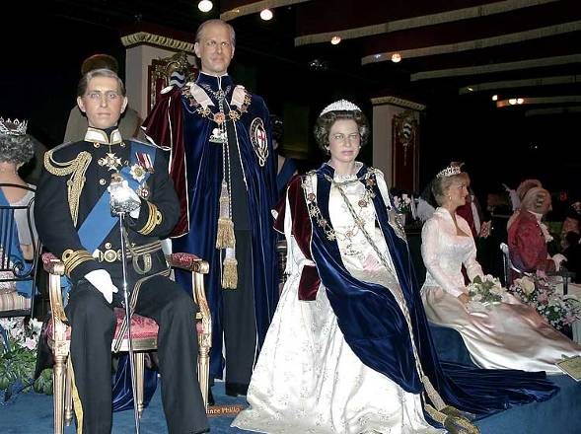

|  |  |  |  |  |  |  |  |  |  |
| --- | --- | --- | --- | --- | --- | --- | --- | --- | --- |
|  |  | | | | | | | |  |
| Wax_0792 | | | | | Wax_0821 | | |  |
| Wax_0782 | | |  |
| Wax_0819 | | | | |  |
| Wax_0828 | | |  |
| Wax_0781 | | | | |  |
| Wax_0804 | | |  |
| Wax_0778 | | | | |  |
| Wax_0832 | | |  |
| Wax_0783 | | | | |  |
| Wax_0848 | | |  |
| Wax_0842 | | | | | | | |  |
| Wax_0863 | | | | | | | |  |
|  |  | | Wax_0785 | | | Wax_0788 | |  |
| Wax_0841 | | |  | |  |
| Wax_0837 | |  |
| Wax_0851 | | |  |
| P5250032 | |  |
| Wax_0827 | | |  |
| Wax_0824 | |  |
| Wax_0826 | | |  |
| Wax_0838 | |  |
| Wax_0823 | | | Wax_0825 | |  |
|  | Wax_0795 | | |  |
|  | Wax_0846 | |  |
| Wax_0793 | |  | | |  |
| Wax_0818 | | |  |
| Wax_0787 | | Wax_0786 | | |  |
| P5250021 | | | | | | |  |
| Wax_0597 | | | | | | |  |
|  | |  |  |  |  | | --- | --- | --- | --- | | [MainPage](http://members.shaw.ca/panthers6/MainPage.html) | [Index01](http://members.shaw.ca/panthers2/index01.html) | [Index02](http://members.shaw.ca/panthers2/index02.html) | [Index03Victoria](http://members.shaw.ca/panthers2/index03Victoria.html) | | | | | | |  |
|  |  |  |  |  |  |  |  |  | | |  |  |

Royal London Wax Museum, Victoria