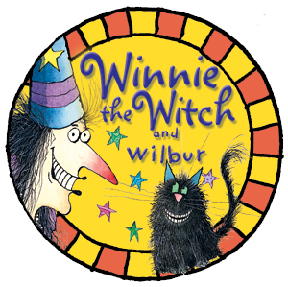
Magic Test
Your name: _______________

How does Winnie's house look at the beginning of the story? Fill in the blanks.

Winnie lives in a _____ house in the ________ .
The house is black with a black ______ .
The _______ are black, the ________ are black.
The _________ are black, the ________ are black.
The _____ is black. Even the ________ is black!
Winnie lives in her black house with her _____ Wilbur.

Choose the correct option:

Why can Winnie see Wilbur when he sits on a black chair?

1. Wilbur meows loudly to show Winnie that he is on the chair.
2. Winnie can see Wilbur's green eyes.
3. Wilbur wags his tail all the time.

How does the trouble begin?

1. Wilbur is a mean old cat and ruins all Winnie's magic potions.
2. Wilbur wants Winnie to find another pet to keep him company.
3. Wilbur is black and Winnie trips over him when he sleeps on the black carpet.

After a nasty fall, what does Winnie decides to do?

1. She sends him to her cousin Willow.
2. Winnie turns Wilbur into a bright green cat.
3. Winnie turns Wilbur into a black owl.

Why does Winnie send Wilbur outside?

1. Wilbur sleeps on her black bed, which he is not
allowed to do.
2. Winnie wants to be alone in the house.
3. Wilbur wants to go outside to play on the grass.

Why is Winnie furious?

1. She sees Wilbur chasing butterflies.
2. She cannot see the green cat on the grass and
trips over him.
3. Wilbur wants to play in the forest.

What does Winnie do after falling into a rose bush?

1. She laughs.
2. She decides to pick some roses to decorate her house.
3. She picks up her magic wand and waves it 5 times.

What happens to Wilbur?

1. He becomes a colourful cat.
2. He runs away.
3. He turns into a frog.

Does Wilbur like being colourful?

1. Wilbur loves his new colours!
2. Wilbur thinks he is funny and laughs.
3. Wilbur knows that he is ridiculous and is very unhappy.

What does Wilbur do?

1. He climbs to the top of the tallest tree to hide.
2. He wants to show his new colours to his friends.
3. He runs back inside.

How does Winnie solve the problem?

1. Winnie decides to turn Wilbur into a white owl.
2. Winnie leaves Wilbur on the tree.
3. Winnie turns Wilbur into a black cat and changes her whole house which is now very colourful and cheerful.

