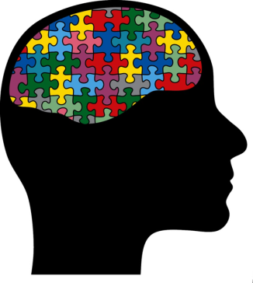
Intellectual game “Brain-Ring”
Round V. Final test
Questions to Scots:

- What is the name of the first English King?
a — Henry I
b — William I
c — Edward I

- What is the capital of Northern Ireland?
a — Birmingham
b — Belfast
c — Dublin

- What is the political centre of London?
a — Westminster
b — Kensington
c — Notting Hill

- What is the official currency of the United Kingdom?
a — euro
b — dollar
c — pound

- What is the most important airport in Great Britain?
a — Heathrow Airport
b — Gatwick Airport
c — Stansted Airport

- Who is the author of the famous books about Harry Potter?
a — J. R. R. Tolkien
b — J. K. Rowling
c — A. A. Milne

- Mark the English artist.
a — J. Turner
b — P. Gauguin
c — P. P. Rubens

- English breakfast consists of:
a — ham & eggs
b —fish & chips
c — oats

