¹ |  | ³ |  |  |  |  |  |  |  |  |  |  |  |  |  |  | 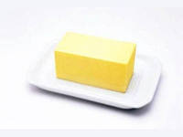 |  |  |  | 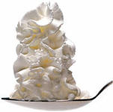
 |  |  |  |  |  |  |  |  |  |  | ¹³ |  | ¹⁴
²
 |  |  |  |  |  |  |  |  | ⁷ |  |  |  |  |  |  | ²⁵ |  |  |  | ²⁶
 | ⁵
 |  | ⁶ |  |  |  |  |  |  | ¹² |  |  |  |  |  |  |  |  |  |  |  |  |  |  | 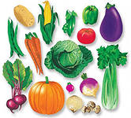
 |  |  |  |  |  |  |  |  |  |  |  |  |  |  |  |  |  | ²⁷
⁴ |  |  |  |  |  |  |  | ⁹
 |  |  |  | ¹⁰ |  | ¹¹ |  |  | ¹⁵ |  | ¹⁶ |  |  |  |  |  | ²⁸
 |  | ⁸ |  |  |  |  |  |  |  |  |  |  |  |  |  |  |  |  |  |  | ²⁴
 |  |  |  |  |  |  |  |  |  |  |  |  | ¹⁸
 |  |  |  |  |  |  |  |  |  | 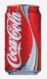 | ¹⁷
 |  |  |  |  |  | 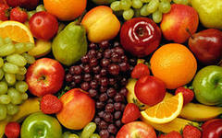 |  |  |  |  |  |  |  |  |  |  |  | ²³
 |  |  |  |  |  |  |  |  |  |  |  |  | ¹⁹
 |  |  |  |  |  |  |  |  |  |  |  |  |  |  |  |  |  | ²⁹ |  |  | 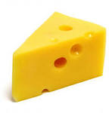
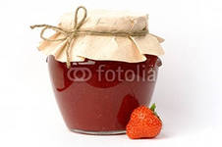 |  |  |  | 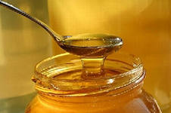 |  |  |  |  |  | ²² |  | ²⁰
 |  |  |  |  |  |  |  |  | ²¹

Across:
2. 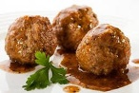 4. 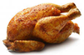 5. 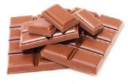 6. 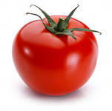 8. 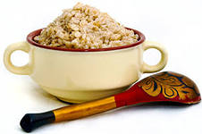 9. 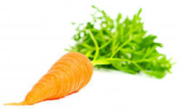
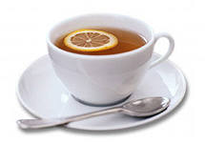
12 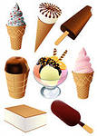 13 17.
18. And my sister Bunny 19. [ ˈbʌtә]
Eats too much ___. 20.An apple is a _____.
21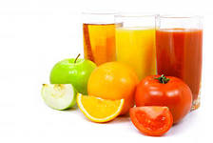23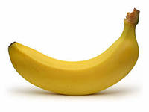24 [ˈsɔ:lt]
25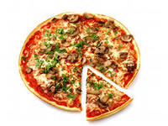
27 But do you want to know the food that is a dream?
It’s chocolate cake, with lots of good ___.
28. My big brother Jake
Is fond of ___.

Down:
- Hi, my name is Sam,
I like eating ___.
3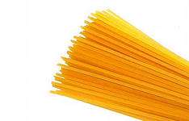 4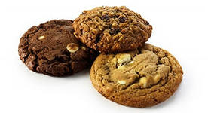7
8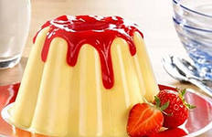 10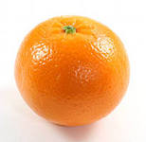 11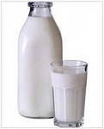
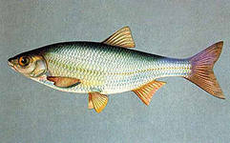
13. My name is Louise, 14
I like to eat ____.
15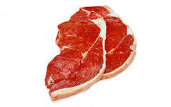18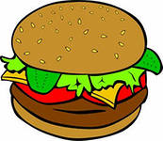22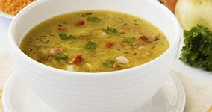
23. And this boy is Fred. 24. [ˈsᴂӀәd]
He likes eating ___.
25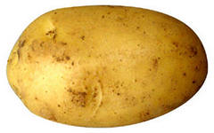26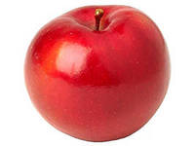 27. This is Lola.
She likes drinking ___.
29. What is white outside and yellow inside?
Ответы:
¹j |  | ³s
a |  | p |  |  |  |  |  |  |  |  | ¹³c | o | ¹⁴f | f | e | e
²m | e | a | t | b | a | l | l | s |  |  | h |  | i
 |  | g |  |  |  |  |  |  | ⁷v |  | e |  | s |  |  | ²⁵p | i | z | z | ²⁶a
 | ⁵c | h | o | c | o | l | a | t | e |  | e |  | h |  |  | o |  |  |  | p
 |  | e |  |  |  |  |  |  | g |  | s |  |  |  |  | t |  |  |  | p
 |  | ⁶t | o | m | a | t | o |  | ¹²i | c | e | - | c | r | e | a | m |  |  | l
 |  | t |  |  |  |  |  |  | t |  |  |  |  |  |  | t |  | ²⁷c | r | e | a | m
⁴c | h | i | c | k | e | n |  | ⁹c | a | r | r | o | t |  |  | o |  | o
o |  |  |  |  |  |  |  |  | b |  |  |  |  |  |  |  |  | l
o |  |  |  | ¹⁰o |  | ¹¹ m |  |  | ¹⁵l | e | ¹⁶m | o | n |  |  |  | ²⁸c | a | k | e
k |  | ⁸p | o | r | r | i | d | g | e |  | e |  |  |  |  |  |  |  |  |  | ²⁴s | a | l | t
i |  | u |  | a |  | l |  |  | s |  | a |  | ¹⁸h | o | n | e | y |  |  |  | a
e |  | d |  | n |  | k |  |  |  |  | ¹⁷t | e | a |  |  |  |  |  |  |  | l
s |  | d |  | g |  |  |  |  |  |  |  |  | m |  |  |  |  | ²³b | a | n | a | n | a
 |  | i |  | e |  |  |  |  |  |  |  |  | ¹⁹b | u | t | t | e | r |  |  | d
 |  | n |  |  |  |  |  |  |  |  |  |  | u |  |  |  |  | ²⁹e | g | g
 |  | g |  |  |  |  |  |  |  | ²²s |  | ²⁰f | r | u | i | t |  | a
 |  |  |  |  |  |  |  |  |  | o |  |  | g |  |  |  |  | d
 |  |  |  |  |  |  |  |  | ²¹j | u | i | c | e
 |  |  |  |  |  |  |  |  |  | p |  |  | r

