***Приложения к уроку***

***Игра «Крестики-нолики»***

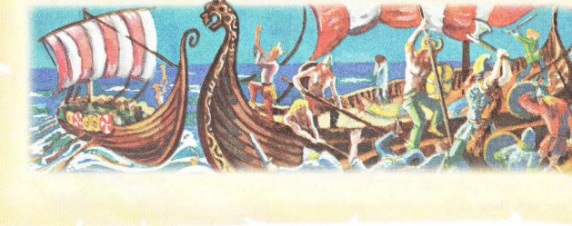

***Match the sentences with the translations.***

*1.    Five months later the Vikings were getting on their ships again. They had broken their promise to King Alfred.  
2.    He saw a horrible thing: the soldiers from the last English ship had killed all his family.  
3.    In an hour everything was over. The Vikings had burnt the last English ship and had come to the English shore.  
4.    At that moment Bjorn looked at the ring on his finger. The ring had saved his life.*

*a)    Через час все было кончено. Викинги сожгли последний английский корабль и высадились на английский берег.  
b)    В    этот момент Бьёрн посмотрел на кольцо на своем пальце. Кольцо спасло ему жизнь.  
c)    Пять месяцев спустя викинги вновь садились на свои корабли. Они нарушили свое обещание королю Альфреду.   
d)    Он увидел ужасную картину: солдаты с последнего английского корабля убили всю его семью.*

***Match the parts of the text with the pictures.*** *[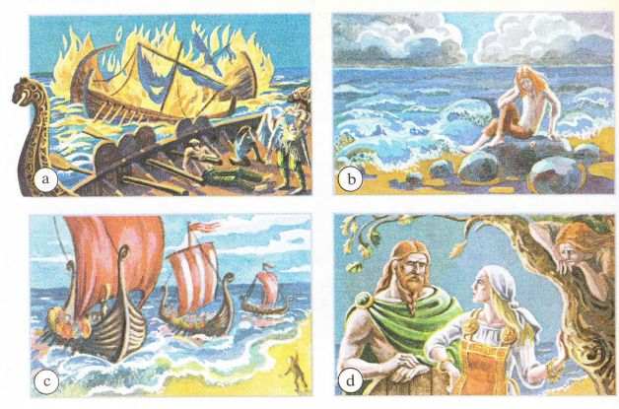](http://school.xvatit.com/index.php?title=%D0%A4%D0%B0%D0%B9%D0%BB:13-10-66.jpg)*

***Choose the right answer:***

*1.    Bjorn lived in*

*a) Norway   
b) Denmark   
c) England  
  
2.    Vikings called England*

*a) Englaland   
b) Scotland   
c) India  
  
3.    Englaland means*

*a) the land of Indians   
b) the land of Angles   
c) the long island*

*4.    The Vikings were the kings of the sea because*

*a) they had gold and silver   
b) they had good ships   
c) they were strong  
  
5.    The Vikings were scared of King Alfred because*

*a) Alfred was a friend of the wizard Merlin   
b) Alfred built ships   
c) Alfred was very kind  
  
6.    The Viking women wanted to live in Englaland because*

*a) The English climate was nicer   
b) there was a lot of silver and gold there   
c) they wanted to see a new country* ***Make questions for these answers.***

*1.    His name was Bjorn.  
2.    He lived in Norway.  
3.    One morning he saw his father's ship.  
4.    His father raided Englaland.  
5.    His mother was angry because she wanted to live in Englaland.  
6. Bjorn's  fathеr gave  him a ring.  
7. Thе Vikings  wеnt  to Еnglaland  in spr  
8. Thе Еnglish  killеd Bjоrn's  family.  
9. Bjorn wantеd  to go baсk  to his homeland.****Answer the questions. Support your answers with the information from the text.***

*1.    How did Bjorn's father get the ring?  
2.    Did the ring make Bjorn happy? Why?  
3.    Did Bjorn want to stay in England?  
4.    Why did he say in the end, "I want to live in Norway?*

