Приложение 1 (бланк для ответов учащихся- the answer sheet)
History and Civilizations Name ___________________Form 9_______ Date ______________2010
Tasks:
I. Slide 3: Match the words with their definitions:_
1. mankind a. to begin to create, to start to
happen;
2. to achieve b. modern or relating to the
present time;
3. contemporary c. all humans;
4. generation d. to succeed in doing what you
planned to do
5. to establish e. belonging to the same time

II. Slide 6: Tick the modern gadgets represented in the film “The Flintstones”:
a car | a bicycle | a train
theatre | circus | drive-in-movie
a motorbike | a two-wheeled bicycle | a three-wheeled bicycle
a helicopter | a plane | a spaceship

III. Slide 8: read the definition of civilization and fill the gaps with the words:
art, advanced, political, religion.
1 ________________, 2 _________________
3 ________________, 4_________________

IV. Slide 9: match the geographical map and the civilization:
1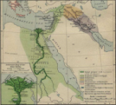2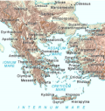3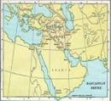4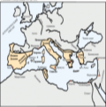5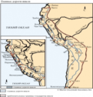
Babylon - ______; Egypt - _______; Greece - ________; Incas - ______; Rome - _______

V. Slides 11, 12, 13: Where do they belong to? Are they Egyptian? Greek? Roman?
Put the numbers of the items into the correct column.
Civilizations | Egyptian | Greek | Roman
№№ of items on the slides

- Trojan horse; 2 public baths; 3 an excellent road; 4 a gladiator; 5 the Sphinx; 6. a legionary;
7. Mummy; 8 Coliseum; 9.the first theatre; 10.Spartan warriors; 11.papyrus; 12.sport games; 13. Mount Olympus; 14 a pharaoh; 15.Emperor.

VI. Slide 14: to video “Seven Wonders of Greece”.
Watch and tick the correct items.
The first city of Maya | The lost city of Atlantis
Minotaur | Dinosaur
The Highland Games | The Olympic Games
Delphic Oracle | The Speaker in the Senate
The first movies | The first theatre
The Nelson’s Column | The Colossus of Rhodes
The Parthenon | The Coliseum

VII. Slide 17: Can you read ancient Egyptian?



