Приложение 1
I (dis)agree with  because…

Приложение 2
For me, the most important points are…

Приложение 3
Кроссворд

1. → |  |  |  |  |  |  |  | 5.↓
 |  |  |  |  | 2. →
 |  |  |  |  |  |  | 6. ↓
 |  |  |  |  |  |  |  | 3. →
 |  | 4. →
- the surroundings or conditions in which a person, animal, or plant lives or operates
- to use, consume, or expend thoughtlessly, carelessly
- waste material; refuse or litter
- convert (waste) into reusable material
- the phenomena of the physical world collectively, including plants, animals, the landscape, and other features and products of the earth, as opposed to humans or human creations
- the presence in or introduction into the environment of a substance which has harmful or poisonous effects

The Second Conditional
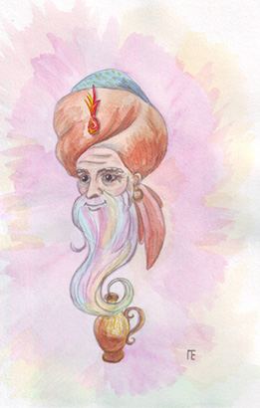
"If I met a genie, I would ask for infinite wealth..."
We use the second conditional when talking about future events that are not likely to happen.
Structure:
If + Simple Past, + Would + Base Form
OR
Would + Base Form + If + Simple Past
Examples:
- If I won a million dollars, I would travel around the world.
(There is a small possibility that I would actually win.)
- If I met him again, I would tell him the truth.
(There is a small possibility that I would actually meet him again.)

Приложение 5
- If all the people decided to save our world, ______________________________________________.
- If people took cans, bottles, paper to local recycling centres,________________________________.
- If people bought only the things they really needed,________________________________________.
- If people avoided buying packaged goods,_______________________________________________.
- If people didn’t waste papers,_________________________________________________________.

Приложение 6

Приложение 7

Criterias:
- Originality of the project(1 point)
- Completeness of the project(1 point)
- Clarity of the project( presence of subtitles)(1 point)
- Presence of at least 4 slides(1 point)
- Use of phrases with new words: avoid, least(1 point)
Each item gives a group 1 point. Maximum amount of points - 5.

Приложение 8
