8. The Opening the Western Front
«Открытие второго фронта (в Европе)»
Скрин-шот слайдов и технические комментарии | № | КОММЕНТАРИИ и текст выступающих
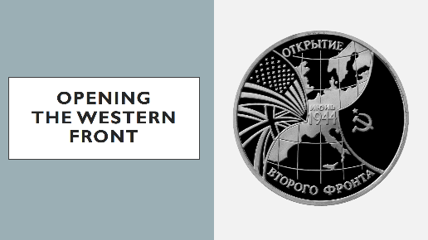 | 1 | ВЫСТУПАЮЩИЙ 1:  On the 6th of June in 1944 the forces of the anti-Hitler coalition allies led by general Eisenhower …
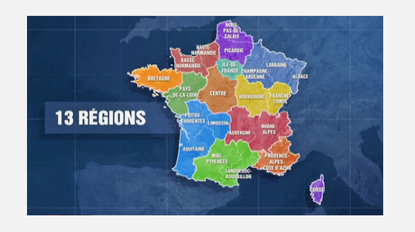 | 2 | ВЫСТУПАЮЩИЙ 2:  …started their landing in Normandy (Northern France).
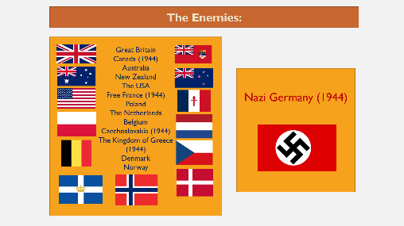 | 3 | ВЫСТУПАЮЩИЙ 1:  For doing the battle against Nazi Germany the allies united the forces of 13 countries: Great Britain, Canada, Australia, New Zealand, The USA, Free France, Poland, The Netherlands, Belgium, Czechoslovakia, The Kingdom of Greece, Denmark and Norway.
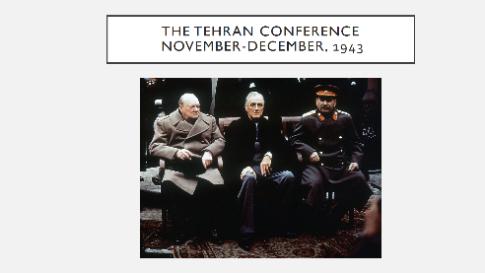 | 4 | ВЫСТУПАЮЩИЙ 2:  Only in 1943 at the Tehran Conference the treaty was finally signed and the date of the operation was set.
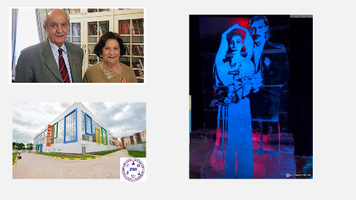 | 5 | ВЫСТУПАЮЩИЙ 1:  During our working at the project we have got to know that they are going to fix up a monument to Gevork Andreevich Vartanian on the territory of the school №2070. This man is famous today as a Soviet intelligence agent who at the age of 19 took part in the operation to fail the assassination of Stalin, Roosevelt and Churchill in Tehran.  ВЫСТУПАЮЩИЙ 2:  The personality of Gevork Vartanian was used as a prototype of the main character from the French-Soviet thriller “Tehran-43”. The role of the main character-spy was played by the Soviet actor Igor Kostolevsky.
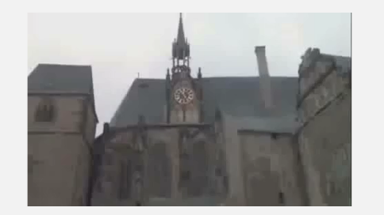  Включить обрезанное ВИДЕО (первые 30 сек.) по щелчку. | 6 | (просмотр видео – 30 сек.)  /Источник полного видео: https://www.youtube.com/watch?v=5zTcKKYwtq4 /
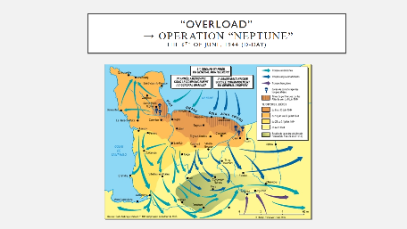 | 7 | ВЫСТУПАЮЩИЙ 1:  The Battle of Normandy was started on the D-Day or on the 6th of June. It was named “Overload” and this operation made the beginning of the Western Front opening.
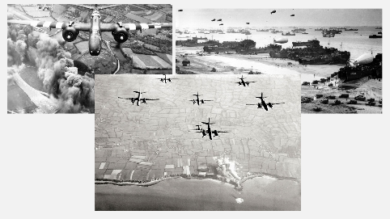 | 8 | ВЫСТУПАЮЩИЙ 2:  The first stage was air-landing operation – the biggest one in the Second World War.  The second stage was amphibious raid.
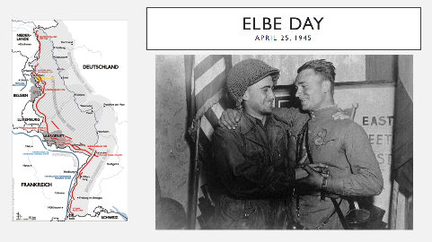 | 9 | ВЫСТУПАЮЩИЙ 1:  On the 25th of April in 1945 the armies of allies met on the Elbe and Germany was bound in the vice of two fronts.
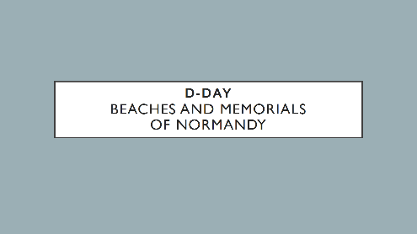 | 10
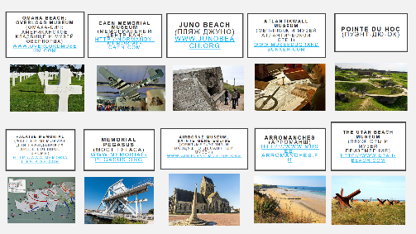 | 11 | ВЫСТУПАЮЩИЙ 2:  Nowadays the Normandy seaside beaches near the English Channel remind the terrible days and their victims.
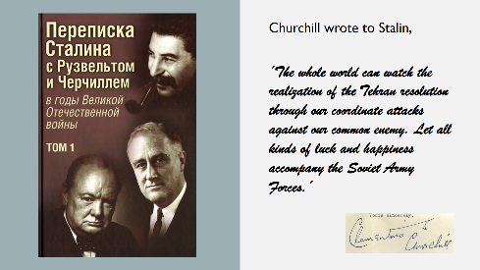 | 12 | ВЫСТУПАЮЩИЙ 1:  In the personal secret correspondence Churchill wrote to Stalin,  ВЫСТУПАЮЩИЙ 2:  (сценка: выступающий НАИЗУСТЬ в роли У. Черчилля в шляпе-котелке произносит низким голосом)  ´The whole world can watch the realization of the Tehran resolution through our coordinate attacks against our common enemy. Let all kinds of luck and happiness accompany the Soviet Army Forces.´

