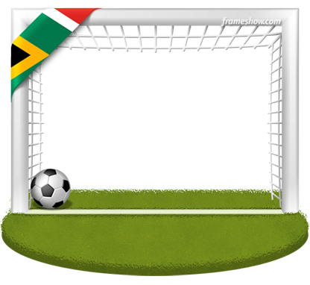

Listen. Circle the correct option.
Oh, what a living / feeling / seeing
Look what we've done / sound /overcome
Oh, I'm gonna wave a’ wave my flag / hand / hat
And count all the seasons / reasons / treason
We are the champions
There ain't no turning/ loving / morning , turning back.
Saying "Oh, can't you taste the feeling, feeling"
Saying "Oh, we all together living / singing / giving".
Order the lines.
___ Hands up for your colors
___ Now, now, now, now
___ We still got a long way
___ I'm ready, I'm ready
___ Now, now, now, now
___ Oh, oh, oh, oh, oh (x2)
___ But look how far we've come
___ There's beauty in the unity we've found
___ Look how far we've come
Complete the gaps.
Ready the pupil/ people /children
A new day has just begun
And I wear my colors / flowers / bags on my back
We're created equal
One race , and that's human
Can't wait ‘til they all see, all see run / clean /dance

Saying "Oh, can't you taste the feeling, feeling"
Saying "Oh, we all together living / singing / giving".

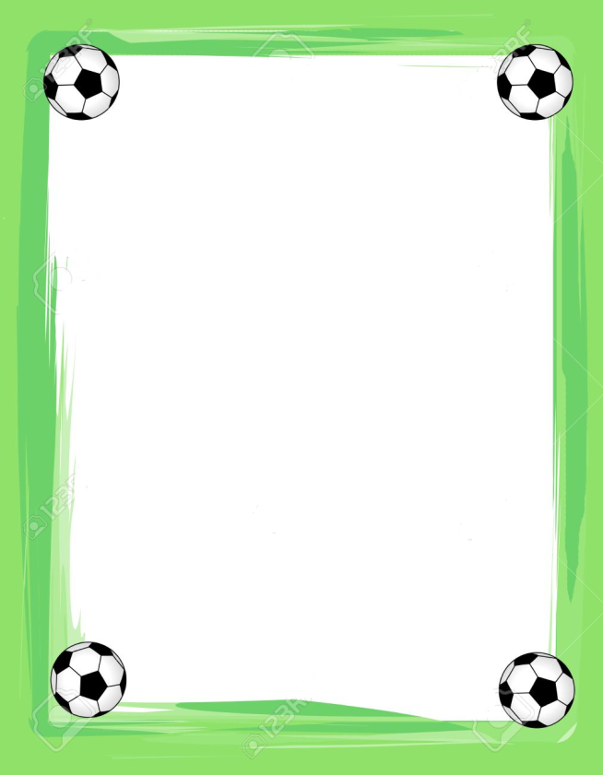

Discuss:
1. What does the phrase
“show your true colors” mean?
2. What is the message of the song?

