Приложение 1 Схема плана «Барбаросса»

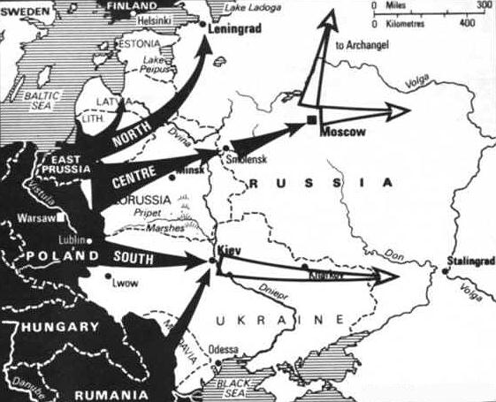
Operation Barbarossa was the largest military operation in human history in both manpower and casualties. Its failure was a turning point in the Third Reich's fortunes. Most important, Operation Barbarossa opened up the Eastern Front, to which more forces were committed than in any other theatre of war in world history. Operation Barbarossa and the areas that fell under it became the site of some of the largest battles, deadliest atrocities, highest casualties, and most horrific conditions for Soviets and Germans alike – all of which influenced the course of both World War II and 20th century history.

