Шустова М.А 274-997-777

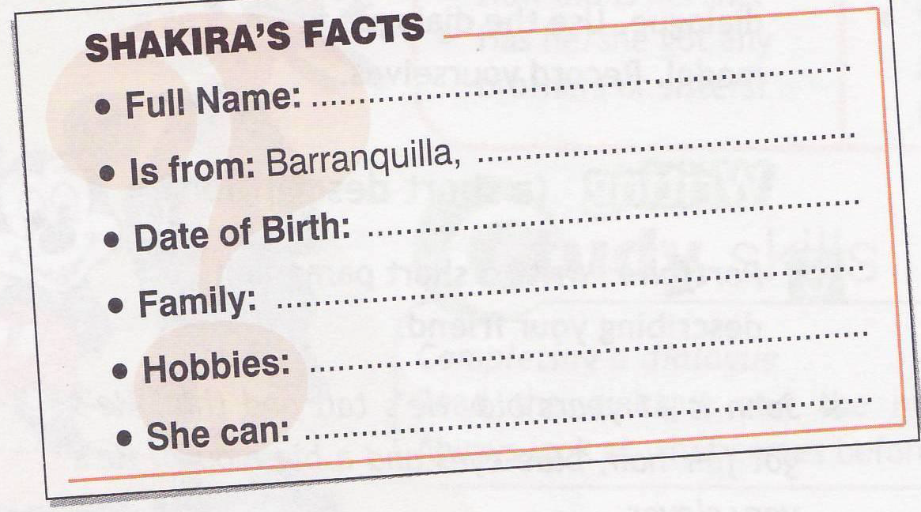

Шустова М.А 274-997-777

Shakira,s full name is_________. She is from ________. Her birthday is on________. She has got _______.
Her hobbies are_________. She can______.

Shakira,s full name is_________. She is from ________. Her birthday is on________. She has got _______.
Her hobbies are_________. She can______.

Shakira,s full name is_________. She is from ________. Her birthday is on________. She has got _______.
Her hobbies are_________. She can______.

Shakira,s full name is_________. She is from ________. Her birthday is on________. She has got _______.
Her hobbies are_________. She can______.

Shakira,s full name is_________. She is from ________. Her birthday is on________. She has got _______.
Her hobbies are_________. She can______.

Shakira,s full name is_________. She is from ________. Her birthday is on________. She has got _______.
Her hobbies are_________. She can______.

Ex.  mark | Ex.1 | Ex.2 | Ex.3 | Ex.4 | Ex.  mark | Ex.1 | Ex.2 | Ex.3 | Ex.4
 | 5 | 5 | 5 | 5 |  | 5 | 5 | 5 | 5
 | 4 | 4 | 4 | 4 |  | 4 | 4 | 4 | 4
 | 3 | 3 | 3 | 3 |  | 3 | 3 | 3 | 3
 | 2 | 2 | 2 | 2 |  | 2 | 2 | 2 | 2
 | 1 | 1 | 1 | 1 |  | 1 | 1 | 1 | 1
Ex.  mark | Ex.1 | Ex.2 | Ex.3 | Ex.4 | Ex.  mark | Ex.1 | Ex.2 | Ex.3 | Ex.4
 | 5 | 5 | 5 | 5 |  | 5 | 5 | 5 | 5
 | 4 | 4 | 4 | 4 |  | 4 | 4 | 4 | 4
 | 3 | 3 | 3 | 3 |  | 3 | 3 | 3 | 3
 | 2 | 2 | 2 | 2 |  | 2 | 2 | 2 | 2
 | 1 | 1 | 1 | 1 |  | 1 | 1 | 1 | 1
Ex.  mark | Ex.1 | Ex.2 | Ex.3 | Ex.4 | Ex.  mark | Ex.1 | Ex.2 | Ex.3 | Ex.4
 | 5 | 5 | 5 | 5 |  | 5 | 5 | 5 | 5
 | 4 | 4 | 4 | 4 |  | 4 | 4 | 4 | 4
 | 3 | 3 | 3 | 3 |  | 3 | 3 | 3 | 3
 | 2 | 2 | 2 | 2 |  | 2 | 2 | 2 | 2
 | 1 | 1 | 1 | 1 |  | 1 | 1 | 1 | 1
Шустова М.А 274-997-777

