Раздаточный материал
Приложение 1
Match each invention with its inventors
Russian Invention | Invention | Foreign invention
the Cherepanovs | steam locomotive | the Wright brothers
Alexander Mozhaisky | aeroplane | Kirkpatrick Macmillan
Efim Artamonov | the first bicycle with pedals | George Stephenson

Keys:
Russian Invention | Invention | Foreign invention
the Cherepanovs | steam locomotive | George Stephenson
Alexander Mozhaisky | aeroplane | the Wright brothers
Efim Artamonov | the first bicycle with pedals | Kirkpatrick Macmillan

Приложение 2
Save Time and Energy
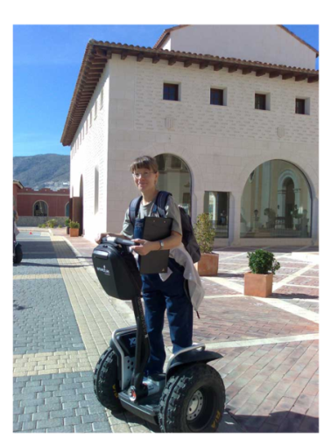
Does it take you ages to get to work or school? Are you tired of carrying heavy bags back from the shops? Here is the perfect solution for you: the Segway Human Transporter. The Segway will change your life and make your journeys good fun, too.

The Segway has only got two wheels plus a sophisticated computer which helps you to balance. The Segway is easy to use and moves with your body. It’s enjoyable to ride, too. One user has said: “It’s like flying along the street, in a way – you can move without trying!”

The Segway is very convenient and practical. It weighs only 50 kilos and is easy to carry. Its maximum speed is 30 kph and it can carry a person weighing less than 110 kg. Its electric battery has a range of 18 kilometres. It’s also safe and stops immediately when you want it to. The Segway is very useful for journeys around your town or city and it doesn’t cause any pollution, either!

The Segway is a bargain at only € 5,000. And you don’t need to spend money on petrol, either. Contact www.segway.com for more information about this revolutionary product!

Приложение 3
name
purpose/usage
design
max speed
weight
advantages
price

Key:
