Беличенко Наталья Николаевна (216-050-150)
Приложение 1.
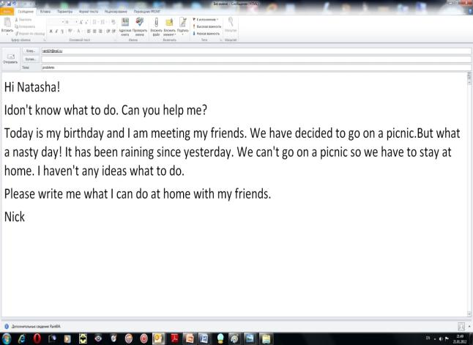

Приложение 2.
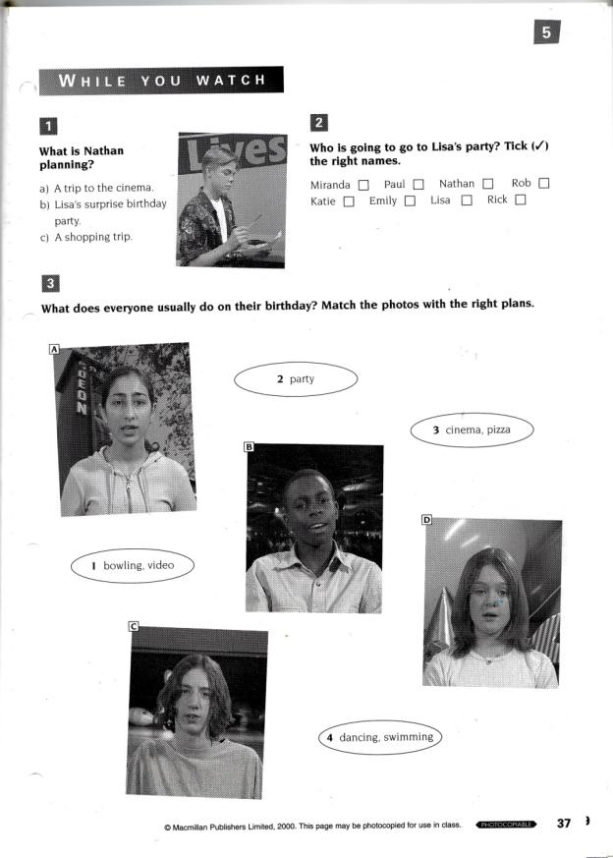
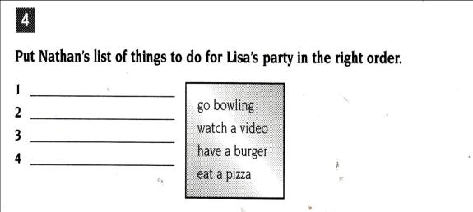

Приложение 3
When the weather is good | When the weather is nasty
- hang out with friends  - To eat out  - go sailing  - go for a walk  - go bowling  - take photographs  - play different kind of sports.  - go fishing  - go cycling  - roller-skating  - skateboarding | - watch videos.  - play board games  - play computer games/surf the net  - listen to music

Приложение 4.

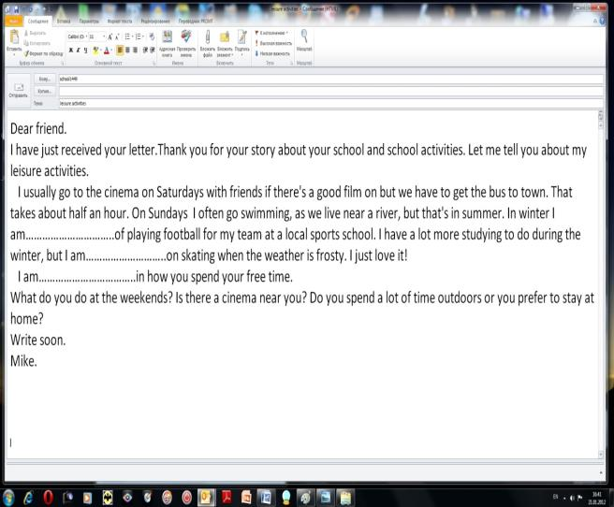

- Mike usually goes to the cinema with his parents. .....................
- It takes him less than an hour to get the town. .....................
- On Fridays Mike often goes swimming. ......................
- He plays football for his team at a local sports school. .......................
- Mike is interested in how you spend your school activities. .......................

