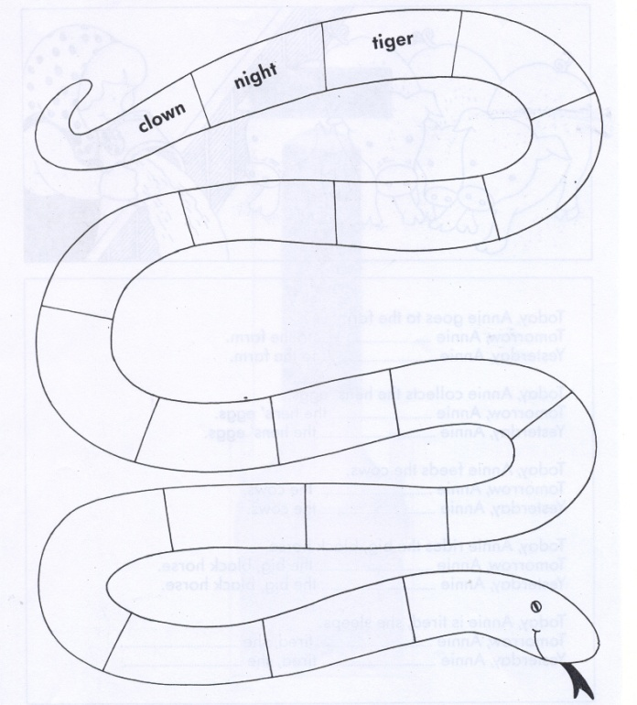

rose | eat | tall | library | yellow | weak
kangaroo | orange | expect | typist | tear | round
dear | rock | kite | expensive
read | dull | love | ears | sight | true
excellent | twelve | each | hello | opportunity | yard
donkey | yes | strong | giraffe

