Can you read Ancient Egyptian?
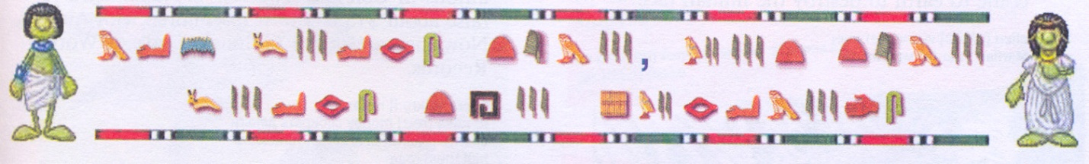

Can you read Ancient Egyptian?

