Приложение № 6
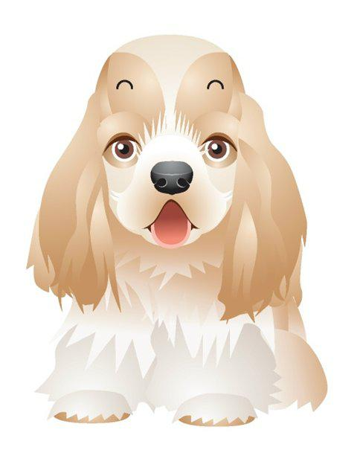

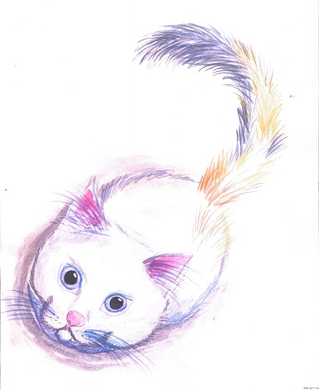

“Bow – Wow”, - said the dog, “Mee – ow, mee – ow”, - said the cat, “Crunt, crunt”, - said the hog, “Squeak, squeak”, - said the rat, “To – whoo”, - said the owl, “Caw, caw”, - said the crow, “Quack, quack”, - said the duck, What the cuckoos said, you know.

