Try to find wh-words
n | o | w | e | l
e | w | h | a | w
w | h | e | w | h
h | o | r | h | e
y | w | e | o | n
w | h | a | t | h

Make up questions:
- Do, like, you, fairy tales?
- your, is, birthday, When?
- old, How, you, are?
- you, What season, do, like?
- funny, Can, pictures, you, draw?

Do or Does?
- … your friend like summer?
- What season … you like?
- Where … you skate in winter?
- What sport … his mother like?
- What … they have for breakfast?
- Why … he like to draw?

Do the crossword puzzle
1
2
3
4
5
6
7
8

1 - 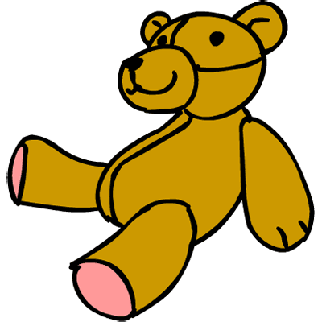 5 - 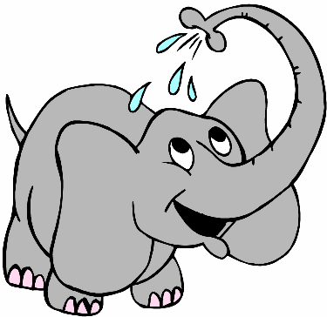
2 - 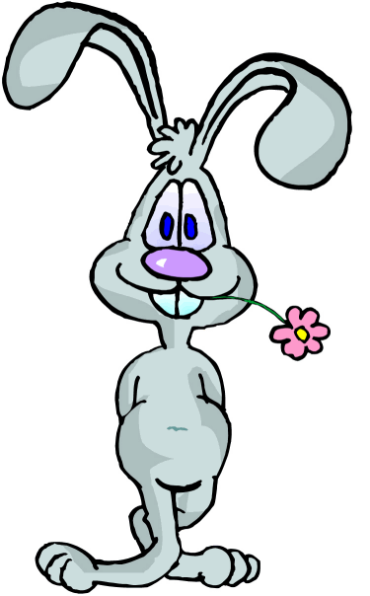 6 - 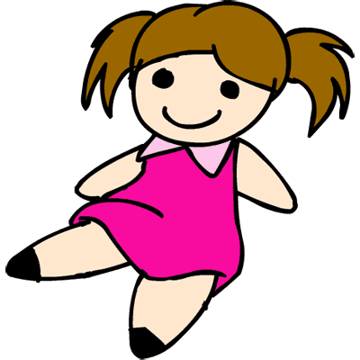

3 - 7 - 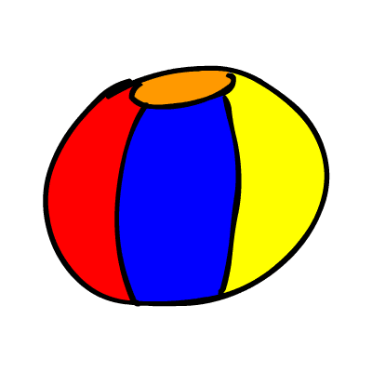

4 - 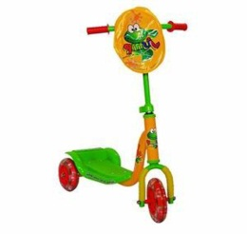 8 - 