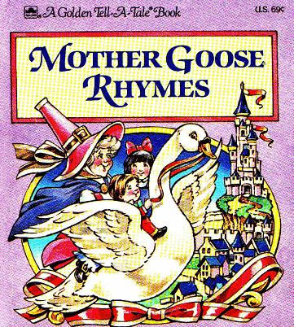
To the winner of
“Mother Goose Rhymes”
Competition

__________________________________

___________________________________

You are the best in
_________________________________
_________________________________

Congratulations!
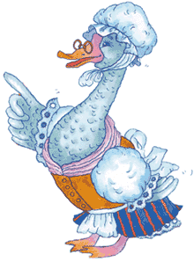

Jury:

school 33
ozersk
2010

